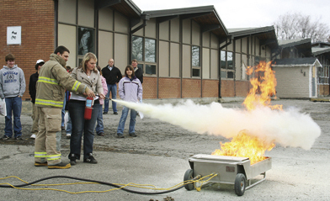
Courtesy of Wendy Molenaar, WMM Photography and The Canadian Agricultural Safety Association
Acknowledgement of Fire Extinguisher Training
I acknowledge that ____________________________(student) has undergone training on the use of fire extinguishers present on our farm or agricultural worksite. This student was trained by ____________________________(trainer).
This student has effectively demonstrated their understanding of the use of a portable fire extinguisher.

Signed and dated:

Trainer: ____________________________________________________

Student: ____________________________________________________

Date:_______________________________________________________

