(21 marks) | Module 1: Lesson 3 ASSIGNMENT  This Module 1: Lesson 3 Assignment is worth 39 marks. The value of each assignment and each question is stated in the left margin.

(12 marks) | Lesson 3 Assignment: The Basic Units of the Nervous System—The Neuron and the Reflex Arc

(12 marks) | Lab Part 1  Examining Neural Tissue  In this investigation, you will examine pictures/photographs of microscope slides of neural tissue. As you observe the tissues and make diagrams, identify the specialized structures that allow neurons to carry out their functions.  Question  How does the structure of different neurons relate to their functions?  Materials  • Slide pictures to be used as your slides for the purposes of creating your diagrams.  Procedure  Observe each slide provided by your teacher, as well as the micrographs below, and identify any key neural structures.  Analysis  1. Slide and micrograph 1 show a cross-section of the brain. Sketch your observations, and label the white and grey matter. Describe the structural differences between the two types of neural tissue.  2. Slide and micrograph 2 show a cross-section of a nerve. Sketch your observations, and label the nerve bundles and neurons. Explain the basic function of a neuron.  3. Slide and micrograph 3 show a cross-section of the spinal cord. Sketch your observations, and label a sensory neuron, a motor neuron, and an interneuron. (Hint: See Figure 11.6.) Explain the function of each neuron, and trace the neural pathway.  4. Slide and photograph 4 show several unmyelinated neurons. Sketch one neuron that you can see, and label the basic structures. Indicate the direction of impulse transmission down the neuron.  5. Slide and micrograph 5 show a longitudinal view of a myelinated axon. Sketch your observations, and label the axon, the myelin sheath, a Schwann cell, and a node of Ranvier. Describe the functions of the myelin sheath.  6. Slide and micrograph 6 show a view of the neuromuscular junction between the dendrites of a motor neuron and the receptors on a muscle fibre. Sketch your observations, and label the motor neuron, muscle fibre, and synapse. Hypothesize how the impulse coming from the motor neuron might reach the muscle fibre (effector).  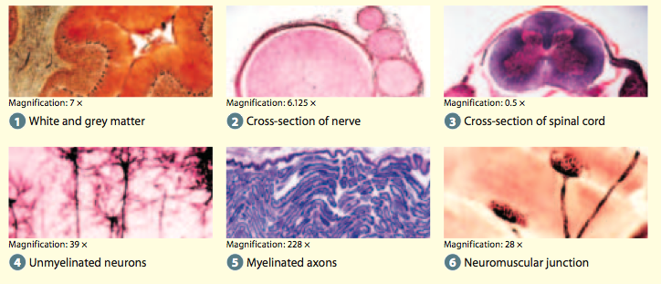

Answer:
Insert scanned drawings here.

(9 marks) | Lab Part 2  Do the lab titled “Investigation 11.A: Move Fast! Reflex Responses” on page 371 of your textbook. (See Below)

Answer:
Move Fast! Reflex Responses
Reflexes are rapid, involuntary neural pathways that help to protect the body. The knee-jerk (patellar) reflex is an example of the numerous stretch adjustments your body makes every second to unconsciously maintain your balance and coordination. (Your teacher may add others.) Try to initiate the following three common reflexes.

Question
How does a reflex arc help to protect the body from harm?

Safety Precautions
Do not use excessive force when testing the knee-jerk reflex.

Materials
• cotton balls
• 20cm by 20cm clear
plastic sheet
• room light • chair

Procedure

Part 1: Pupillary Reflex

1. Work with a partner. Dim the lights in the room for a
few minutes. Look at the pupils in your partner’s eyes.
2. Turn on the lights. Check the size of the pupils.

Part 2: Blink Reflex

1. Have your partner hold a piece of clear plastic in
front of the face.
2. Without warning, quickly throw a cotton ball at your partner’s eyes. Your partner should blink, demonstrating the blink reflex.

Part 3: Knee Jerk (Patellar) Reflex

1. Have your partner sit in a chair with legs crossed,
so the top leg can swing freely.
2. Hit the top leg softly, just below the knee, with the side of your hand. The leg should kick out immediately, demonstrating the patellar reflex

Analysis
1. Copy the diagram below into your notebook. Use it as a model to represent and summarize each of the reflex responses that you tested and observed in this investigation. (3 marks)
2. Explain why reflexes are important for the body. (1 mark)

Conclusion
3. Describe how the three reflexes tested in this investigation might protect the body. (3 marks)
.
Applications
4. A student puts her hand on hot glassware, but withdraws her hand before she feels the pain. Explain how and why her awareness of the pain is delayed. (2 marks)

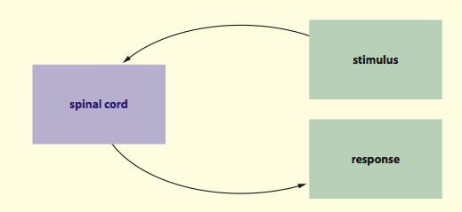

Once you have completed all of the questions, submit your work to your teacher.

