(34 marks) | Module 7: Lesson 5 ASSIGNMENT  This Module 7: Lesson 5 Assignment is worth 34 marks. The value of each assignment and each question is stated in the left margin.

Part 1: Recreating the First Chimera

(12 marks) | Read the information below and then answer the questions.

Answer:
In genetic engineering, a chimera is a genetically engineered organism that contains DNA from unrelated species. The first chimera was created in 1973 by the American team of Stanley Cohen and Herbert Boyer Bacteria were then exposed to a recombinant plasmid. Those bacteria that displayed tetracycline resistance had taken up the plasmid.

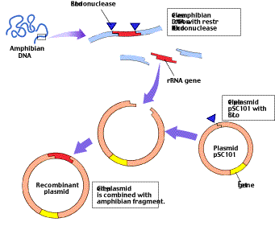
In Cohen and Boyer’s experiment, the amphibian gen coded for the production of rRNA. The bacterial gene tet^{R} conferred resistance to the antibiotic tetracycline. They used the restriction endonuclease EcoR1 and DNA ligase to splice (insert) a gene from a toad into a molecule of bacterial DNA plasmid pSC101.

- Describe the procedure (in your own words) used to produce the Chimera ? (4 marks)

- The Cohen-Boyer experiment was important because it created a colony of bacterial cells that were resistant to the antibiotic tetracycline and produced amphibian rRNA. What other bacterial phenotypes would have resulted from this experiment ? What would each phenotype indicate about events at a molecular level ? (4 marks)

- Give one example of how you might use this technology for a social or industrial purpose ? (1 mark)

4. What environmental, social, or ethical issues does this kind of technology raise ? Make a list of these issues. (3 marks)

(22 marks) | Part 2—Review Questions

(6 marks) | 1. | Complete the following table.
 |  | Using transgenic pigs as organ donors | Benefits | Risks
 |  | To individual people
 |  | To society
 |  | To the economy
 |  | To other species
 |  | To the environment

(4 marks) | 2. | Describe two features that are characteristic of the action of restriction endonucleases. How do these features make restriction endonucleases useful to genetic engineers?

Answer:

 | 3. | A farmer plants a strain of transgenic corn in her fields. The corn carries a recombinant gene that confers resistance to a common herbicide. The next year, a species of weed growing near the cornfields is found to be herbicide-resistant. A study shows that the weed is expressing the recombinant gene. You are a journalist assigned to report on the story.

(2 marks) | a. | What is the significance of the herbicide-resistant weed?

Answer:

(10 marks) | b. | Write two main points that you would expect to hear from each of the following individuals you interview: the farmer; an official from the genetic engineering corporation that created the transgenic corn; the owner of a nearby organic farm; a consumer organization opposed to the development of genetically modified organisms; a genetics researcher.

Answer:

Once you have completed all of the questions, submit your work to your teacher.

