**Welcome to the Art 20 course! Please find below the details of the Art 20 course content.**

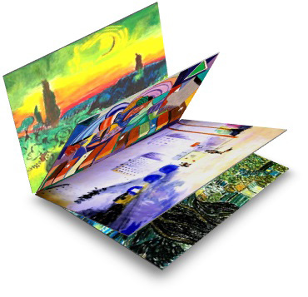

**Introduction:**

The Art 20 course is offered as a five credit course. Art 20 includes major disciplines of drawing, design, painting, printmaking, architecture, sculpture, and art history. Students are encouraged to use non-traditional approaches such as metamorphosis or accidental occurrences as the basis for certain

compositions. Art images in the lessons are used to study art history and appreciation. Students will require a variety of art materials that are listed in the Introduction of the Art 20 Course Booklet, as well as in the Supplies List document that is available in the ‘**Print Resources**’ section of the course in Moodle.

**Course Materials:**

* One [Course Information Booklet](https://drive.google.com/drive/folders/1YFHBaXxLnJ7EJNdOJhssy3WZTK-ZyMPZ?usp=sharing) that consists of twenty lessons (digital copy available in the ‘Print Resources’ section in Moodle. Please also view the updated [Course Introduction document](https://drive.google.com/drive/folders/1YFHBaXxLnJ7EJNdOJhssy3WZTK-ZyMPZ?usp=sharing).
* [20 Assignments Booklets](https://drive.google.com/drive/folders/1YFHBaXxLnJ7EJNdOJhssy3WZTK-ZyMPZ?usp=sharing) (digital copies available in the ‘Print Resources’ section in Moodle).
* Digital Art Images to be inserted in the Course Booklet for the study of art history and art
* appreciation. **Note:** since the hardcopy of the Art Cards are no longer in Print, use the [Images of Art Cards](https://drive.google.com/file/d/0B6JStCBYH1vIdURhTTlidGtxRGc/view?usp=sharing) document to reference the Art Card images in the respective lesson.
* [Supplies List](https://drive.google.com/file/d/0B6JStCBYH1vIdVZtVDBETWN1WVE/view?usp=sharing)
* [Extra Information Document](https://drive.google.com/file/d/0B6JStCBYH1vIWkFlcnJDMThETjg/view?usp=sharing)
* [Sketchbook Requirements](https://drive.google.com/file/d/0B6JStCBYH1vIaUlJQ3FoQXJPakE/view?usp=sharing)
* Final Exam Study Guide (see ‘Final Exam Documents’ in Moodle)
* Final Exam (see ‘Final Exam Documents’ page in Moodle)
* Final Exam Key (see ‘Final Exam Documents’ page in Moodle)

**How Do Students Use the Course Information Booklet and Assignment Booklets?**

As students work through each lesson, they should use the Course Information Booklet to learn and review the course material and to complete the assignments in the respective Assignment Booklets. It is imperative that students read the entire lesson in the Course Information Booklet first and then follow the instructions in the related Assignment Booklet. **Link to PDF copies of the Art 20 Print Resources**: [**Art 20**](https://drive.google.com/drive/folders/1YFHBaXxLnJ7EJNdOJhssy3WZTK-ZyMPZ?usp=sharing)

**Assessment Information:**

* **Introductory Activity:** Students are first required to complete the ‘Introductory Activity’, which is located as the first assignment in the ‘**Assignment Booklet Submissions**’ section in **Moodle**. The ‘Introductory Activity’ serves as a collection of Pre-Assessment Questions, as well as a source of information to assist Teachers to learn a bit more about a student on a personal level. When the ‘Introductory Activity’ is completed, a completion mark should be entered (i.e. 100%).
* **Course Answer Key:** There is an [**evaluation key**](https://drive.google.com/a/phrd.ab.ca/file/d/1mvSO5tNU1VUXZV6Vh8I0Hf40REOU_uOg/view?usp=sharing) available that provides suggested values, guidance and advice for marking the Assignment Booklets, as well as [**rubrics**](https://drive.google.com/drive/folders/1pUs55Dh0UH_tsbdIS7BSyF5xENB9sfbQ?usp=sharing) for each Assignment Booklet.
* **Important Notes:** It should be the goal of conscientious art students, to develop their own unique artwork imagery through direct observation, research, expanded art experience, personal exploration, and discussion/critique feedback from others. The assignments reflected in the lessons allow students wide latitude in decision-making, in applying choices and exploring broad themes, to help to ensure that they develop their own ideas and style in art. Hence, it is expected of students to only use their own experiences, views, and personal efforts in creating original creative expressions through visual art. Thus, students are encouraged to develop their own style of art and move away from emulating existing artworks, unless an assignment specifically requests a reproduction-related activity. Also, unless an assignment specifically indicates otherwise, students should be creating their artworks on full sheets of white art paper of an approximate format of not less than 45 cm × 60 cm or 18” × 24”.
* **Online Visual Exemplars:** In addition to the visual exemplars that are included in each Assignment Booklet, students are strongly encouraged to visit the online [**Art 20 Student Exemplar Site**](http://artdesignstudies.weebly.com/art-20-exemplars.html), where they will find Art 20 visual exemplars (submitted from fellow Art 20 students) for each Art 20 Assignment Booklet, which may inspire and/or assist students with their progress in Art 20.

**Help:**

Please contact the ADLC Lead Teacher of this course with any content or course specific questions you may have. [**Partner Support**](https://www.adlc.ca/about/our-team/partner-support/) can help you with any general, registration, or procedural questions, or can help you get into contact with the ADLC Lead Teacher.

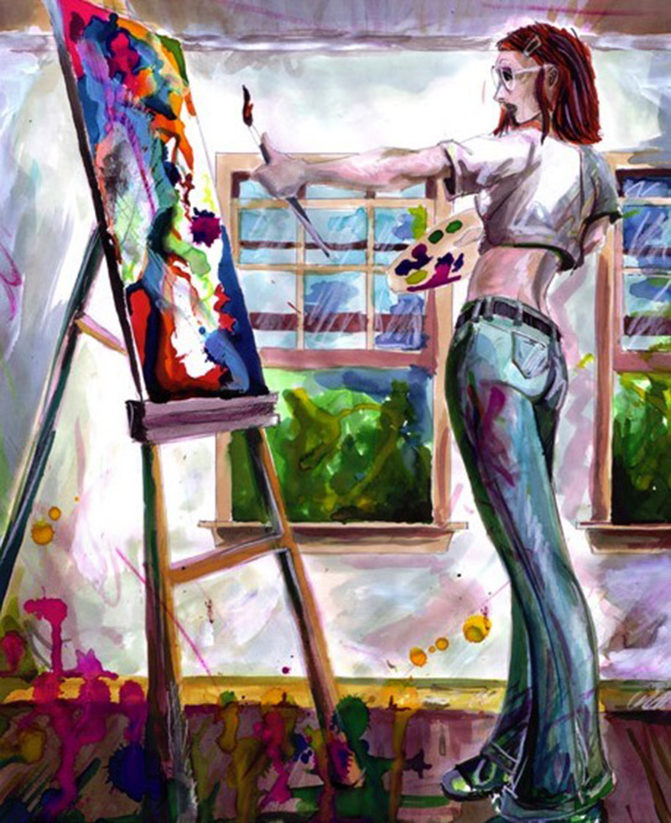

* **ADLC Lead Teacher Information:**

Crystal Waldowski-Puskeppelies

[crystal.puskeppelies@adlc.ca](mailto:crystal.puskeppelies@adlc.ca)

1-866-774-5333 ext. 7364

Please visit [**Moodle Technical Support**](https://www.adlc.ca/contact-us/technical-help-training/moodle-training-resources/) for further documentation on the features of Moodle.

***We wish your students much success and enjoyment in Art 20!***