Art Courses Overview & Curriculum Maps**:**

**Art** 10, 20 & 30

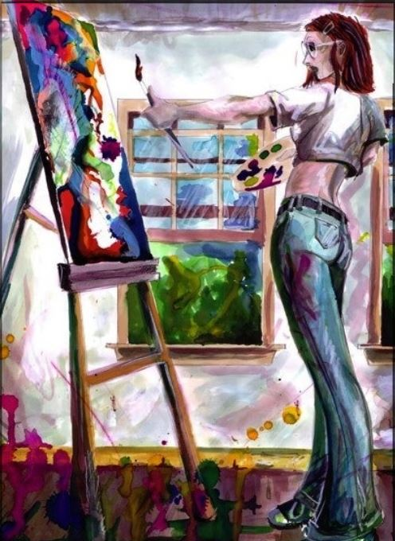

# Introduction:

Art is a fundamental dimension of human life. Throughout the history of humanity, humans have employed the Visual Arts to give form and meaning to ideas and feelings, and to express and communicate profoundly felt experiences to others. Hence, the presence of Art as a formative medium is found not only in museums and galleries, but in all of those objects and technologies that have their origin in visual (or spatial) thinking and their ensuing development in visual design.

Human experience is organized in various ways: numerically, verbally, musically, kinaesthetically, as well as visually. Students need authentic experience in all these areas, if they are to gain the maximum benefit from their education. Education in Art assists students to become selective and discriminate in their visual judgements, as well as to improve their understanding of their visual environment. Students also need practice recognising and understanding the relations between these areas of human experience. Education in Art encourages students to consider the relation between verbal and visual learning (i.e. ‘to become visually literate.) For these reasons, education in Art is essential education. When educational environments provide meaningful and imaginative Art programs that combine the disciplines of intellectual activity, along with physical skills in creative problem-solving experiences, they are supporting the development of many life essential skills. Students who participate in these respective art programs not only gain a knowledge of Art and the role it plays in human interaction, but this participation also assists students to become selective and discriminating in their visual judgement, and thus improve their understanding of their own visual environment.

Students in Art Education programs must develop some mastery of basic art skills and acquire a working knowledge of the artistic fundamentals and art history, as well as the satisfaction of personal achievement, including comprehension and enjoyment of the artistic creation of other artists. Art skills are important keys to greater freedom, personal growth and artistic confidence. A well-developed art program will include opportunities for students to see and feel visual relationships; to develop imagination and personal imagery; to engage in the practical production of artwork; to appreciate the art of others; to develop an informed aesthetic and critical awareness; and to evaluate their own work and that of others. Although visual images may make strong and evocative impressions, regardless of their source of origin, fuller comprehension of them depends on knowledge gained through effective educational preparation. A well-developed Art program will expand and clarify visual awareness, and will deepen self-knowledge and self-enrichment, as well as increase students’ understanding of others. 

# **Importance of the Arts (based on the Ministerial Order Competencies)** We are living in a global economy and environment that increasingly prizes *innovation*, *creativity*, *critical thinking*, *collaboration* and *communication*. Hence, to prepare students today for tomorrow's world, they require authentic foundational skills in critical thinking, problem-solving ability, creative thinking, personal development, and communication skills, to facilitate students’ individual inner resource development, and the ability to undergo values clarification, life-visioning, and goal-setting, in an ever increasingly flexible manner. Hence, active engagement in the Art 10, 20 & 30 courses will assist students with the beginning attainment of the above indicated foundational skills, as well as it will optimize their personal learning goals, with the intent of moving their progression towards engaged world citizenship & empowerment, through learning activities of mindfulness and varied creative and reflective activities. Meaningful engagement in the Art 10, 20 & 30 courses will also assist students to develop a healthy emotional intelligence, and the lifelong ability to be more skillful, as well as successful, in their academic, professional and personal lives. In our ever-evolving world, thinking critically and creatively '*like an artist*' may be one of the most important skills of all. Engagement in the Art 10, 20 & 30 courses will provide a forum for *safe expression*, *communication*, *exploration* and *imagination*, as well as *cultural* and *historical understanding*.

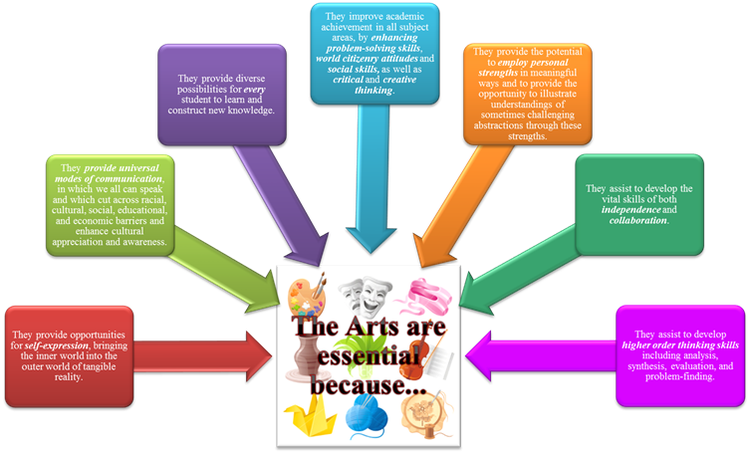

# Importance of Art Education (based on research)

# 

# Sufficient research exists to overwhelmingly support the conviction that study and participation in Art Education is a key component in improving student learning throughout all academic areas. Furthermore, evidence of its effectiveness in “*reducing student dropout, raising student attendance, developing enhanced cooperation, fostering a passion for learning, improving greater student dignity, enhancing student creativity, and producing a more prepared and flexible, critical thinking citizen for the workplace of the future*” (National Art Ed Council, 2016), can be found documented in many academic studies, conducted in many varied settings, from school environments, to the business world.

# 

# Evidence from brain research is only one of many reasons education and engagement in the Fine Arts is beneficial to the educational process. The Fine Arts assist to develop neural systems that produce a broad spectrum of benefits ranging from fine motor skills to creativity and improved emotional balance. For example, in a comprehensive study conducted by Dr. J. Burton from Columbia University, research indicates that school subjects such as mathematics, science, and language require complex cognitive and creative capacities “*typical of arts learning*” (Burton, Horowitz, & Abeles, 2014). “*The arts enhance the process of learning. The systems they nourish, which include our integrated sensory, attentional, cognitive, emotional, and motor capacities, are, in fact, the driving forces behind all other learning*” (Jensen, 2015).

# 

# Art Education also provide learners with non-academic benefits such as promoting self-esteem, motivation, aesthetic awareness, cultural exposure, creativity, improved emotional expression, as well as social harmony and appreciation of diversity.

# 

# Moreover, in the Distance Education Environment, Arts Education promotes students to also learn to become sustained, self-directed learners, “*where the student does not just become an outlet for stored facts from direct instruction, but seeks to extend instruction to higher levels of proficiency through creative art-making*” (Canadian Society for Education through Art, 2017).

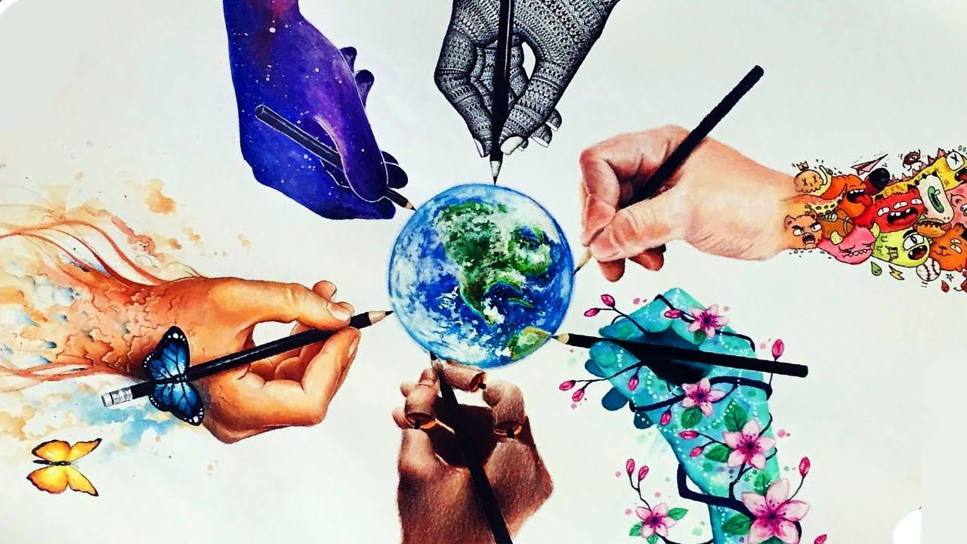

# The Student Experience:

**Five adjectives that we would like students to use when describing the Art** 10, 20 & 30 **courses:**

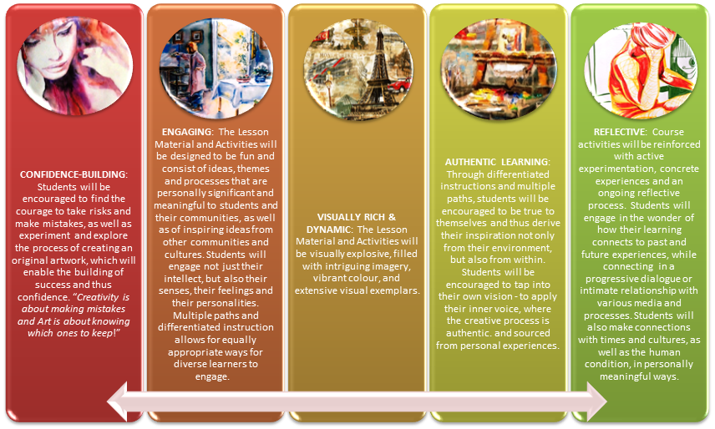

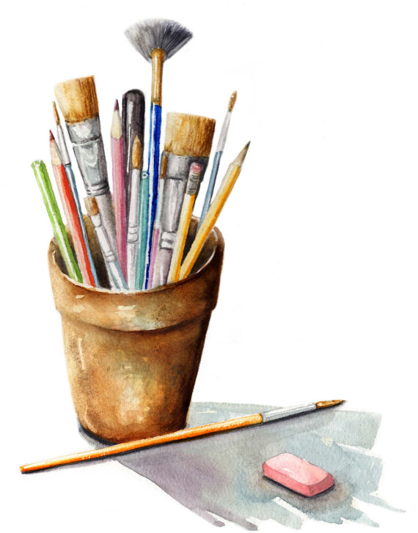

Art 10, 20 & 30 Curricular Outcomes Overview:

Types of Curriculum Connections that are incorporated into all aspects of the Art 10, 20 & 30 Courses:

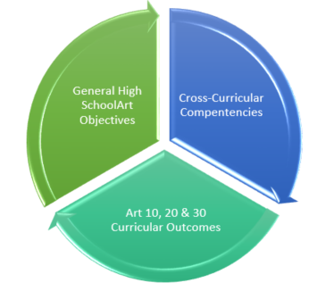

|  |  |  |
| --- | --- | --- |
| **Curriculum Connections** | **Description** | **Priority**  **(Important, Enduring,**  **Good to Know)** |
| **General High School**  **Art Objectives** | * Derived from the Curriculum Prototyping Process | Enduring |
| **Cross-Curricular Competencies** | * Ministerial Order:   Learning through  Competencies   * Inspiring Ed Competencies | Important  Good to Know |
| **Art** 10, 20 & 30  **Curricular Outcomes** | * Derived from the existing Art 10, 20 & 30 Curriculum Guide - Curriculum Objectives | Enduring |

**General Art 10, 20 & 30 Objectives:**

The Art 10, 20 & 30 courses expect students to build upon their current levels of artistic ability and creativity, through applying and engaging in various artistic processes, media and products. It is our utmostendeavor, to encourage and assist students with developing an attitude of creative risk-taking, experimentation, engagement and discipline, all of which are imperative for true success in a student's artistic journey, to achieve, in particular,the following General Art 10, 20 & 30 Objectives (which are embedded throughout the entirety of each course) :

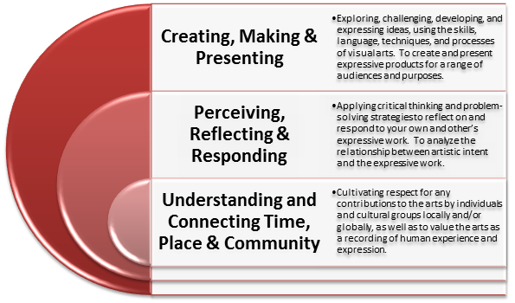

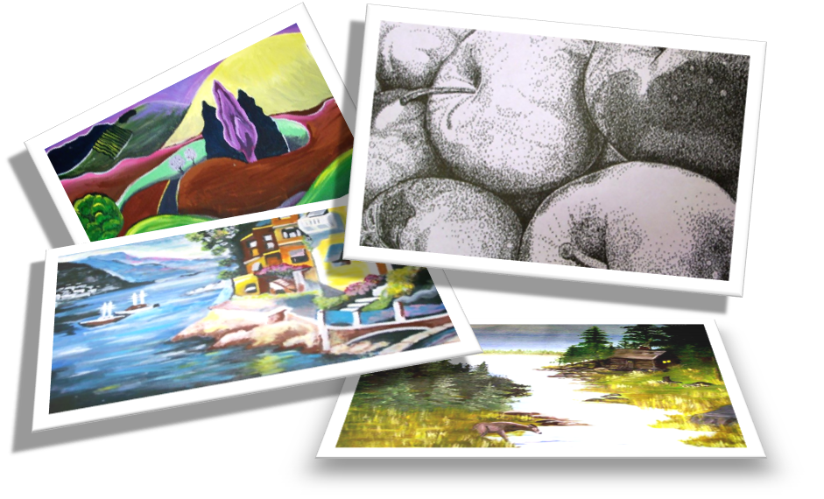

**Cross-Curricular Competencies:**

**Ministerial Order Competencies:**

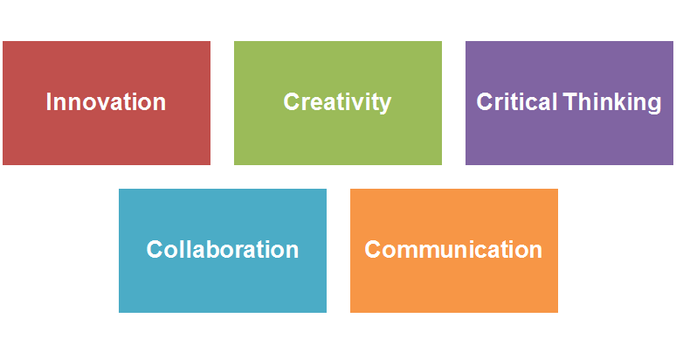

**Inspiring Ed Competencies:**

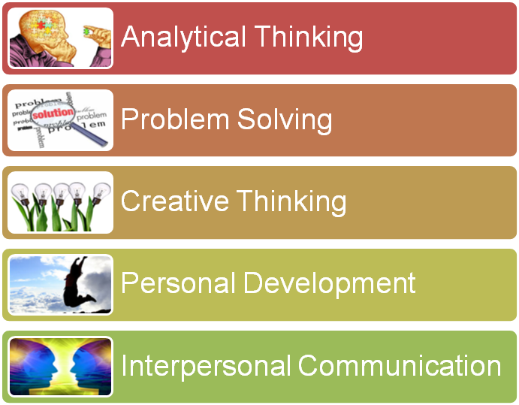

**Curricular Outcomes from the Art** 10, 20 & 30 **Curriculum Guides:**

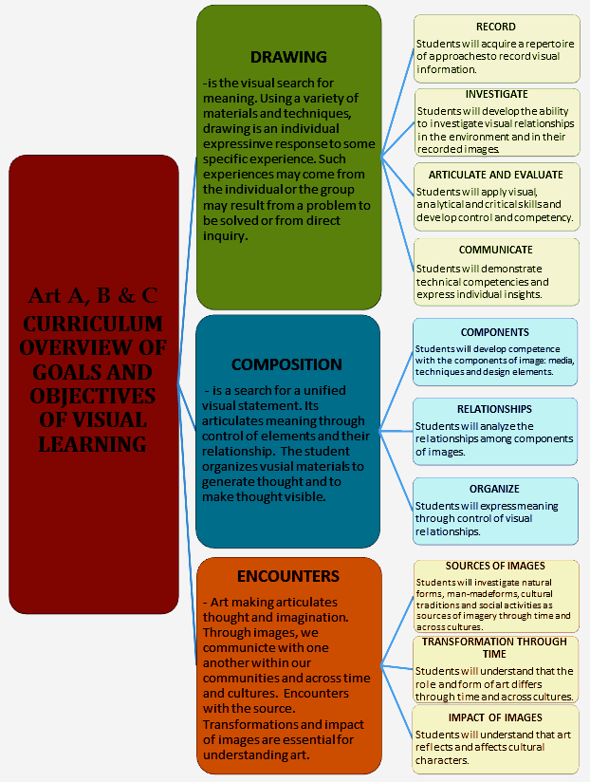

Drawings

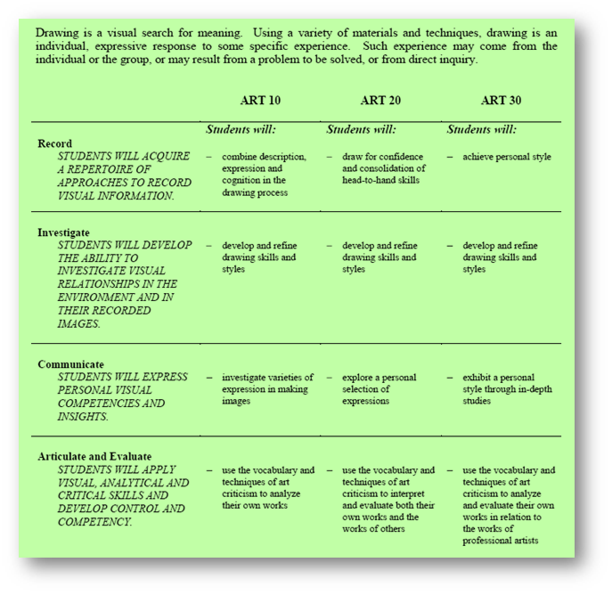

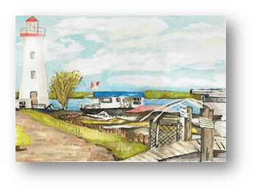

Compositions

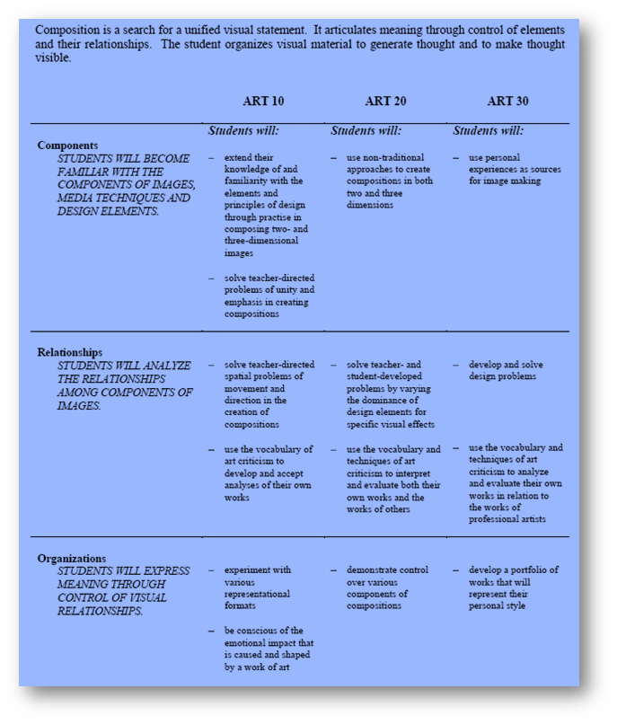

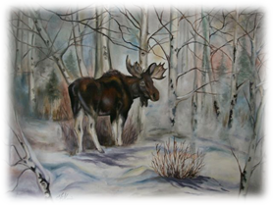

Encounters

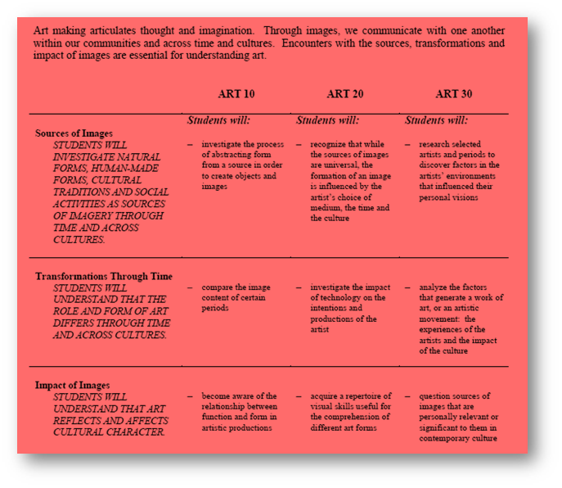



# Prioritized and Correlated Outcomes for each Course

|  |
| --- |
| **Overarching Essential Questions & Understandings: Art** 10 |

**Essential Questions:**

1. How will students actively participate in their own learning through play, interaction and experimentation rather than passively absorbing information?
2. How will an artist apply, arrange and articulate the Elements and Principles of Art and Design in compositions?
3. How does an artist begin to develop a reflective practice and learn how to talk about Art?
4. How will students identify similarities and differences in symbols and cultural artifacts of selected cultural groups?
5. How does an artist begin to explore, develop and express ideas?
6. How will learning enhanced by technology and differentiated instruction create multiple pathways to engage students?

**Enduring Understandings:**

1. Elements of Art and Principles of design are the building blocks of strong Art Compositions.
2. Being able to critique the artwork of others and develop reflective practice is the key to development of a strong art practice.

**Students will know:**

1. Terms describing materials, techniques, and subject matter, which comprise the basic vocabulary of Art.
2. Dominant elements and principles and the application of media in relationship to each other to effectively solve visual problems.

**Students will be able to:**

1. Begin to identify design elements used in creating images as part of learning to talk about Art.
2. Identify and discuss one’s visual problems in drawing and composing images as part of learning to talk about art.
3. Begin developing a proficiency in creating stronger compositions.
4. Begin experimentation in new mediums.
5. Explore working conceptually and literally in 3-dimensions, both in pictorial and sculptural domains.
6. Begin to work with dominant elements and principles and application of media in co-relationship with each other, to effectively solve visual problems.

|  |  |  |  |
| --- | --- | --- | --- |
| **Art** 10 **- Assignments and Prioritized Outcomes per Lesson - Curriculum Map** | | | |
| **Lesson #** | **Lesson Title** | **Goals and Objectives** | **Curricular Connection(s)** |
| 1 | **Expressive** Drawing | * Employ various drawing skills. * Realize that various drawing media affect the expression of a work of art. * Value the benefit of exploring and manipulating various media and line qualities to create a desired effect. * Students will explore how line and line quality express emotion and also how value and tone are connected to feeling. | DRAWING  Record: Concepts: A & B  Investigate: Concept: C  Communicate: Concepts:  A-B-C-D  Articulate and Evaluate: Concepts: A-B-C-D  COMPOSITION  Component 2: Concept: C  Relationship 1: Concepts: A-B |
| 2 | **Colour Theory** P**ainting** | * Students will develop knowledge of primary and secondary colours, bright and dull colours, cool and warm colours, advancing and receding colours. * Extend knowledge of and familiarity with colour theory and the elements and principles of design through practice in composing two- and three-dimensional images because colour and value concepts are important components of an artist’s compositional skills. | DRAWING  Articulate and Evaluate: Concepts: A-B-C-D  COMPOSITION  Component 1: Concepts: A-B-C  Component 2: Concept C  Relationship 1: Concepts: A-B |
| 3 | Collage | * Create a theme-based collage, using various textures and shapes as well as mixed media to produce a comprehensive composition. | DRAWING  Record: Concept A-C  Articulate and Evaluate: Concepts: A-B-C-D  COMPOSITION  Relationship 1: Concepts: A-B |
| 4 | Weight, Modelled, and Foreshortening Drawings | * Develop and refine drawing skills and styles, and understand that tactile qualities of surfaces can be rendered through the controlled use of line drawings. | DRAWING  Record: Concepts: B-C  Investigate: Concepts: A-B-C  Articulate and Evaluate: Concepts: A-B-C-D  COMPOSITION  Component: 2 - C  Relationship 1: Concepts: A-B |
| 5 | Negative and Positive Space Painting | * Observe positive and negative space in one’s surroundings, and discover the importance of positive and negative space in a composition. | DRAWING  Investigate: Concept A-B-C  Articulate and Evaluate: Concepts: A-B-C-D  COMPOSITION  Component 1 A-B-C  Relationship 1: Concepts: A-B  Component 2 A-B  ENCOUNTERS  Sources of Images: Concepts: A-B  Transformation Through Time: Concepts: A-B-C-D  Impact of Images:  Concepts: A-B-C |
| 6 | Art from Nature Drawings | * Learn that many artistic creations are inspired from designs and elements located in the natural environment. * Understand that realistic designs can be simplified through a progression of semi-abstraction to fit into certain forms and spaces. | DRAWING  Articulate and Evaluate: Concepts: A-B-C-D  COMPOSITION  Relationship 1: Concepts: A-B |
| 7 | Posters and Calligraphy | * Experiment with decorative calligraphic lettering. * Discover the elements of a well-designed poster. * Understand the importance of a well-designed advertisement poster. | DRAWING  Articulate and Evaluate: Concepts: A-B-C-D  COMPOSITION  Relationship 1: Concepts: A-B |
| 8 | Weaving | * The weaving assignment is included in the Art 10 course, because it highlights the historical value of weaving on the development of the arts for humankind. Archaeologists believe that basket making and various other types of weaving, were probably the first art-related creations developed by humans. Research indicates that cultures on every continent devised crude looms and methods of making webs, and further study indicates great similarities of the looms constructed and in the weavings produced by various cultures. * Weaving has served as a powerful metaphor for life in the arts, literature, and mythology of many cultures. * Learning about the history of weaving and completing a simple weaving project are important to assist in this understanding. | DRAWING  Articulate and Evaluate: Concepts: A-B-C-D  COMPOSITION  Relationship 1: Concepts: A-B  Component 2  ENCOUNTERS  Sources of Images: Concepts: A-B |
| 9 | Cartoon Drawings | * Cartooning techniques of exaggeration and elimination, especially in portraiture, assist to portray features in recognizable and powerful ways, without the need to include realistic details. * Creating cartoons can be a visually meaningful way to express one’s opinion, especially related to political, social, and personal views (such as editorial cartoons). | DRAWING  Articulate and Evaluate: Concepts: A-B-C-D  COMPOSITION  Component 1: Concepts: A-B-C  Component 2: Concepts: A-B  Organization: Concepts: A-B |
| 10 | Shadow and Still-Life Drawing | * Compose a still-life drawing with angular, flat, and rounded surfaces. * Understand the importance of shaded areas on objects and cast shadows on various surfaces. * Understand the importance of textures of objects and surfaces. | DRAWING  Articulate and Evaluate  Concepts: A-B-C-D  COMPOSITION  Relationship 1: Concepts: A-B  Organization: Concepts: A-B |
| 11 | Surrealism and Mixed Media | * Compose a surrealistic composition. * Apply unusual scale, space, or time as well as dreamlike images to enhance the effect of surrealism. * Apply mixed media elements to achieve unusual effects. | DRAWING  Articulate and Evaluate: Concepts: A-B-C-D  COMPOSITION  Relationship 1: Concepts: A-B  Component 2: A-B-C  ENCOUNTERS  Component 2: Concepts: A-B-C  Concepts: A-B  I |
| 12 | Analyzing Art | * Compose an art analysis based on a famous artwork. * Discover the possible motivations and deeper meanings of this famous artist’s artwork. * Develop awareness that the elements and principles of art assist one to experience an artwork and to view it in new and various ways. | DRAWING  Articulate and Evaluate: Concepts: A-B-C-D  COMPOSITION  Relationship 1: Concepts: A-B |
| 13 | Painting a Portrait | * Discover and depict realistic details, including texture, shading, and dimension, by observing a subject matter directly. * Paint a person from direct observation, or paint a self-portrait using a mirror. * Show the modelling of the facial features in the portrait through colour. | DRAWING  Articulate and Evaluate: Concepts: D-E-F  COMPOSITION  Relationship 1: Concepts: D -E  Component 4: A-B-C  ENCOUNTERS  Component 5: Concepts: A-B-C  Concepts:C-D |
| 14 | Movement Drawings | * Illustrate movement through various drawing techniques. | DRAWING  Articulate and Evaluate  Concepts: C-D  COMPOSITION  Relationship 4: Concepts: A-B  Organization: Concepts: C-D |
| 15 | The Golden Section Painting | * Apply the Golden Section and Ratio method as it will assist students to create effective genre paintings. * Be aware that genre paintings are effective ways to depict scenes or events from everyday life. * Discover that various painting techniques allow one to create various effects to enhance the mood of compositions. | DRAWING  Articulate and Evaluate: Concepts: D-E-F-G  COMPOSITION  Component 4: Concepts: D-E-F  Component 5: Concepts: A-B  Organization: Concepts: D-E  ENCOUNTERS  Component 6: Concepts: D-E-F  Concepts: H-J |
| 16 | Sculpture | * Discover the importance of positive and negative spaces in subtractive sculptures. * Create a subtractive sculpture with a choice of sculpting media. | DRAWING  Articulate and Evaluate: Concepts: D-F-G  COMPOSITION  Relationship 3: Concepts: A-B  Component 6: A-B-C  ENCOUNTERS  Component 7: Concepts: A-B-C  Concepts: D-E |
| 17 | Printmaking | * Discover the expressive qualities and value of printmaking. * Learn how to execute the steps of a relief printmaking technique. | COMPOSITION  Component 7: Concepts: D-E-F  Component 8: Concepts: A-B  Organization: Concepts: F-G |
| 18 | Landscape Sketching | * Discover various aspects of dimensions and perspectives by observing landscapes from various viewpoints. * Practise various techniques of perspective and landscape design methods through sketching and drawing based on direct observations. | DRAWING  Articulate and Evaluate  Concepts: H-J-K-L  COMPOSITION  Relationship 6: Concepts: A-B  Organization 2: Concepts: A-B |
| 19 | Landscape Painting | * Create a landscape painting of a local scene. * Experiment with various painting techniques to create an effective landscape painting, including mixing colours to affect shades and shadows. * Use the applied media to depict the various effects of weather and climate as well as experiment with the various techniques needed for depiction of foreground, middle ground, and background. | COMPOSITION  Component 7: Concepts: C-D-E  Component 8: Concepts: A-B  Organization 4: Concepts: D-E  ENCOUNTERS  Component 6: Concepts: D-E-F  Concepts: H-J |
| 20 | Form and Function & Final Reflection | * Realize that the process of reflection is an integral part of any creative production. * Recognize that reflection is not an ‘add-on’ piece to your learning and creative process, but it is essential and integral to the complex process of becoming a successful learner and creator. * Become conscious that successful reflection enables self-awareness, personal, and professional growth and thus will improve learning practices. * Appreciate that reflecting on any part of the learning process is worthwhile. | ENCOUNTERS  Component 8: Concepts: G-H-I  Concepts: K-L |

|  |
| --- |
| **Overarching Essential Questions & Understandings -** Art 20 |

**Essential Questions:**

1. How will differentiating instruction create multiple pathways for students with different abilities, needs, experiences, and interests to engage in the process of learning about Visual Art?
2. How will an artist apply and arrange Elements and Principles of Art and Design to make strong compositions?
3. How do artists use the vocabulary of Art Criticism to discuss the work of other artists and their own compositions?
4. How do natural and man-made forms reflect and transform the human experience through time and artifacts?
5. How do we as artists and global citizens cultivate respect for the contributions of individuals and cultural groups to the value of art as a vehicle for the reflection of the human condition?

**Enduring Understandings:**

1. Understanding and Connecting Time, Place and Community - Students will develop an understanding of the connection between themselves and their culture, as well as the global community, in the past, the present, and the future.
2. Students will apply Elements and Principles of Art and Design using a variety of mediums.

**Students will know:**

1. How to apply vocabulary and concepts describing materials, techniques and subject matter in the process of creating their own images.
2. How natural and manmade forms impact human activity and artifacts.
3. The dominant elements and principles and applications of medium, to enhance, discuss, and reflect on relationships, to effectively solve visual challenges.
4. The contributions of art created by individuals and cultural groups, in a historical and contemporary context.

**Students will be able to:**

1. Use the vocabulary of Art Criticism to develop a positive analysis of their own work and the work of others.
2. Create stronger compositions/images based on technical proficiencies of compositional space and processes.
3. Work in multi-mediums, as a tool to develop and express ideas.
4. Respect and communicate the value of the arts and the artistic contributions by individuals and across cultural groups.

PRP

|  |  |  |  |
| --- | --- | --- | --- |
| **Art** 20 **- Assignments and Prioritized Outcomes per Lesson -** Curriculum **Map** | | | |
| **Lesson #** | **Lesson Title** | **Goals and Objectives** | **Curricular Connection(s)** |
| 1 | Art Review and Drawing, Modelling & Shading | * Review the Elements of Art, Principles of Design & Colour Theory   • Employ your drawing skills, including the use of modelling and shading techniques.  • Realize that the type of drawing media affects the expression of a work.  • Value the benefit of exploring and manipulating various tones, textures and media. | DRAWINGS  Record - Concepts A  Investigate - Concepts A  Articulate & Evaluate: Concept B  COMPOSITIONS  Relationships 2 - Concepts A  Organizations - Concepts B |
| 2 | Design – Mixed Media & Format Adaptation | * Create a cohesive mixed media composition (i.e. collage) that explores the effects of combining several different tones & textures, to create an aesthetic design. * Understand that the format of a design, along with positive & negative space, affect the aesthetics of a composition. | DRAWINGS  Record - Concepts C  Investigate - Concepts C  Articulate & Evaluate: Concept B  COMPOSITIONS  Components - Concepts A  Relationships 1 - Concepts A  Relationships 2  Organizations - Concepts B  ENCOUNTERS  Sources of Images - Concepts B  Transformations Through Time - Concepts A |
| 3 | Colour Theory & Semi-Abstract Painting | * Extend your knowledge of and familiarity with colour theory, including learning about colour art movements and their related artists. * Apply colour theory principles like The Law of Simultaneous Contrasts and Projecting & Receding Colours, along with the elements of art & principles of design, to create an engaging composition. | DRAWINGS  Articulate & Evaluate: Concept B  Concepts:  COMPOSITIONS  Relationships 2    ENCOUNTERS  Sources of Images - Concepts A  Impacts of Images - Concepts A & C |
| 4 | The Happy Accident | • Discover that the inspiration and ideas for creating artworks can be derived from unusual sources.  • Discover that chance occurrences or accidental outcomes of art-making can influence the making of a work of art. | DRAWINGS  Record: Concept C  Investigate: Concept A  Communicate: Concept A  Articulate & Evaluate: Concept B  COMPOSITION  Components: Concepts A & C  Organizations: Concept B  Relationships 2  ENCOUNTERS  Source of Images: Concept B |
| 5 | Emotion: Drawing Techniques & Dominance | * Discover that emotions can be achieved in a composition by using implied detail, closure and different expressive line qualities, as well as the position of movements (especially for animal and human depictions) affects the emotion of a drawing. * Show that the perception of dominance can create an emotional effect on a composition. | DRAWINGS  Record: Concept A  Investigate: Concepts A, B & C  Articulate & Evaluate: Concept B  COMPOSITIONS  Relationships 1  Relationships 2  ENCOUNTERS  Source of Images: Concept B |
| 6 | Stencilling & Print-Making | * Discover that printmaking is the art of creating multiple images, and that stenciling is one way to create multiple prints of the same mage. * Discover that points of view can vary according to the expressive purposes of a composition. * Create repeating arrangements of an image to portray different expressive qualities. | DRAWINGS  Investigate: Concepts A  Articulate & Evaluate: Concept B  COMPOSITIONS  Relationships 1 - Concepts A  Relationships 2  ENCOUNTERS |
| 7 | Portraiture | • Discover that the historical manner of dress, the environment the model is placed in, facial expressions and symbols, all contribute to the meaning and expression of a portrait composition.  • Discover that formulas and shadows help place facial features correctly, and assist with proper proportion and dimension in portraiture  • Explore the creation of a mixed media portrait. | DRAWINGS  Record - Concepts A & C  Investigate - Concepts C  Articulate & Evaluate - Concepts B  COMPOSITIONS  Relationships 2 - Concepts A  Organizations - Concepts B  ENCOUNTERS  Sources of Images - Concepts A  Impact of Images - Concepts A & C |
| 8 | 1-Point & 2-Point Perspective | • Explore the concepts of both 1-point and 2-point perspective through the creation of perspective compositions.  • Discover that shifting the perspective or changing the point of view of a composition provides a way to solve a visual problem. | · DRAWINGS  R Articulate & Evaluate: Concept B  COMPOSITIONS  Relationships 2  ENCOUNTERS |
| 9 | Emotion – Foreshortening & Expression | • Discover and explore that exaggeration, diminution, elimination of details, expression, tone, colour, eye level, and foreshortening are all ways to achieve emotion and impact in your compositions.  • Discover and explore that personal themes (and one’s thoughts on various issues) can provide powerful inspiration for expressive artworks. | DRAWINGS  Investigate - Concepts A & C  Communicate - Concepts A  Articulate & Evaluate: Concept B  COMPOSITIONS  Relationships 2  ENCOUNTERS |
| 10 | Image Experimentation | • Discover and explore that new images can be created using “found” objects.  • Discover and explore that artists use different methods to create images, such as combining several parts of existing images, or by adding human characteristics to inanimate objects. | DRAWINGS  Articulate & Evaluate: Concept B  COMPOSITIONS |
| 11 | New Technology - New Art | • Discover that artists throughout time have been creative with a variety of media.  • Discover and explore that the adoption of a new medium will effect change in an artist’s work.  • Discover and explore that technology has an affect on the materials and imagery used to create artworks. | DRAWINGS  Articulate & Evaluate: Concept B  COMPOSITIONS  Relationships 2  ENCOUNTERS  Sources of Images - Concepts B  Transformations Through Time - Concepts A, B & C  Impact of Images - Concepts C |
| 12 | Movements in Art & Personal Art Style | • Discover and explore that artists throughout history use different media to communicate their ideas.  • Discover and explore that artwork can be categorized into specific subject matter categories, as well as art movements, which knowledge heightens the viewer’s appreciation and can assist to translate the artwork’s deeper meaning. | DRAWINGS  Articulate & Evaluate: Concept B  COMPOSITIONS  Relationships 2 |
| 13 | Metamorphosis | • Discover and explore that self-portraiture is an effective way to observe the subject matter of your artwork, as well as showcase your personal feelings and essence.  • Discover and explore that camouflage, disguise, transmutation and metamorphosis are used to create image changes from one state to another. | DRAWINGS  Articulate & Evaluate: Concept B |
| 14 | Landscape Sketches | • Discover and explore the different areas of a landscape, namely the Background, Middleground and Foreground, and explore the use of a viewfinder when composing a landscape.  • Discover and explore that the illusion of distance in a landscape can be achieved by the diminution of shapes, by linear perspective, by overlapping and by aerial perspective. | DRAWINGS  Articulate & Evaluate: Concept B |
| 15 | Landscape Painting | • Discover and explore that Landscape Paintings provide a way to communicate contemporary views of society and their surrounding environment.   * Discover and explore that depth and 3--dimensionality can be achieved in a landscape through a focus on the foreground, middleground and background. | DRAWINGS  Articulate & Evaluate: Concept B  COMPOSITIONS  Relationships 2 - Concepts A  Organizations - Concepts B  ENCOUNTERS  Sources of Images - Concepts A  Impact of Images - Concepts A, B & C |
| 16 | Styles in Architecture | • Discover and explore that throughout history, different cultures exhibit different preferences for form, colours, and materials in their artifacts, including the different structural classifications in their architecture.  • Discover and explore that similar architectural considerations span all time periods, but are just represented in different manners. | DRAWINGS  Articulate & Evaluate: Concept B  COMPOSITIONS  Relationships 2 - Concepts B  Organizations - Concepts B  ENCOUNTERS  Sources of Images - Concepts C  Transformations through Time - Concepts C  Impact of Images - Concepts C |
| 17 | Personal Media Artwork | • Discover that artists select different media to communicate their ideas.  • Discover and explore that an artist’s style can be recognized by the imagery, themes, and elements they prefer and also by the manner in which the media has been used. | DRAWINGS  Articulate & Evaluate: Concept B  Communicate - Concepts A  COMPOSITIONS  Relationships 2 - Concepts A  ENCOUNTERS  Sources of Images - Concepts B  Transformation Through Time - Concepts A  Impact of Images - Concepts B & C |
| 18 | Distortion | • Discover and explore that an artist uses distortion (i.e. altering a shape from its original look) to emphasize certain portions, characteristics, or emotional effects in an artwork.  • Discover and explore that meaning in an artwork can be affected by the technique of distortion. | DRAWINGS  Articulate & Evaluate: Concept B  COMPOSITIONS  Relationships 1 - Concepts A & B  Relationships 2 - Concepts A  Organizations - Concepts B  ENCOUNTERS  Impact of Images - Concepts C |
| 19 | Sculpture | • Discover and explore that sculptures can be carved (subtractive process, whereby material is taken away from a larger mass), modelled (additive process, which deals with adding on material), or assembled (where found items are assembled to create sculptures that are stationary or kinetic (i.e. movement is a basic element).  • Discover and explore that pre-planning activities like sculpture sketches are essential for visual problem-solving and creating personal expressions. | DRAWINGS  Investigate - Concepts A & C  Communicate - Concepts A  Articulate & Evaluate: Concept B  COMPOSITIONS  Components - Concepts B  Relationships 1 - Concepts A & C  Organizations - Concepts A  ENCOUNTERS  Sources of Images - Concepts B  Transformations Through Time - Concepts C  Impact of Images - Concepts B |
| 20 | Art Analysis | • Discover and explore the power of art analysis, to interpret artworks.  • Discover and explore that meaning is expressed in works of art through subject choice, media selection and design element emphasis.  • Discover and explore that the relationships of different features of an artwork may be compared to the total effect of the artwork | DRAWINGS  Articulate & Evaluate: Concepts A, B & C  COMPOSITIONS  Relationships 2 - Concepts A & B  ENCOUNTERS  Sources of Images - A, B & C  Impact of Images - Concepts A, B & C |

|  |
| --- |
| **Overarching Essential Questions & Understandings: Art** 30 |

**Essential Questions:**

1. How will an artist apply and arrange Elements and Principles of Art and Design to make strong compositions?
2. How will an artist apply critical thinking and reflective practice to articulate their understanding of art and process?
3. How will students cultivate a respect and understanding for the contribution of the arts by individuals and cultural groups towards our understanding of our connection through time and place and community?
4. How will students record their experiences as individuals and global citizens of the human condition?
5. How will learning enhanced by technology and differentiated instruction create multiple pathways to engage learners?

**Enduring Understandings:**

1. Cultivating respect for individuals and cultural groups both past and present fosters an understanding of our global connection, as well as the value of art to express the human condition.
2. To be able to express, create and present authentically the artist's vision, is a goal of making art.
3. Art Criticism and its many tools and expressions are an integral part of the art process.
4. The fundamental theory of art creates strong artists and compositions.
5. We learn and apply our understanding in many ways and they are all valid.
6. Confidence in one's own process stems from successes and failures.

**Students will know:**

1. The essential Elements of Art and Principles of Design and be able to recognize theory and its implication in other artists work through time, and also be able to apply their understanding in their own art practice.
2. That the experimentation and exploration of multi mediums assists in the creation of original art.
3. Individuals and cultural groups contribute to our global understanding of the value of art and its power to express the human condition.

**Students will be able to:**

1. Use the technique of Art Criticism for analysis and comparison of their own art works.
2. Use the vocabulary and techniques of Art Criticism for analysis and comparison of artworks through time.
3. Explore, challenge, develop and express original ideas.

NOTE: In Progress - currently being updated...

|  |  |  |  |
| --- | --- | --- | --- |
| **Art** 30 **- Assignments and Prioritized Outcomes per Lesson- Curr**iculum Map | | | |
| **Lesson #** | **Lesson Title** | **Goal** | **Curricular Connection(s)** |
| 1 |  |  |  |
| 2 |  |  |  |
| 3 |  |  |  |
| 4 |  |  |  |
| 5 |  |  |  |
| 6 |  |  |  |
| 7 |  |  |  |
| 8 |  |  |  |
| 9 |  |  |  |
| 10 |  |  |  |
| 11 |  |  |  |
| 12 |  |  |  |
| 13 |  |  |  |
| 14 |  |  |  |
| 15 |  |  |  |
| 16 |  |  |  |
| 17 |  |  |  |
| 18 |  |  |  |
| 19 |  |  |  |
| 20 |  |  |  |

# Assessment Plan:

**Note: Each Art** 10, 20 & 30 **Print course consists of an Introductory** Activity, 20 **Assignment Booklets, as well as** a Final Exam Project**.**

|  |  |
| --- | --- |
| **Total Weightings for each Assignment Booklet** | |
| **Assignment Booklet** | **Weighting** |
| Introductory Activity | 2% |
| Assignment Booklets #1-20 | 83% |
| Final Exam Project | 15% |
| **TOTAL** | **100%** |

|  |  |
| --- | --- |
| **Individual Assignment Booklet Value Weightings** | |
| **Assessment** | **Weight** |
| Assignment(s) | 80% |
| Artist Statement | 10% |
| Sketch Activity | 10% |
| **TOTAL** | **100%** |

# 

# 

# Student Learning Plan:

**Instructional Time Allotment**:

* The recommended time for course completion for each of the 5-credit Art 10, 20 & 30 courses is 125 hours. Thus, approximately 5- 6 hours should be spent on each of the 20 Lessons in each course.

**Outline of Course Material, including Assessments and Supplementary Material:**

* **Introduction to Course:** 
  + This consists of a *Course Information Booklet* including Introductory Material & Basic Art Concepts, including the Assessment Outline, as well a Course Supplies List for each Assignment Booklet.
  + Students are provided instructions on how to complete an *Introductory Activity Survey* (to serve as a collection of Pre-Assessment Questions, as well as a source of information to assist Teachers to learn a bit more about a student on a personal level). When completed, students receive a completion mark (i.e. 100%).
  + Students will also need to complete a Review Activity (part of Assignment Booklet #1), which will demonstrate their understanding of the prior necessary skills and knowledge necessary to successfully complete the course.
* **Each of the** 20 **Lessons for each course will consist of the following:**
* ***Lesson Content*** (Visual Step-by-Step Demos, Visual Exemplars, Art History Images & Text-based Content, including Glossary Terms, as well as Practice Activities, Checklists and Pre-Planning Components that are included as Formative Assessment interactions.)
* ***Assignment Booklet Section***:
  + - Goals (& alignment to curricular outcomes)
    - Assignment(s) Instructions
    - Student Visual Exemplars
    - Sketch Activity
    - Artist Statement
    - Art 30: Self-Assessment Checklist (Points to Ponder)
    - Assessment Guide: Art 10, 20 & 30 Assignments are evaluated using the following General Marking Criteria, with the use of detailed and specific rubrics:
      * Composition: The artwork demonstrates an excellent understanding of composition incorporating, when necessary, several of the design elements and principles (line, shape, colour, balance, contrast, harmony, emphasis, movement, proportion, pattern, variety, unity, rhythm, repetition).
      * Content: The artwork(s) is expressive and imaginative, and fulfils the requirements of the assignment instructions.
      * Craftsmanship: The artwork reflects deliberate control of media and quality craftsmanship. The student shows an awareness of filling the space adequately to create a unified composition.
      * Creativity: The artwork is innovative, original, well thought out, and thoroughly developed.
  + *Note*: Students will be encouraged to engage in the following ‘Creative Process’ for the creation and completion of their Assignments:

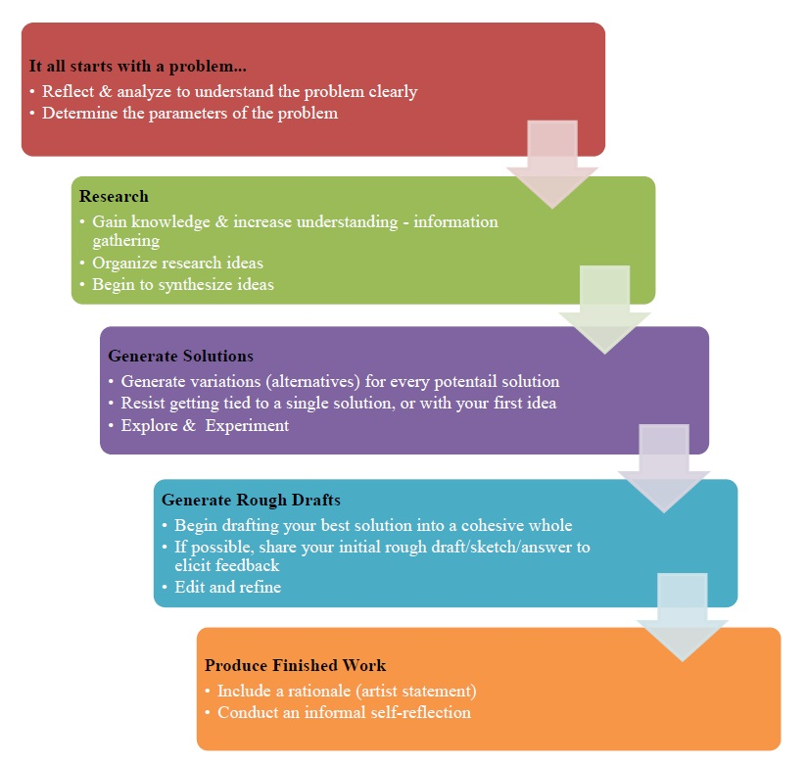

* **Glossary of Art Terms**: Entire List of Art terms, including written definitions and visual examples, are compiled as a separate document, but each glossary term will also be embedded in each Lesson Booklet, with definitions displayed as margin pop-outs.
* **Supplementary Website:** Online Visual Exemplars for each Assignment Booklet:
  + [Art 10](http://artdesignstudies.weebly.com/art-10-exemplars.html)
  + [Art 20](http://artdesignstudies.weebly.com/art-20-exemplars.html)
  + [Art 30](http://artdesignstudies.weebly.com/art-30-exemplars.html)
* **Supplementary Website:** [Online Student Artwork Gallery](http://artdesignstudies.weebly.com/student-art-gallery.html)

**Accessibility:**

* **Universal Design for Learning (UDL) -** The Principles of UDL are embedded into all aspects of the development of the Lesson Content and the respective Assignment Booklet sections, through:
  + Representing information in multiple formats and media (e.g. Print courses will be supplemented by online resources - e.g. supplementary website containing video tutorials related to each Lesson)
  + Providing multiple pathways for students’ actions and expressions (e.g. wide range of media choices, from traditional media to digital)
  + Providing multiple ways to engage students’ interests and motivation (e.g. Pre-Assessment Introductory Activity, Self-Reflection and Practice Activities)



