# Art 30 Online Submission Instructions



First, you will need to log-into our [Student Information System](https://sis.adlc.ca/) using your log-in credentials, which you received in your ‘Course Registration’ e-mail.

Once you have logged into the [Student Information System](https://sis.adlc.ca/), please use the following instructions to submit your completed Assignment Booklets online:

* Click on the hyperlinked '**Art 30**' link, which is listed in the '**Academic Snapshot**' section of your '**Dashboard**'. This will take you directly to your Art 30 course in Moodle - you may wish to view the '**Start Here**' section. Additionally, PDF copies of all of the course material are located in the '**Print Resources**' section.
* To start your course, click on the '**Assignment Booklet Submissions**' section. You will be led directly to the '**Introductory Activity**' submission area (this is the first component you need to complete for your Art 30 course). To submit a completed Assignment Booklet, you just need to click on the '**Content**' column and select '**Table of Contents**'. Then, you will be able to select the respective Assignment Booklet.
* In the '**Assignment Booklet #1**' submission area, after reading the 'Reminder' section, download the '**Digital Submission Form**' by clicking on the 'Digital Submission Form' green button. Once the form is downloaded to your computer, save it as 'Lesson 1 Digital Submission Form' along with your name, and then fill it out accordingly - you just need to type directly into it (and save it when you have finished filling it in) - ***note***: if you experience difficulties with the Digital Submission Form, you may just type the required information (see below image) into a separate Word document, or include the information in the '**Online text**' box, located in the assignment submission area.

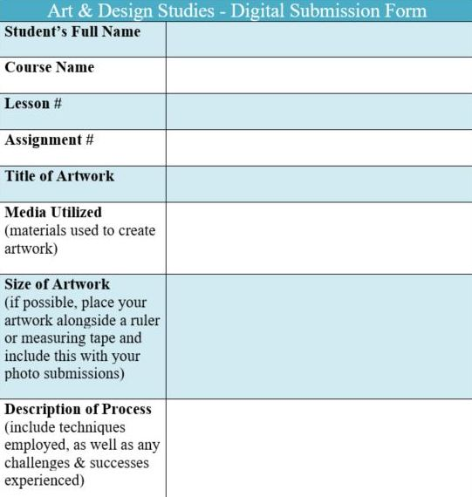

* Then, scroll down to the bottom of the '**Assignment Booklet #1**' submission area and click on '**Add Submission**'.
* In the '**Online text**' box, you may add any other comments you wish to include for your Teacher, including the required Digital Submission Form information .
* In the '**File submissions**' area, this is where you upload any attachments related to your submission - **artworks should be uploaded as high-quality photos that are labelled according to the submission guidelines outlined in each Assignment Booklet submission section (including the completed Digital Submission Form - it is best to compile all of your photos for a particular Assignment Booklet, into a single file, like a PowerPoint or Google Slides Presentation, Google Doc, Word document, PDF, etc.)**.
* Click on '**Save changes**'. You will notice that the 'Submission status' has changed from 'No attempt' to '**Draft (not submitted)**'. This means your work has not been submitted yet, so you can still go back and make changes if you want. To edit any of your submissions before you submit them, click on the '**Edit submission**' button.
* Once you are satisfied with your submission, click '**Submit assignment**'.
* Then, check the box beside the plagiarism statement. Click '**Continue**' to submit your work. Caution: Once you press this button, you won’t be able to make any more changes.
* You will now notice that the Submission status has changed from 'Draft (not submitted)' to '**Submitted for grading**'. This means that your submission is now complete. You just need to check back later to review the feedback and mark your teacher has left for you. ***Note***: To benefit from the provided feedback from your teacher, no more than two to three Assignment Booklets should be submitted at the same time.
* See [**How to Submit Assignments in Moodle**](https://docushare.phrd.ab.ca/dsweb/Get/Document-562141/M10%20-%20Submitting%20Assignments.pdf), for additional instructions that include screenshots.
* Once you have submitted your first submission in Moodle, you may want to let me know, to allow me to confirm that it has indeed been successfully submitted.
* **Reminder**: Please also remember to review the student visual exemplars for each Assignment Booklet at the following link: [**Art 30 Visual Exemplars**](http://artdesignstudies.weebly.com/art-30-exemplars.html)