**Welcome to the Art 30 course! Please find below the details of the Art 30 course content.**

**Introduction:**

The Art 30 course is offered as a five credit course. Art 30 provides encounters with art and study of composition and various drawing and mark-making methods to assist in the development of art skills and styles. Composition involves development of form and purposeful manipulation of the elements of art according to principles of design. Drawing practice includes contour and gesture drawing, stippling, and crosshatching. Expressive drawing employs bamboo, felt brushes, calligraphy pens, and other media. Students expand skills in colour theory, relief, painting and assemblage sculpture as well as study the influence of artists, art movements, and artistic styles. A culminating art exhibition assignment may be submitted as an electronic visual presentation, a video or digital movie, a collection of still photographs, or a portfolio. Students will require a variety of art materials that are listed in the Introduction of the Art 30 Course Booklet (copy located in the ‘Print Resources’ section in Moodle), as well as the included [Supplies List](https://drive.google.com/file/d/0B6JStCBYH1vIaFpfSUc1blhnczQ/view?usp=sharing).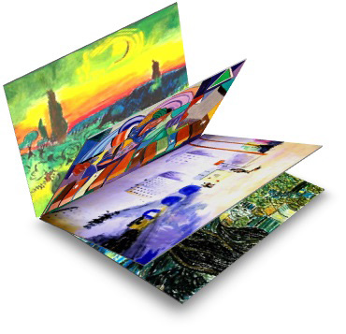

**Course Materials:**

* One [Course Information Booklet](https://drive.google.com/drive/folders/1dWE8KRA2C5YaHJ7tuTnd-97rUkcCFw5p?usp=sharing) that consists of twenty lessons (digital copy available in the ‘Print Resources’ section in Moodle).
* [20 Assignments Booklets](https://drive.google.com/drive/folders/1dWE8KRA2C5YaHJ7tuTnd-97rUkcCFw5p?usp=sharing) (digital copies available in the ‘Print Resources’ section in Moodle).
* [Supplies List](https://drive.google.com/file/d/0B6JStCBYH1vIaFpfSUc1blhnczQ/view?usp=sharing)
* [Booklet of Reproductions](https://drive.google.com/file/d/0B6JStCBYH1vIRTBHNlFYcldoSHc/view?usp=sharing): **IMPORTANT NOTE**: Since the ‘[Booklet of Reproductions](https://drive.google.com/file/d/0B6JStCBYH1vIRTBHNlFYcldoSHc/view?usp=sharing)’ that is referred to in the course materials is no longer in print, please use the included digital document to locate the corresponding image(s) indicated in the Course Information Booklet. The numbers in the ‘Booklet of Reproductions’ document correspond to the images indicated in the Course Information Booklet.
* Final Exam Study Guide (see ‘Final Exam Documents’ in Moodle)
* Final Exam (see ‘Final Exam Documents’ page in Moodle)
* Final Exam Key (see ‘Final Exam Documents’ page in Moodle)

**How Do Students Use the Course Information Booklet and Assignment Booklets?**

As students work through each lesson, they should use the Course Information Booklet to learn and review the course material and to complete the assignments in the respective Assignment Booklets. It is imperative that students read the entire lesson in the Course Information Booklet first and then follow the instructions in the related Assignment Booklet. \*\*\***Link to Art 30 Print Resources**: [**Art 30**](https://drive.google.com/drive/folders/1dWE8KRA2C5YaHJ7tuTnd-97rUkcCFw5p?usp=sharing)

**Assessment Information:**

* **Introductory Activity:** Students are first required to complete the ‘Introductory Activity’, which is located as the first assignment in the ‘**Assignment Booklet Submissions**’ section in **Moodle**. The ‘Introductory Activity’ serves as a collection of Pre-Assessment Questions, as well as a source of information to assist Teachers to learn a bit more about a student on a personal level. When the ‘Introductory Activity’ is completed, a completion mark should be entered (i.e. 100%).
* **Course Answer Key:** There is an [evaluation guide](https://drive.google.com/file/d/1-4aoCeVbiGLcMz7tC0RqHa6jCHqiytmz/view?usp=sharing) available that provides suggested values, guidance and advice for marking the Assignment Booklets.
* **Example Evaluation Rubrics:** Although each individual Assignment Booklet does not yet contain a specific rubric for each assignment, three different example rubrics have been included for use in evaluating the Art 30 Assignment Booklet, as well as an example rubric checklists for Assignment Booklets #9 and #18.
  + [Example Rubric #1](https://drive.google.com/file/d/0B6JStCBYH1vILW5ZTTVpUWROdkE/view?usp=sharing)
  + [Example Rubric #2](https://drive.google.com/file/d/0B6JStCBYH1vIeElZZ0pHZWN2ME0/view?usp=sharing)
  + [Example Rubric #3](https://drive.google.com/file/d/0B6JStCBYH1vISTA3ZXFZVk1OSUk/view?usp=sharing)
  + [Example Rubric Checklist for Assignment Booklet #9](https://drive.google.com/file/d/0B6JStCBYH1vIS3kzVWRsZWxoMjQ/view?usp=sharing)
  + [Example Rubric Checklist for Assignment Booklet #18](https://drive.google.com/file/d/0B6JStCBYH1vIYXVwb1RLRnBXQzA/view?usp=sharing)
* **Important Notes:** It should be the goal of conscientious art students, to develop their own unique artwork imagery through direct observation, research, expanded art experience, personal exploration, and discussion/critique feedback from others. The assignments reflected in the lessons allow students wide latitude in decision-making, in applying choices and exploring broad themes, to help to ensure that they develop their own ideas and style in art. Hence, it is expected of students to only use their own experiences, views, and personal efforts in creating original creative expressions through visual art. Thus, students are encouraged to develop their own style of art and move away from emulating existing artworks, unless an assignment specifically requests a reproduction-related activity. Also, unless an assignment specifically indicates otherwise, students should be creating their artworks on full sheets of white art paper of an approximate format of not less than 45 cm × 60 cm or 18” × 24”.
* **Online Visual Exemplars:** In addition to the visual exemplars that are included in each Assignment Booklet, students are strongly encouraged to visit the online [**Art 30 Student Exemplar Site**](http://artdesignstudies.weebly.com/art-30-exemplars.html), where they will find Art 30 visual exemplars (submitted from fellow Art 30 students) for each Art 30 lesson, which may inspire and/or assist students with their progress in Art 30.

**Help:**

Please contact the ADLC Lead Teacher of this course with any content or course specific questions you may have. Your [Partner Support Team](https://www.adlc.ca/about/our-team/partner-support/) can help you with any general, registration, or procedural questions, or can help you get into contact with the ADLC Lead Teacher.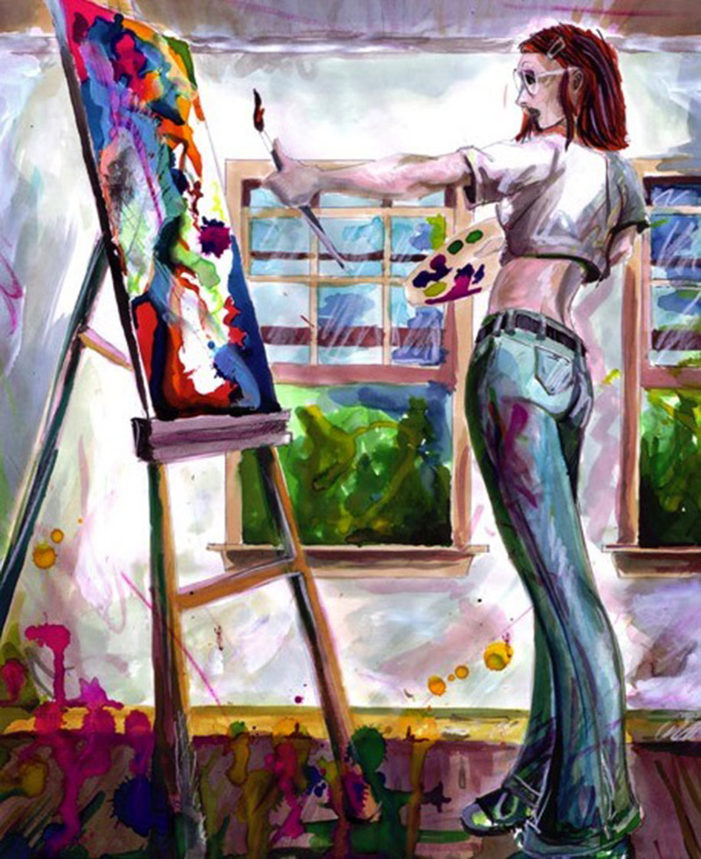

Please visit [Using Moodle](https://www.adlc.ca/contact-us/technical-help-training/moodle-training-resources/) for further documentation on the features of Moodle.

* **ADLC Lead Teacher Information:**

Crystal Waldowski-Puskeppelies

[crystal.puskeppelies@adlc.ca](mailto:crystal.puskeppelies@adlc.ca)

1-866-774-5333 ext. 7364

Please visit [Moodle Technical Support](https://www.adlc.ca/contact-us/technical-help-training/moodle-training-resources/) for further documentation on the features of Moodle.

***We wish your students much success and enjoyment in Art 30!***