English 10-1 Module Two Challenge Four (M2C4)
Complete the following tasks as thoughtfully and thoroughly as possible.
If you are completing this work on a computer, type in the text boxes below each question; the space will expand to fit your work.
If you are completing this work off-line, by hand, please know that you may (and are encouraged to) write on a separate piece of paper, and use as much space as you need.
TASK ONE: MODERN BALLADS: INITIAL RESPONSE
In this section of the module, you learned the characteristics of modern ballads – songs and poems that tell stories.
Modern ballads are compelling because they combine the rhythmic, rhyming, evocative language of poetry with the components of narratives like setting, conflict, characters, and plot.
Attached to this challenge are four modern ballads.
As you read each poem, make notes, a running commentary if you will, about the text and how you are experiencing it.
Submit your notes here:
“Cat’s Cradle” by Harry Chapin and Sandy Chapin

“The Highwayman” by Alfred Noyes

“The Wreck of the Edmund Fitzgerald” by Gordon Lightfoot

“Coward of the County” by Roger Dale Bowling and Billy Ed Wheeler

TASK TWO: MODERN BALLADS: GETTING THE STORY STRAIGHT
Create a graphic organizer in which you keep track of the essential story and poetic elements of each ballad.
You should include: title, author, refrain/chorus, protagonist, antagonist, conflict, initial incident, climax, setting, evocative words, and any other criteria of modern ballads that you can think of.

TASK THREE: MODERN BALLADS: THE NEXT DIMENSIONS
In addition to telling a story, ballads are musical in nature and meant to be sung. Nearly every song nowadays has a visual component in the form of a video.
Following the lyrics for each of the modern ballads, you’ll find a url address for the song on YouTube.
Go to each link and listen to each song at least twice. If you can, turn off your computer screen so you can listen to the words without the visuals once, then turn on the visuals the second time through.
- For each of the songs, describe how hearing the words being set to music altered your experience of the text.
“Cat’s Cradle”

“The Highwayman”

“The Wreck of the Edmund Fitzgerald”

“Coward of the County”

- For each of the songs, describe how the visual component of the video altered your experience of the text.
“Cat’s Cradle”

“The Highwayman”

“The Wreck of the Edmund Fitzgerald”

“Coward of the County”

TASK FOUR: MODERN BALLADS: CLOSE EXAMINATION
Select one of the poems you studied in this section and create a graphic response to the poem you chose.
The graphic response should include the following elements:
- a title that reveals what the focus of your response will be
- three significant quotations from the poem
- brief comments on the significance of each quotation
- a graphic that relates to each quotation
The following suggestions and guidelines may help you complete this assignment:
• Create an extended title that focuses on an important aspect of narrative poetry that you wish to explore. State a definite position or opinion in this extended title. The three quotations that you choose should serve as detail to support that opinion.
• The position or opinion expressed in the title should focus on a significant aspect relating to your study of narrative poetry. For example:
- Robert Service depends on exaggeration to create humour in "The Shooting of Dan McGrew."
- Unlike most traditional ballads, Stan Rogers' "White Squall" attempts to teach a moral lesson.
- The parents in Alden Nowlan's "Warren Pryor" have done more harm than good.
Do not restrict yourself to the previous four suggestions. If there is another position concerning any of the poems that you wish to explore, please feel free to do so.
• Choose quotations that you can comment upon to develop or defend your position. Keep the quotations brief.
• For each of the quotations, compose one or two brief sentences that explore or defend your position.
• Find or create graphics that somehow illustrate the generalized point being made in each of the quotations. Do not try to find illustrations that correspond to the words in the quotations on the literal level. Think of the general issues or emotions raised by the quotations.
The following chart may help you organize your response.
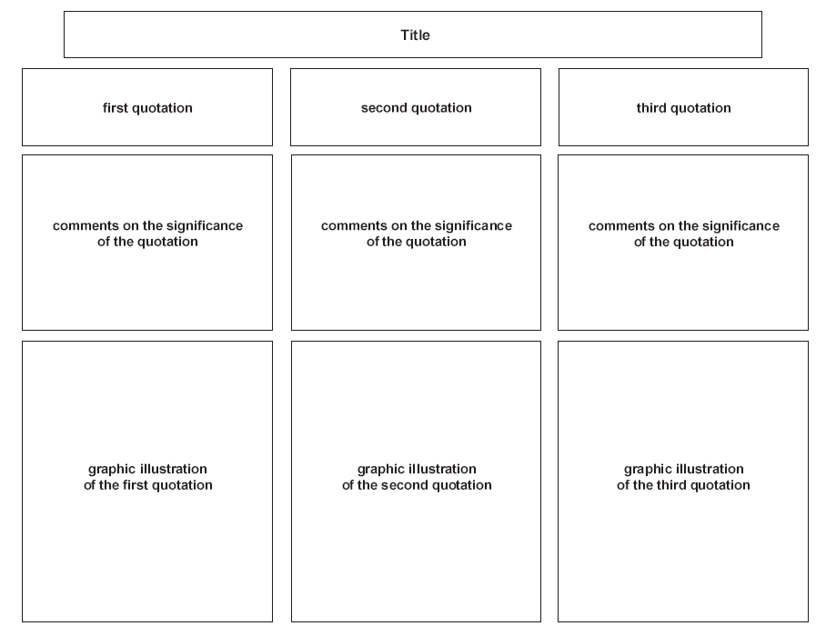

TASK FIVE: MODERN BALLADS: WHAT’S THE POINT
In a well-written, well-organized, well-supported mini-essay, discuss whether or not modern ballads should remain on the English Language Arts curriculum. Be sure to support your ideas with evidence (ie. Quotations and examples) from the ballads that you’ve studied in this module.
Minimum: 1.5 pages

