ENGLISH 10-1 MODULE THREE CHALLENGE TWO (M3C2)
Complete the following tasks as thoughtfully and thoroughly as possible.
If you are completing this work on a computer, type in the text boxes below each question; the space will expand to fit your work.
If you are completing this work off-line, by hand, please know that you may (and are encouraged to) write on a separate piece of paper, and use as much space as you need.
TASK ONE: MAJOR vs. MINOR DETAILS IN THE NEWS
Here's your opportunity to demonstrate that you can distinguish between major and minor details in a news story.
A crime has been committed. You are a reporter sent to investigate and write up the story. Some facts are listed below.
Use the inverted-pyramid model to write them up into an accurate and interesting news story. You may add any details you wish, just be sure to organize the facts according to their news-appropriateness.
• The crime occurred at 11:00 p.m. on Thursday, October 6. • It occurred on Edmonton's Jasper Avenue. • Mrs. Donohue, a tourist from Oregon, had her purse snatched. • Mrs. Donohue said she had been told that Edmonton was a safe city. • She said she'd never return to Canada. • Mrs. Donohue chased the robber but stopped when he turned and pointed a gun at her. • The purse snatcher is a 15-year-old youth who cannot be named in the newspaper. • An off-duty police officer saw the crime take place, wrestled the thief to the ground, and held him until on-duty police officers arrived. • The police officer, Constable Sophia Rossi, said that her training made her act instinctively to apprehend the criminal.

TASK TWO: NEWS STORY STRUCTURE
In Lesson 1 of this section, you learned about the inverted-pyramid structure of news stories.
Select a brief article of your choice from a newspaper, and, using the model provided, fill in the information for each box.
For this exercise, a straightforward, factual news story works best.
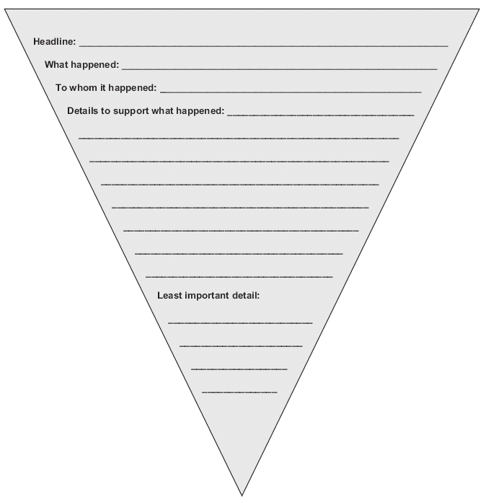You may work on a different page if you like.
TASK THREE: NEWSWORTHINESS
In Lesson 1, you learned about eight elements that make an event newsworthy.
They are: • prominence • timeliness • nearness (also called “proximity”) • significance • human interest • oddity • romance • innovation or progress
Turn to page 315 of Sightlines 10 and read the news article “And I Won’t Blow Your House Down” by Rita Feutl. The story related in Rita Feutl's article is newsworthy because it contains at least six of the previously listed elements.
Identify and explain four of them. Use details from the article to support your ideas.
Newsworthy Element One:

News worthy Element Two:

Newsworthy Element Three:

Newsworthy Element Four:

TASK FOUR: SQ3R
In Lesson 4, you learned about or reviewed the SQ3R technique. In this assignment, you will be asked to demonstrate that you know how to apply each of the steps to a careful reading of a text.
Turn to page 284 of Sightlines 10. Using the SQ3R process, read the financial report called "Nelvana." Pause at the end of each step of the SQ3R process to answer the following questions. If you choose to use a word processor and/or your own paper, ensure that your pages are firmly attached to this Assignment Booklet and that they are fully and clearly labeled.
a. Survey: What did you learn about the financial report as you surveyed it? List at least five important points.

b. Question: What questions did you create for yourself? You should list at least one question for each part or paragraph of the report.

c. Read: What notes did you take as you read the report? You may indicate your response in short sentences or point form.

d. Recite: Write a short paragraph in response to the following questions:
• Did you check after each part or paragraph to make sure that you understood what you were reading? • Did you reread any of the parts? If not, why not? • To what extent did this step help you to focus your reading?

e. Review: Now is your chance to find out if using SQ3R has helped you to have a better understanding of what you've read. For this to work, you have to be honest with yourself. Without looking at the textbook or your notes, try to list five main points from the report. No marks will be awarded for this question. Its value comes from what it reveals to you about your reading process using SQ3R.
These are the points that I recall from the financial report called "Nelvana" without having looked at my notes or Sightlines 10:

f. In a well-supported, well-organized paragraph, discuss your reading process when you use SQ3R.
Consider the following questions as you write:
• Do you think SQ3R helps you to be a better and more active reader? Why or why not? • Do you think you will use SQ3R again? Under what circumstances? • Have you used SQ3R before you were asked to explore it in this course? When? Do you still use it? Explain why or why not. • Do you use a reading strategy similar to SQ3R? If so, describe it. • Can you think of a way of adapting and personalizing the SQ3R method to suit you better? Elaborate.

