

**CALM COURSE TIPS – Navigation and Course Expectations**

To get the most out of this course, apply the concepts to your current life situation. Be realistic and try to seriously consider your current and future health and wellness. Read your assignment feedback and ask for assistance when needed.

To start, watch the **boot camp video and read this tips document**.  Both are an overview of course navigation.

Next, explore the buttons found on the Navigation Toolbar.  These will give you access to resources, the discussion forum, grades, as well as informational items to assist you. You will submit assignments within the course itself.

**Buttons found on the Navigation Toolbar:**



*The **Content** button is where you will find the table of contents and access to your course home page.

*Under **Resources**, you will find Checklist information regarding your progression within the course. If you click on a unit’s Checklist title, you can track your completion of all required tasks within the course. You will also find Checklists within each unit.

*The **Communication** button allows you quick access the **Forums.** This is where you will find the Connect discussion posts. Use this button to search for completed posts or if you need to return to a post without going back into the content. Otherwise, the link to Connect discussions are in the content and will take you directly to the post you need to complete. It will open in a new window and once you post you may close that window. You will see this icon in the course when you are ready to complete a Connect discussion post:

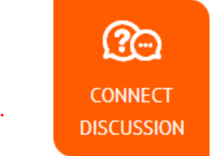

*The **Grades** button is where you will find access to your grades. Check here often. The assignments and connect posts are the items assessed in this course.

*You will find teacher and marker information under the **My Teacher** button

**Assignments & Discussions**

**You do not go looking for assignments to complete;** the course does not work that way.  You will complete discussion postings and submit projects when asked to do so.  Discussion postings are required and help you become part of the global community. Assignments are only accessible in the content, in the Action section of each unit.

**3 buttons you will see at the start of each unit**

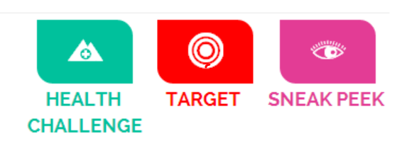

*The **Health Challenge** button is where you will find the instructions regarding the required Health Challenge you will work on throughout your course. You will need to review the instructions BEFORE starting Unit 1. It can also be reviewed at the start of each unit. This is related to the Assignment in Unit 4.

* The **Sneak Peak** and **Target** buttons at the beginning of each unit page will give insight into what needs to be completed and what’s to come. These are for **informational purposes** only, you do not complete work from this area.

**Toolbox**

*You will see this button in each Unit’s Action section. The Action section of the unit is where the assignment instructions are located. The Toolbox has helpful tutorials and informational course info that may help you complete assignments.

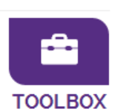

**E-Portfolio**

An e-Portfolio created using a tool of your choice is recommended, but not required. If you start one, you are encouraged to store completed assignments there for future personal/professional use. For example; your completed resume and cover letter.

**Notes**

***Notes*** are a section found throughout the content. They help you reflect on the content presented and document information that may be useful when completing your assignments and discussion posts. You are able to download the *Notes* at the beginning of each Unit from the “Watch & Reflect” page of content. Save them to an area of your choosing and enter your responses when requested to do so. **These notes are not graded**.

**To Start**

Click on the course introduction. After watching the Boot Camp and reviewing the tips document, you will work through each unit in sequential order and follow the instructions on each page.  Each unit is broken down into 5 sections; Introduction, Watch & Reflect, Deep Dive, Connect, and Action.

Once you have completed the course introduction, click on the **Unit 1 home-page tile** to start.

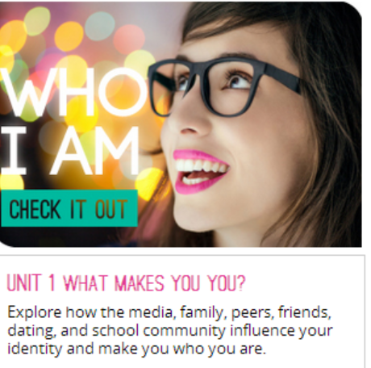

*\*\*Please note all* ***PDF documents*** *must be downloaded and saved BEFORE working in them.  This will prevent them from uploading as a blank document.  To do this, right click on the link (do not open it) and choose “save link as…”.  Save the PDF to a USB, your desktop, or place of your choosing.  Now you can open the saved PDF and complete it, save it again, and upload into the dropbox. If using a Mac, be sure you are opening the PDF in Adobe Acrobat Reader. If you are using Windows 8, download and install Adobe Reader and make sure you use it to open/edit the pdfs.*

Re-submissions will be required if work is incomplete. Please ensure you submit ALL parts of each assignment, to the designated areas. Re-dos will only be accepted if your marker makes this request, so ensure you submit thoughtful work the first time. There is no final exam, so all assessed items are required to successfully complete the course.

There is fantastic media in this course.  If you need further technical support, please contact

1-866-774-5333 ext 5322

Please do not hesitate to contact your lead teacher for assistance.

