Module 3 Summative Assessment

Marks
Maximum Possible | Earned | %
65

- Write balanced reaction equations, including states, for the following processes. Identify each process as exothermic or endothermic.

Answer (6 Marks)
Process | Reaction Equation
Photosynthesis

Cellular respiration
Complete hydrocarbon combustion of octane in an open system

Process | Exothermic/Endothermic
Photosynthesis
Cellular respiration
Complete hydrocarbon combustion

Lesson 1
- Enthalpy cannot be directly measured, but change in enthalpy can be measured. When measuring the change in enthalpy of a chemical system, which 2 variables must be held constant? As a result, what does the enthalpy change of a chemical system represent?

Answer (2 Marks)
Lesson 2
- Define activation energy. Sketch a diagram that illustrates the concept of activation energy using the concept of bond energy.

Answer (3 Marks)

Use the following information to answer the next two questions.
When solid potassium is placed in a beaker of water at room temperature, an immediate, violent reaction occurs:

- Sketch and label an energy pathway diagram for this reaction.
Your diagram should include:
- labelling of the X and Y axes
- general shape of the energy pathway
- labeling of the reactant plateau, the product plateau, the activation energy (Ea) and the change in enthalpy (Δ_{r}H)
No specific numerical values are required.

Answer (4 Marks)

- Refer to the diagram you drew in Question 4. When solid potassium is placed in a beaker of water at room temperature, what should happen to the temperature of the water?
Answer (1 Mark)

View the “Catalyst Virtual Investigation” in Module 3 Lesson 2.3
Use the information in the Virtual Investigation to answer Questions 6-14.

- Research! What are the safety concerns surrounding experiments using hydrogen peroxide? Include the WHMIS symbol(s) that should be displayed on a container of hydrogen peroxide. (Remember to use 2015 WHIMIS symbols)

Answer (3 Marks)

- The “sizzling” sound in this experiment (amplified by the microphone) is caused by _____________________?

Answer (1 Mark)

- Identify the liver enzyme that catalyzed the decomposition of hydrogen peroxide.

Answer (1 Mark)

- Regarding the Catalyst Virtual Investigation, identify the following variables.

Hint: Manipulated variables are conditions that are deliberately changed by the experimenter. Responding variables are conditions that change in response to the change in the manipulated variables. Controlled variables are conditions that could have changed but did not because of the intervention of the experimenter.

Answer (4 Marks)
Manipulated Variable
Responding Variable
Controlled Variables (Identify two (2))

- Design a data chart to collect and record data while watching the Catalyst Virtual Investigation. In your chart, list every catalyst used and describe the effect of the catalyst on the relative reaction rate. To gauge the speed of the reaction, use the amount of bubbling (as evidenced by the sound).
Answer (3 Marks)
Catalyst used | Relative reaction rate
No catalyst | No evidence of decomposition

- Refer again to the Catalyst Virtual Investigation. For the following system, record the initial and final temperatures.

Answer (2 Marks)
System | Initial temperature (ºC) | Final temperature (ºC)
Hydrogen peroxide and manganese dioxide catalyst

- Based on the temperature change of the surroundings, classify the decomposition of hydrogen peroxide as endothermic or exothermic.

Answer (1 Mark)

- Sketch an energy pathway diagram that includes the activation energy and the catalyzed activation energy for the decomposition of hydrogen peroxide.

Answer (2 Marks)

- Suggest how this experiment might be improved.

Answer (1 Mark)

Use the following information to answer Questions 15-18.

Sucrose, commonly known as table sugar, will be hydrolyzed to fructose and glucose in the presence of the enzyme sucrase. The reaction equation for this hydrolysis is

The energy changes for this reaction are diagramed below.
The blue line represents the reaction progress with sucrase and the red line represents the reaction progress without sucrase.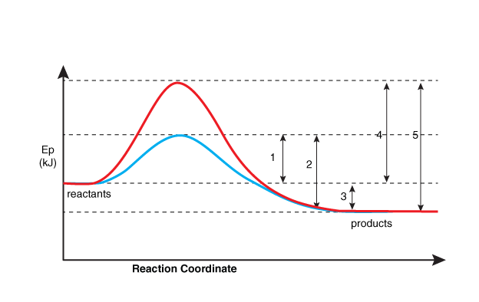

- The enzyme sucrase will (1 Mark)

- increase the reaction rate of the hydrolysis of sucrose.
- provide an alternate pathway, with higher Ea, for the hydrolysis of sucrose
- lower the value of ΔH.
- change the reaction from exothermic to endothermic
Answer:

- Because it lowers the activation energy, the enzyme sucrase is classified as a _______.

Answer (1 Mark)

- Describe how adding a catalyst to a reaction system affects the enthalpy change for the overall reaction.

Answer (2 Marks)

- Identify which energy value is indicated by each of the numbers in the above energy pathway diagram.

Answer (5 Marks)
Number | Energy value
 | Change in enthalpy for both forward and reverse reaction
 | Uncatalyzed activation energy for the forward reaction
 | Uncatalyzed activation energy for the reverse reaction
 | catalyzed activation energy for the reverse reaction
 | catalyzed activation energy for the forward reaction

Lesson 3
Use the following information to answer Questions 19-23
Dinitrogen pentaoxide, N₂O₅(g), is a strong oxidizer that forms explosive mixtures with organic compounds and ammonium salts. At standard state, dinitrogen pentaoxide decomposes into NO₂ and O₂ according to the following equation.

- The above reaction is __i__ and the standard enthalpy of reaction is __ii__.
The statement above is completed by the information in row_____.
(1 Mark)
Row | i | ii
A. | endothermic | Δ_{r}Hº = + 219 kJ
B. | endothermic | Δ_{r}Hº = - 219 kJ
C. | exothermic | Δ_{r}Hº = + 219 kJ
D. | exothermic | Δ_{r}Hº = - 219 kJ

- Calculate the standard molar enthalpy of reaction for dinitrogen pentaoxide.

Answer (2 marks)

- Sketch and label a chemical potential energy diagram for the standard molar enthalpy of reaction for dinitrogen pentoxide. Indicate the enthalpy change using r as a subscript.
Answer (3 marks)

- When 10.0 mol of nitrogen dioxide is produced in the above reaction, the enthalpy change is ____kJ

Answer (1 Mark)

- Is energy absorbed or released in the above reaction?

Answer (1 Mark)

Use the following information to answer Questions 24 to 27.

Galvanizing is the process of coating an object with zinc. When exposed to oxygen, zinc forms an oxide coating that protects the metal from further corrosion. At standard state, this reaction is represented by the following equation.

- Sketch and label a chemical potential energy diagram for the process shown in the previous information box. Indicate the standard enthalpy of reaction using r as a subscript.

Answer (3 marks)

- The formation of zinc oxide is classified as an __i_(endothermic/exothermic) reaction, and the reactants have __ii__ (less/more) potential energy than the products.
Answer (2 Marks)
i
ii

- When the above reaction occurs, it is expected that the temperature of the surroundings will __i__ (decrease/increase). This change in temperature would indicate that the surroundings are undergoing a change in __ii__ (kinetic/potential) energy.

Answer (2 Marks)
i
ii

- Calculate the standard enthalpy of reaction when 25.0 g of zinc oxide is produced. Show all work for full marks.

Answer (2 Marks)

Lesson 4
Use the following information to answer Questions 28 and 29.

Welding utilizes a variety of fuels. Two such fuels identified for comparison are acetylene (ethyne C₂H₂(g)) and propylene (propene C₃H₆(g)).
Fuel | Molar enthalpy of combustion (kJ/mol)
acetylene | -1 300.8
propylene | -2 058.1

- Calculate and compare the values of the enthalpy of combustion in kJ/g for each fuel.
Answer (3 Marks)

- Describe two other factors that can be used to evaluate the fuel.
Answer (2 Marks)

