Module 5 Summative Assessment

|  |  |  |
| --- | --- | --- |
| ***Marks*** | | |
| ***Maximum Possible*** | ***Earned*** | ***%*** |
| ***73*** |  |  |

**Lesson 1**

|  |
| --- |
| View the Virtual Investigation on Oxidation States in Module 5 Lesson 1.5 and use the information to fill in the table in Question 1. |

1. Identify the characteristic colour of the various oxidation states of manganese.

**Answer (3 Marks)**

|  |  |
| --- | --- |
| **Oxidation State** | **Colour** |
| +7 |  |
| +6 |  |
| +4 |  |

1. Classify each of the following reactions as redox or non-redox.

**Answer (4 Marks)**

|  |  |
| --- | --- |
| **reaction equation** | **redox or non-redox** |
| 3Cl2(g) + 6NaOH(aq) →5NaCl(aq) + NaClO3(aq) + 3H2O(l) |  |
| CO2(g) + H2O(l) → H2CO3(aq) |  |
| 2 NH4Cl(aq) + Ca(OH)2(aq) →2 NH3(aq) + 2H2O(l) + CaCl2(aq) |  |
| 2HNO3(aq) + 6HI(aq) →2NO(g) +3 I2(s) + 4H2O(l) |  |

1. Describe disproportionation. Next, consider the reactions shown in Question 2 above and indicate if any of the reactions demonstrate disproportionation.

**Answer (2 Marks)**

|  |
| --- |
|  |

**Lesson 2**

*Use the following information to answer Questions 4 - 7.*

|  |
| --- |
| In an experiment to study the reactivity of different substances, the following observations were made.  2V3+(aq) + In1+(aq) → 2V2+(aq) + In3+(aq) spontaneous reaction  2 Rh4+(aq) + Tl1+(aq) → 2 Rh3+(aq) + Tl3+(aq) spontaneous reaction  Tl1+(aq) + 2 V3+(aq) → Tl3+(aq) + 2 V2+(aq) no evidence of a reaction  **Hint:** By looking at changes in oxidation numbers, you can determine the OA and RA for each reaction. Then apply the spontaneity rule. (p. 572-573 in text). |

1. Using the above results, construct a table of reduction half-reactions that contains four half-reactions. Be sure to include the number of electrons in each half-reaction. Model your table on the set-up shown below:

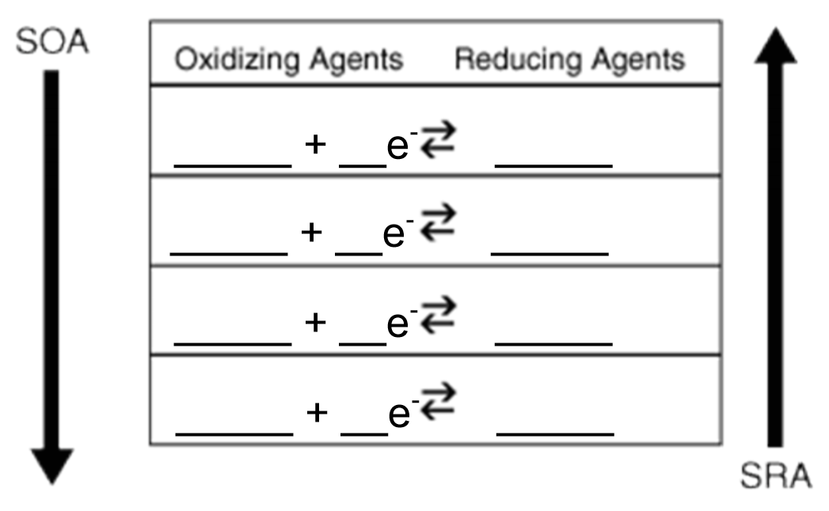

**Answer (2 Marks)**

|  |
| --- |
|  |

1. Identify the reducing agent that has the weakest attraction for electrons.

**Answer (1 Mark)**

|  |
| --- |
|  |

1. Identify the oxidizing agent that has the strongest attraction for electrons.

**Answer (1 Mark)**

|  |
| --- |
|  |

1. Based on the table you constructed in Question 4, write an equation that represents another spontaneous reaction that could occur.

**Answer (1 Mark)**

|  |
| --- |
|  |

|  |
| --- |
| View the Virtual Investigation “Predicting Redox Reactions” in Module 5 Lesson 2.3 and use the results to answer Questions 8 -12. |

1. Predict the products for each system in the Virtual Investigation. Your response should include

* All species initially present
* All oxidizing agents and reducing agents. Identify the Strongest Reducing Agent (SRA) and Strongest Oxidizing Agent (SOA)
* If the reaction is spontaneous, indicate “yes” and write the half-reactions and the balanced net ionic equation. If the reaction is non-spontaneous, simply indicate “no” in the blank . Include the half-reactions but it is not necessary to write net ionic equation if the reaction is non-spontaneous.
* *System 1 and 2 have been completed for you as examples.* ***Refer to these examples before completing the rest of the System tables – they will be very helpful in clarifying common mistakes!***

***System 1 Example – liquid water and solid calcium***

|  |  |
| --- | --- |
| Species List | *H2O(l), Ca(s)* |
| Oxidizing agents | *H2O(l)*  *SOA= H2O(l)* |
| Reducing agents | *H2O(l), Ca(s)*  *SRA= Ca(s)* |
| Spontaneous? | *Yes* |
| Reduction half-reaction | *2 H2O(l) + 2e- → H2(g) + 2 OH-(aq)* |
| Oxidation half-reaction | *Ca(s) →Ca2+(aq) + 2e-* |
| Net ionic equation | *2 H2O(l) + Ca(s) →Ca2+(aq) + H2(g) + 2 OH-(aq)* |

***System 2 Example – aqueous hydrochloric acid and solid silver metal***

|  |  |
| --- | --- |
| Species List | *H+(aq), Cl-(aq), H2O(l), Ag(s)* |
| Oxidizing agents | *H2O(l), H+(aq)*  *SOA= H+(aq)* |
| Reducing agents | *H2O(l), Ag(s), Cl-(aq), Cl-(aq) + H2O(l),*  *SRA= Ag(s)* |
| Spontaneous? | *No* |
| Reduction half-reaction | *2 H+(aq) + 2e- → H2(g)* |
| Oxidation half-reaction | *Ag(s) → Ag1+(aq) + 1e-* |
| Net ionic equation | *Non-spontaneous* |

**System 3 – aqueous hydrochloric acid and solid magnesium metal**

**Answer (4 Marks)**

|  |  |
| --- | --- |
| Species List |  |
| Oxidizing Agents |  |
| Reducing agents |  |
| Spontaneous? |  |
| Reduction half-reaction |  |
| Oxidation half-reaction |  |
| Net ionic equation |  |

**System 4 – Acidified aqueous iron(II) nitrate and aqueous potassium dichromate**

***Hint:*** *Study the species list carefully and remember to consider combination agents!*

**Answer (4 Marks)**

|  |  |
| --- | --- |
| Species List |  |
| Oxidizing agents |  |
| Reducing agents |  |
| Spontaneous? |  |
| Reduction half-reaction |  |
| Oxidation half-reaction |  |
| Net ionic equation |  |

**System 5 – aqueous hydrogen peroxide and aqueous iron(III) nitrate**

***Hint:*** *This system is not acidified.*

**Answer (4 Marks)**

|  |  |
| --- | --- |
| Species List |  |
| Oxidizing Agents |  |
| Reducing agents |  |
| Spontaneous? |  |
| Reduction half-reaction |  |
| Oxidation half-reaction |  |
| Net ionic equation |  |

**System 6 – aqueous zinc nitrate and aqueous chromium(II) chloride**

**Answer (4 Marks)**

|  |  |
| --- | --- |
| Species List |  |
| Oxidizing agents |  |
| Reducing agents |  |
| Spontaneous? |  |
| Reduction half-reaction |  |
| Oxidation half-reaction |  |
| Net ionic equation |  |

**System 7 – aqueous silver nitrate and solid copper metal**

**Answer (4 Marks)**

|  |  |
| --- | --- |
| Species List |  |
| Oxidizing agents |  |
| Reducing agents |  |
| Spontaneous? |  |
| Reduction half-reaction |  |
| Oxidation half-reaction |  |
| Net ionic equation |  |

1. Record your observations from the Virtual Investigation in the following table.

**Answer (5 Marks)**

|  |  |  |  |  |  |  |  |  |  |  |  |  |  |  |  |  |
| --- | --- | --- | --- | --- | --- | --- | --- | --- | --- | --- | --- | --- | --- | --- | --- | --- |
| |  |  | | --- | --- | | **System** | **Observable Evidence of a Spontaneous Reaction** | | 1. | *Bubbling.*  *Solid metal dissolves.*  *pH increases.* | | 2. | *No observable changes.* | | 3. |  | | 4. |  | | 5. |  | | 6. |  | | 7. |  | |

1. Describe the diagnostic test that could be used to identify the gas produced in System 1.

Your response should include

* a description of how the test is performed
* identity of the gas being tested for
* the results of the test

***Hint:*** *See page 805 in your textbook for a list of diagnostic tests.*

**Answer (3 Marks)**

|  |
| --- |
|  |

1. Describe the diagnostic test that could be used to identify the gas produced in System 5.

Your response should include

* a description of how the test is performed
* identity of the gas being tested for
* the results of the test

***Hint:*** *See page 805 in your textbook for a list of diagnostic tests.*

**Answer (3 Marks)**

|  |
| --- |
|  |

1. Measuring pH change is sometimes used as a diagnostic test. In which of the seven systems might we have used pH change as evidence of a spontaneous reaction? Explain your reasoning.  
     
   **Answer (2 Marks)**

|  |
| --- |
|  |

**Lesson 3**

|  |
| --- |
| Perform the Virtual Investigation “**Titration 1, Exercise 1, Procedures 1 and 2**” in Module 5 Lesson 3.1 and use the results to answer Questions 13 - 15. |

1. Record your results for the coarse titration. Remember, a burette measures the volume dispensed.

**Answer (1 Mark)**

|  |  |  |  |  |  |  |  |  |
| --- | --- | --- | --- | --- | --- | --- | --- | --- |
| **Volume of NaOHadded (coarse titration)**   |  |  | | --- | --- | |  |  | | Initial burette reading (mL) |  | | Final burette reading (mL) |  | | Volume of NaOH used (mL) |  | |

1. Record your results for the fine titration.

**Answer (2 Marks)**

|  |  |  |  |  |  |  |  |  |  |  |  |  |  |  |  |  |  |  |  |  |
| --- | --- | --- | --- | --- | --- | --- | --- | --- | --- | --- | --- | --- | --- | --- | --- | --- | --- | --- | --- | --- |
| **Volume of NaOH added (fine titration) – Record the data from the three most consistent trials.**   |  |  |  |  | | --- | --- | --- | --- | |  | Trial 1 | Trial 2 | Trial 3 | | Initial Burette reading (mL) |  |  |  | | Final Burette Reading (mL) |  |  |  | | Volume of NaOH used (mL) |  |  |  | | Average Volume of NaOH used (mL) |  | | | |

1. Calculate the concentration of the hydrochloric acid using the average volume of NaOH used from the fine titration. Follow the steps outlined below.

**Answer (2 marks)**

|  |  |
| --- | --- |
| *Write the balanced reaction between NaOH and HCl* |  |
| *Calculate moles of NaOH added from the average volume of NaOH used* |  |
| *Calculate moles of HCl using the molar ratio in the balanced reaction* |  |
| *Calculate concentration of HCl in mol/L* |  |

|  |
| --- |
| Perform the Virtual Investigation “**Redox Titration, Exercise 1, Procedures 1 and 2**” in Module 5 Lesson 3.2 and use the results to answer Questions 16 – 24. |

1. Fill in the data table below with the data you collected from Exercise 1, Procedure 1, Part 1 (coarse titration using the NEW hydrogen peroxide)

**Answer (1 Mark)**

|  |  |  |  |  |  |  |
| --- | --- | --- | --- | --- | --- | --- |
| **Volume of KMnO4 added (coarse titration)**   |  |  | | --- | --- | | Initial burette reading (mL) |  | | Final burette Reading (mL) |  | | Volume of KMnO4 used (mL) |  | |

1. Fill in the data table below with the data you collected from Exercise 1, Procedure 1, Part 2 (fine titration using the NEW hydrogen peroxide).

**Answer (3 Marks)**

|  |  |  |  |  |  |  |  |  |  |  |  |  |  |  |  |  |  |  |  |  |
| --- | --- | --- | --- | --- | --- | --- | --- | --- | --- | --- | --- | --- | --- | --- | --- | --- | --- | --- | --- | --- |
| **Volume of KMnO4 added (fine titration) - Record the data from the three most consistent trials.**   |  |  |  |  | | --- | --- | --- | --- | |  | Trial 1 | Trial 2 | Trial 3 | | Initial burette reading (mL) |  |  |  | | Final burette reading (mL) |  |  |  | | Volume of KMnO4 used (mL) |  |  |  | | Average volume of KMnO4 used (mL) |  | | | |

1. Calculate the concentration of the NEW hydrogen peroxide, following the steps below. Use your average volume of KMnO4 used the titrant volume from Question 17 above.

**Answer (4 Marks)**

|  |  |
| --- | --- |
| *Write the half-reactions and* ***net*** *redox reaction between H2O2 and KMnO4 (remember KMnO4 dissociates into K+ and MnO4-)* |  |
| *Calculate moles of MnO4- added from the average volume of KMnO4 used* |  |
| *Calculate moles of NEW H2O2* |  |
| *Calculate concentration of NEW H2O2* |  |

1. Use your answer for the concentration of NEW H2O2 above and Table 1 on p. 603 in your textbook to estimate the percentage by volume concentration of the NEW hydrogen peroxide solution. (No calculation is needed here.)

**Answer (1 Mark)**

|  |
| --- |
|  |

1. Fill in the data table below with the data you collected from Exercise 1, Procedure 2, Part 1 (coarse titration using the OLD hydrogen peroxide).

**Answer (2 Marks)**

|  |  |  |  |  |  |  |
| --- | --- | --- | --- | --- | --- | --- |
| **Volume of KMnO4 added (coarse titration)**   |  |  | | --- | --- | | Initial burette reading (mL) |  | | Final burette Reading (mL) |  | | Volume of KMnO4 used (mL) |  | |

1. Fill in the data table below with the data you collected from Part 2 of Experiment 1 (fine titration using the OLD hydrogen peroxide).

**Answer (3 Marks)**

|  |  |  |  |  |  |  |  |  |  |  |  |  |  |  |  |  |  |  |  |  |
| --- | --- | --- | --- | --- | --- | --- | --- | --- | --- | --- | --- | --- | --- | --- | --- | --- | --- | --- | --- | --- |
| **Volume of KMnO4 added (fine titration)**   |  |  |  |  | | --- | --- | --- | --- | |  | Trial 1 | Trial 2 | Trial 3 | | Initial burette reading (mL) |  |  |  | | Final burette reading (mL) |  |  |  | | Volume of KMnO4 used (mL) |  |  |  | | Average volume of KMnO4 used (mL) |  | | | |

1. Calculate the concentration of the OLD hydrogen peroxide, following the steps below. Use your average volume of KMnO4 used as the titrant volume.

**Answer (4 Marks)**

|  |  |
| --- | --- |
| *Write the half-reactions and* ***net*** *redox reaction between H2O2 and KMnO4 (remember KMnO4 dissociates into K+ and MnO4-)* |  |
| *Calculate moles of MnO4- added from the average volume of KMnO4 used* |  |
| *Calculate moles of OLD H2O2* |  |
| *Calculate concentration of OLD H2O2* |  |

1. Use your calculated concentration of OLD H2O2 and Table 1 on p. 603 in your textbook to estimate the percentage by volume concentration of the OLD hydrogen peroxide solution. (No calculation is needed here.)

**Answer (1 Mark)**

|  |
| --- |
|  |

1. Compare your results for the concentration of the NEW hydrogen peroxide to the concentration of the OLD hydrogen peroxide. Based on the properties of hydrogen peroxide, explain any difference that you notice between the NEW and OLD samples.

**Answer (2 Marks)**

|  |
| --- |
|  |