Module 6 Summative Assessment

Marks
Maximum Possible | Earned | %
104

Lesson 1
Use the following information to answer Questions 1-4.
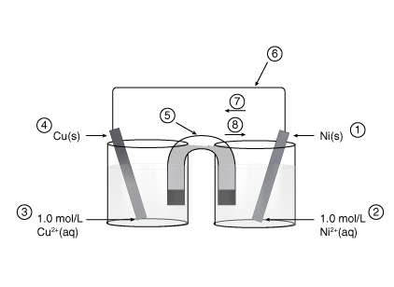

- Match the numbers on the electrochemical cell above with the descriptors below.

Answer (5 Marks)
Number | Descriptor
 | Anode
 | Cathode
 | SOA
 | SRA
 | Positive electrode
 | Negative electrode
 | Pathway that allows electrons to flow
 | Pathway that allows ions to flow
 | Direction that electrons flow
 | Direction that cations flow

- Write the anode half-reaction, cathode half-reaction and the net cell reaction.

Answer (3 Marks)
anode
half-reaction
cathode
half-reaction
net
reaction

- Calculate the electrical potential of the cell.

Answer (1 Mark)

- Describe four empirical observations that would accompany the operation of this cell.

Answer (2 Marks)

- Write the half-reaction for the standard reference half-cell.

Answer (1 Mark)

- How would the net cell potential for the following cell be affected if the reduction of tin(II) ions had been selected as the reference half-cell?

Mg(s) | Mg(NO₃)₂(aq) || Cd(NO₃)₂(aq) | Cd(s)

Answer (1 Mark)

View the Virtual Investigation “Building Voltaic Cells” in Module 6 Lesson 1.3 and use the results of the experiments to answer Questions 7 – 10.

- Complete the following tables to make predictions about the cells constructed in the Virtual Investigation.

- Draw and fully label a diagram for each cell.
- For each cell, indicate the direction of electron flow, cation flow and anion flow.
- Write half-reactions for each half-cell.
- Write a net reaction for each cell.
- Write the cell notation.
- Suggest empirical evidence that would indicate a reaction has occurred in each half-cell. Consider parameters such as pH, mass of electrodes, colour of solution(s) etc.
- Calculate the theoretical standard cell potential.
- Record the Actual Cell Potential seen in the investigation. If the voltage is fluctuating, record the highest value that you observe.
- System 1 has been completed for you as an exemplar. Be sure to read over this example to help you avoid common mistakes!

System 1 – Exemplar:
Fully Labelled Diagram (Example)

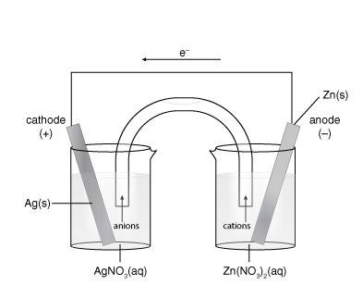
It is NOT permitted to copy this diagram for the next Systems. Make sure you are drawing your own diagrams for the remaining Systems.

Oxidation Half-reaction | Zn(s) →Zn²⁺(aq) + 2 e-
Reduction Half-reaction | Ag⁺(aq) + 1e- →Ag(s)
Net Cell Reaction | 2 Ag⁺(aq) + Zn(s) → Zn²⁺(aq) + 2 Ag(s)
Cell Notation | Zn(s)|Zn²⁺(aq)||Ag⁺(aq)|Ag(s)
Empirical Evidence | Cathode: Mass of silver electrode increases  Anode: Mass of zinc electrode decreases
Theoretical Standard Cell Potential | E ⁰_{cell}= E ⁰_{cathode} - E ⁰_{anode}  E ⁰_{cell}= +0.80 V – (-0.76 V)  E ⁰_{cell}= + 1.56 V
Observed Cell Potential | 1.27 V

System 2

Answer (11 Marks)
Fully Labelled Diagram

Oxidation Half-reaction
Reduction Half-reaction
Net Cell Reaction
Cell Notation
Empirical Evidence | Anode:  Cathode:
Theoretical Standard Cell Potential
Observed Cell Potential

System 3

Answer (7 Marks)
(No Diagram Required)
Oxidation Half-reaction
Reduction Half-reaction
Net Cell Reaction
Cell Notation
Empirical Evidence | Anode:  Cathode:
Theoretical Standard Cell Potential
Observed Cell Potential

System 4

Answer (11 Marks)
Fully Labelled Diagram

Oxidation Half-reaction
Reduction Half-reaction
Net Cell Reaction
Cell Notation
Empirical Evidence | Anode:  Cathode:
Theoretical Standard Cell Potential
Observed Cell Potential

System 5

Answer (7 Marks)
(No Diagram Required)
Oxidation Half-reaction
Reduction Half-reaction
Net Cell Reaction
Cell Notation
Empirical Evidence | Anode:  Cathode:
Theoretical Standard Cell Potential
Actual Cell Potential

- In this Virtual Investigation, would you expect a difference in the cell potentials if larger cells had been constructed and tested? Explain.

Answer (2 Marks)
- Identify how each of the following changes would affect the operation of each cell. Circle either “Cell will operate the same” OR “Cell will not operate the same” to identify the result of the change. Explain why you chose your answer for full marks.

Answer (5 Marks)
Voltaic Cell System | Change
1 | The solution in the salt-bridge is replaced with CH₃OH(aq)
Result (circle one): | Cell will operate the same. | Cell will not operate the same.
Explanation:
2 | The iron(II) nitrate solution is replaced with salt water (NaCl(aq))
Result (circle one): | Cell will operate the same. | Cell will not operate the same.
Explanation:
3 | The carbon electrode is replaced by a solid silver electrode.
Result (circle one): | Cell will operate the same. | Cell will not operate the same.
Explanation:
4 | Instead of a porous cup, the two half-cells are separated by a salt-bridge containing aqueous potassium nitrate
Result (circle one): | Cell will operate the same. | Cell will not operate the same.
Explanation:
5 | The tin electrode was replaced with a carbon electrode.
Result (circle one): | Cell will operate the same. | Cell will not operate the same.
Explanation:

- What does the voltmeter read when the salt bridge is removed? Explain why this occurs.

Answer (1 Mark)

Use the following information to answer the next 4 questions.
Japanese car manufacturer Daihatsu is investigating the use of hydrazine as a fuel for fuel cell electric vehicles. One main advantage of a hydrazine fuel cell compared to a traditional fuel cell, is the use of cheaper more readily available metal catalysts instead of the traditional, expensive platinum catalyst used for most fuel cells.
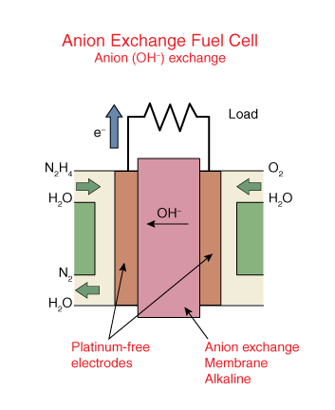

- Given the net cell reaction and the cathode half-reaction determine the anode half-reaction.

net reaction: N₂H₄(aq) + O₂(g) → N₂(g) + 2 H₂O(l)
cathode half-reaction: O₂(g) + 2 H₂O(l) + 4 e- → 4 OH⁻(aq)
Hint: Look at each species in the net reaction and consider which reaction it came from: cathode or anode. If it did not come from the given cathode reaction, it may have come from the anode reaction.
Answer (1 Mark)

- If the cell potential for the hydrazine fuel cell is 0.73 V, calculate the reduction potential for the half-cell involving hydrazine.

Answer (1 Mark)

- Identify an advantage of using a fuel cell over a primary or secondary cell.

Answer (1 Mark)

- Identify an advantage of using a fuel cell over combustion of fossil fuel.

Answer (1 Mark)

Perform the Virtual Investigation “Corrosion” in Module 6 Lesson 1.5 and use the results to answer Questions 15 – 22.

- For this Virtual Investigation, identify the manipulated variable, the responding variable, and two controlled variables.

Hint: Manipulated variables are conditions that are deliberately changed by the experimenter (what you are testing). Responding variables are conditions that change in response to the change in the manipulated variables (the data you collect). Controlled variables are conditions that are held constant to ensure an accurate comparison between trials.

Answer (3 Marks)
Manipulated Variable:

Responding variable:

Two Controlled Variables:
1)

2)

- In each test tube, look for evidence of corrosion. Record your observations in the following data table.

Answer (6 Marks)
Test  Tube | Conditions | Initial observations | Observations After 24 hr
1
2
3
4
5
6

- For test tubes 1-5, list the entities initially present. Also, identify the SOA and SRA and predict the spontaneity of the reaction. Test tube 1 has been completed for you as an example.

Answer (4 Marks)
Test tube | Entities present | SRA | SOA | Spontaneity
1 (Example) | Fe(s), H₂O(l), O₂(g) | Fe(s) | H₂O(l) + O₂(g) | Spontaneous
2
3
4
5

- Test tube 6 is the “experimental control”. What is the purpose of an experimental control?

Answer (1 Mark)

- Using the SOA and SRA identified in Question 17, write the oxidation and reduction half-reactions and the net reaction for Systems 2 and 4.

Answer (4 Marks)
System 2:

System 4:

- Explain why there was accelerated corrosion in test tube 3.

Answer (1 Mark)

- Explain why the nails did not corrode in test tubes 4 and 5.

Answer (2 Marks)

- Research! Provide a real world example of cathodic protection through the use of a sacrificial anode. Be sure to cite your sources.

Answer (1 Mark)

- You wish to set up an electrochemical cell that has a copper anode and an E⁰_{cell} value > 1.00 V. What should your cathode and cathode solution be? (More than one possible answer.)

Your response should include:

- Calculations used to determine a possible cathode
- Possible cathode and cathode solution.

Answer (2 Marks)

Lesson 2

- Identify if the following descriptions apply to voltaic cells, electrolytic cells, or both. Place the corresponding letter in the table identifying each descriptor:

- Voltaic
- Electrolytic
- Both

Answer (4 Marks)
Identification | Description
 | Converts electrical energy into chemical energy.
 | Cathode is positive.
 | Anions flow to the anode.
 | SOA reacts at the cathode.
 | Eº_{net} is negative.
 | Electrons flow from the anode to the cathode.
 | Anode is the site of oxidation.
 | Contains a power source.

Perform the Virtual Investigation “Electroplating Copper” in Module 6 Lesson 2.3 and use the results to answer Questions 25 – 27.

- Record observations in the following table.

Answer (2 Marks)
Data:
Initial Mass of C(s) electrode (g)
Final Mass of C(s) electrode (g)
Initial Mass of Cu(s) electrode (g)
Final Mass of Cu(s) electrode (g)

- Draw a labelled diagram of the apparatus that includes the anode, the cathode, the electrolyte, the direction of ion flow and the direction of electron flow provided by the power source.

Answer (4 Marks)

- Write and identify the half-reactions and net reaction.

Answer (3 Marks)
Cathode
Half-Reaction
Anode
Half-Reaction
Net Reaction

- Besides deposition of Cu(s), what other empirical observation is expected. Identify the electrode where this empirical evidence would be observed.

Answer (2 Marks)

Lesson 3
Use the following information to answer the next question.
Electroplating is a widely used process. Rhodium is sometimes plated onto less precious metal and sold as white gold. The plating of rhodium is simplified in the following half reaction.

Plating of Rhodium Rh³⁺(aq) + 3e⁻ Rh(s)

- The power supply used in commercial electroplating provides a vat with approximately 1.50 x 10³ A of current for 20.0 minutes. Calculate the mass of rhodium plated.

Answer (4 Marks)

