Science 30 Assignment 3.6.1 Electromagnetic Radiation
( 23 Marks)

(1 mark) | 1. | Which grouping lists the individual bands of the electromagnetic spectrum from high frequency to low frequency?  A. X-rays, gamma rays, radio waves, infrared  B. gamma rays, infrared, radio waves, X-rays  C. gamma rays, X-rays, infrared, radio waves  D. infrared, radio waves, gamma rays, X-rays

Answer:

(1 mark) | 2. | Which grouping lists the individual bands of the electromagnetic spectrum according to increasing wavelength?  A. radio waves, ultraviolet light, visible light, X-rays  B. radio waves, visible light, ultraviolet light, X-rays  C. X-rays, ultraviolet light, visible light, radio waves  D. visible light, ultraviolet light, radio waves, X-rays

Answer:

(1 mark) | 3. | Vancouver shortwave radio transmitter CKZU of the Canadian Broadcasting Corporation broadcasts at a frequency of 6160 kHz. What is the wavelength of the radio signal coming from this transmitter?  A. 24.4 km  B. 24.4 m  C. 48.7 km  D. 48.7 m

Answer:

(1 mark) | 4. | The following diagram shows several wavelengths of a beam of electromagnetic radiation.  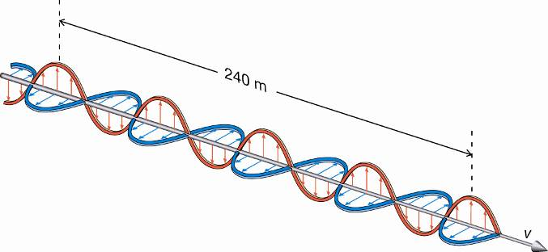  The wavelength of this electromagnetic radiation is  A. 120 m  B. 60 m  C. 40 m  D. 30 m
Answer:

(1 mark) | 5. | In 1969, Apollo 11 astronauts placed a special reflector on the Moon. This reflector sends light back in the direction from which it came, regardless of its angle of incidence. With the Moon about 384 000 km from Earth, how long would it take a light pulse sent from Earth to reach the lunar reflector and then return to Earth?  A. 1.28 s  B. 2.56 s  C. 3.85 s  D. 5.13 s
Answer:

(1 mark) | 6. | The chloroplasts within the leaves of green plants contain the pigment chlorophyl. This pigment provides energy for photosynthesis by absorbing the energy contained in the photons of  A. green light  B. red light  C. violet light  D. red light and violet light
Answer:

(1 mark) | 7. | What kind of electromagnetic radiation is responsible for sunburns?  A. UVA light  B. UVB light  C. visible light  D. infrared light

Answer:

(1 mark) | 8. | High-energy electrons collide against a metal surface to produce what kind of electromagnetic radiation?  A. visible light  B. gamma rays  C. shortwaves  D. X-rays

Answer:

(1 mark) | 9. | What form of electromagnetic radiation can most effectively penetrate human tissue?  A. visible light  B. microwaves  C. UV light  D. X-rays
Answer:

(1 mark) | 10. | Which form of electromagnetic radiation is most destructive to chemical bonds in living tissue?  A. gamma rays  B. UV rays  C. visible light  D. X-rays
Answer:

(3 marks) | 11. |  | Decide whether each statement is true (T) or false (F). Place your answer in the blank space given.
 |  |  |  |  | a. | Cosmic rays are part of the electromagnetic spectrum.
 |  |  |  |  | b. | Electromagnetic radiation is a beam of tiny particles with some mass moving at a high speed through space.
 |  |  |  |  | c. | Orange light is a type of electromagnetic radiation.
 |  |  |  |  | d. | UVC is a form of ionizing radiation.
 |  |  |  |  | e. | Visible light is a form of ionizing radiation.
 |  |  |  |  | f. | Infrared light has a greater wavelength than does red light.
(2 marks) |  | 12. | Match each description with the appropriate term listed. Place your answer in the blank space given.
 |  |  | i. | centimetre |  |  | ii. | frequency
 |  |  | iii. | hertz |  |  | iv. | wavelength
 |  |  |  |  | a. | a unit for frequency
 |  |  |  |  | b. | a unit for wavelength
 |  |  |  |  | c. | the distance required for one complete cycle
 |  |  |  |  | d. | the number of cycles per second

(2 marks) | 13. | A student was wondering why electromagnetic radiation can travel through the vacuum of outer space. The student had learned that sound cannot travel through this region. Explain why electromagnetic radiation can travel in outer space.

Answer:

 | 14. | In the investigation “Electromagnetic Radiation Transfers Energy,” the intensity of EMR in a spectrum of light was measured by a photovoltaic cell.
(1 mark) |  | a. Indicate which membrane of the eye serves a function similar to the photovoltaic cell used in the investigation. Explain your answer.

Answer:

(1 mark) |  | b. The photovoltaic cell was not only moved within the visible spectrum but also in the dark region just beyond the visible spectrum’s red end. The photovoltaic cell produced a current even in this dark region.  Explain why a current could be produced by the photovoltaic cell while it was in the dark region next to the red light.

Answer:

(3 marks) | 15. | A cellphone emits a radio signal with a frequency of 1910 MHz.  Determine its wavelength.

Answer:

(1 mark) | 16. | A student noticed that sunglasses rated for both UVA and UVB protection were not rated for UVC protection. However, the student learned that UVC radiation is far more damaging to body tissues than either UVA or UVB radiation.  Explain why UVC protection for anyone going outside—even on a sunny day—is much less important than UVA and UVB protection.

Answer:

