Name: ______________________________________ Date: ________________________

Student Exploration: Digestive System

Activity A:  Build a digestive system | Get the Gizmo ready:  - If necessary, click Clear screen. | 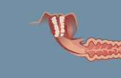

Goal: Design your own digestive system.

- Build: Now it is time to design and build your own digestive system! Start with the LARGE ORGANS tab to build a basic system, starting with the Mouth/pharynx. Next, attach organs from the SMALL ORGANS tab to the large organs to complete your system. Draw a picture of your system below. (If you like, open the Tools menu and click Screen shot. Right-click the image, choose Copy Image, and paste the image into a blank document.)

- Predict: How well do you think your system will digest food? Explain your reasoning.

_________________________________________________________________________

_________________________________________________________________________

_________________________________________________________________________

- Prepare: Select the FOOD tab. The energy we get from food is measured in food calories (Calories). Each Calorie is equal to 4,184 joules of energy. Calories are found in the three main nutrients in food: carbohydrates (sugars and starches), proteins, and fats.

Drag the Cheeseburger above the mouth in your digestive system. How many Calories in the cheeseburger come from carbohydrates, proteins, and fats?

Carbohydrate Calories: ________ Protein Calories: ________ Fat Calories: ________

- Run the Gizmo: Click Play (), and observe the food moving through the digestive system. The muscular contractions that push food through the system are called peristalsis. When food has finished passing through the system, you will see a message.

- What percentage of Calories were absorbed by your system? ________

- What percentage of water was absorbed? ________

- Based on these results, how well do you think this digestive system worked? Explain.

___________________________________________________________________

___________________________________________________________________

___________________________________________________________________

- Revise: Click Reset (). Rearrange the organs of your system to try to improve your results. Describe how you changed your system below.

_________________________________________________________________________

_________________________________________________________________________

_________________________________________________________________________

- Test: Click Play or Fastplay (). List the results below. Did the system improve? ________

Percentage of Calories absorbed: ________ Percentage of water absorbed: ________

- Explain: If your system improved, why do you think this was so? ______________________

_________________________________________________________________________

_________________________________________________________________________

Activity B: | Get the Gizmo ready:  - Click Reset and Clear screen. | 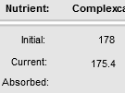

Introduction: Digesting nutrients into simple carbohydrates, amino acids, and fatty acids is important, but it doesn’t matter unless the nutrients get into the bloodstream to feed body cells. This process is called absorption.

Question: How are nutrients absorbed?

- Observe: Look through the descriptions of the large and small organs.

- Which of the large organs allow nutrients and water to pass through their walls?

___________________________________________________________________

- Which of the small organs transport absorbed nutrients to the bloodstream?

___________________________________________________________________

- Set up the Gizmo: Create the digestive system shown. The small intestine has three parts: the duodenum (attached to the stomach), the jejunum (the middle portion), and the ilium (attached to the large intestine). Drag the Pecan pie to the mouth.

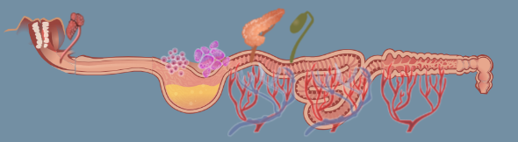

Test each of the scenarios below by removing one or more components from the above setup. For each setup, record the nutrients that are absorbed by the system. (Be sure to look at the “Absorbed” row of the Analysis table.)

Scenario | Sugars | Amino acids | Fatty acids | Water
Remove two sets of capillaries from the small intestine
Remove all lymphatic vessels
Remove one set of capillaries from the large intestine

- Analyze: Examine the results of your four experiments.

- Which nutrients were absorbed by capillaries in the small intestine? _____________

___________________________________________________________________

- Which nutrients were absorbed by capillaries in the large intestine? _____________

___________________________________________________________________

Bacteria in the large intestine break down some types of fiber—a difficult to digest complex carbohydrate—into sugars that are absorbed in the large intestine.

- Which nutrient was absorbed by small intestine lymphatic vessels? ______________

- Did lymphatic vessels absorb anything from the large intestine? ________________

- Draw conclusions: Based on your experiments, where should the capillaries and lymphatic vessels be placed to maximize the absorption of nutrients from food?

Capillaries: ________________________________________________________________

Lymphatic vessels: _________________________________________________________

Activity C:  Optional Review | Get the Gizmo ready:  - Click Reset and Clear screen. | 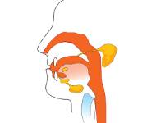

Introduction: Now that you have explored a model of human digestion, it is time to apply what you have learned to the real human digestive system.

Goal: Describe the human digestive system.

- Label: Based on what you have learned, identify the organs of the human digestive system.

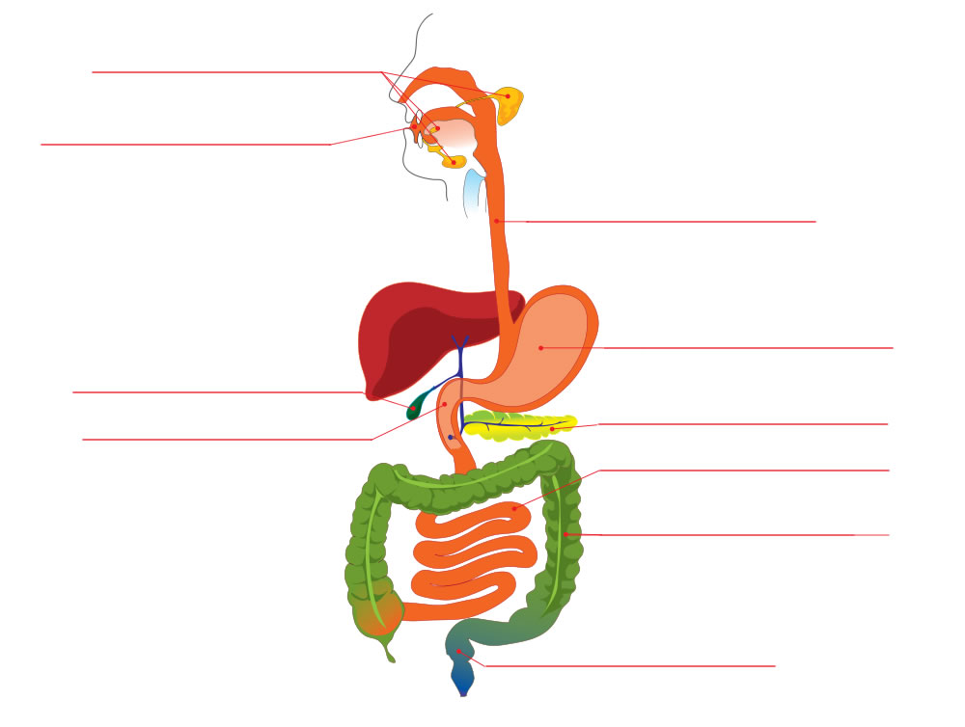

- Think and discuss: Why is it important that the mouth and stomach are near the start of the digestive system? __________________________________________________________
_________________________________________________________________________

- Match: Match each structure, chemical, or process to its function.

_____ Amylase A. Upper section of the small intestine

_____ Peristalsis B. Muscular tube connecting the throat and stomach

_____ Duodenum C. Organ that produces a variety of digestive enzymes

_____ Lymphatic vessel D. Chemical that breaks up large fat droplets

_____ Anus E. Muscular contractions that push food through the digestive system

_____ Large intestine F. Enzyme that starts to digest proteins in the stomach

_____ Esophagus G. Opening through which wastes are eliminated

_____ Pepsin H. Produces hydrochloric acid in the stomach

_____ Pancreas I. Transports absorbed fatty acids to the bloodstream

_____ Parietal cell J. Organ that absorbs water and vitamin K

_____ Bile K. Enzyme that breaks down starches into simple carbohydrates

