AGR 3000: Agriculture Safety
Assignment 2
MARKS:

Chart | /50 | /50
Comments
TOTAL | /100 | %

Directions: 2 marks each
Complete the following fire, flood, power outage safety plan. Enter information between the < > and complete all areas to the best of your ability.

FIRE, FLOOD, POWER OUTAGE SAFETY PLAN

 | 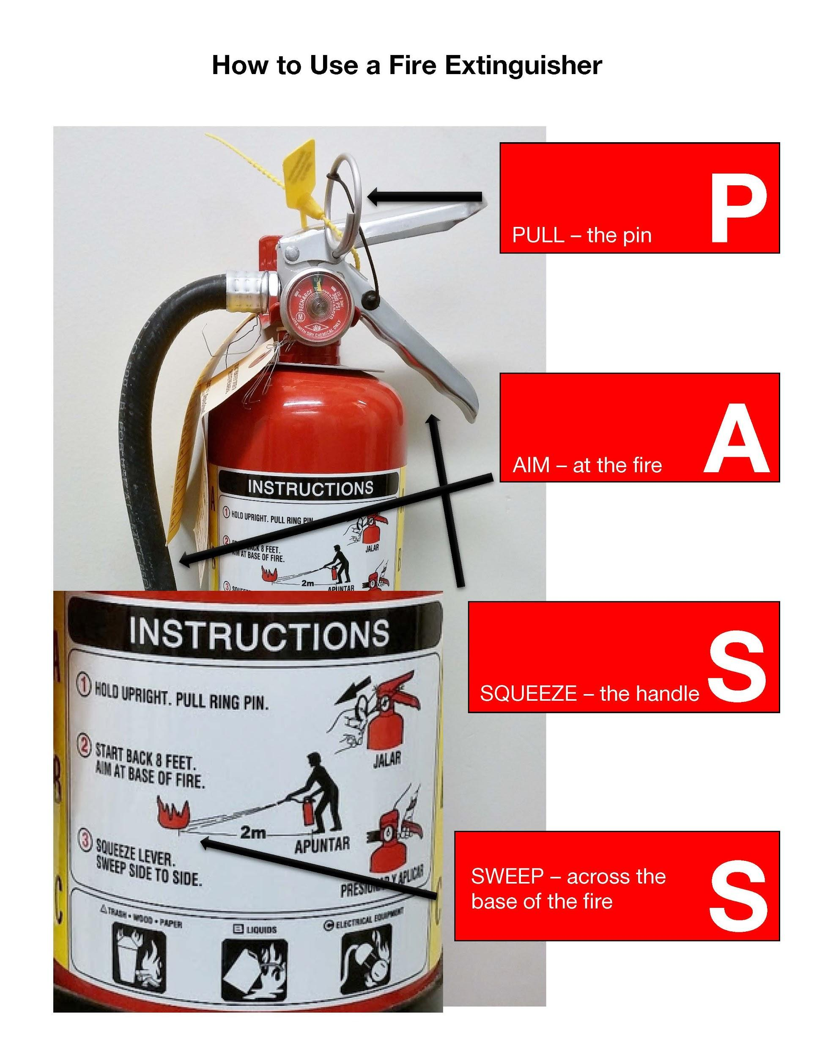 | 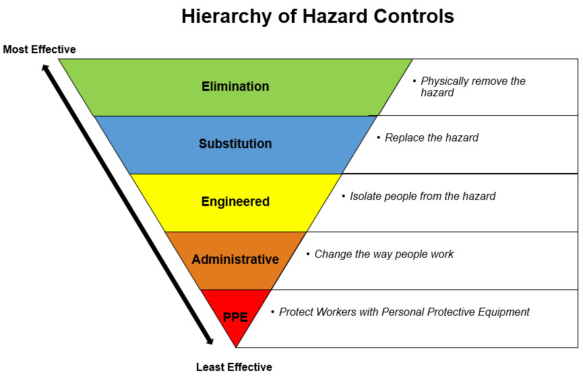

Emergency | Emergency Response  (steps to respond) | Equipment
Worker Injury  (Example) | - If CRITICAL CALL 911 IMMEDIATELY  - Ensure worker is in safe place and out of danger  - Assess imminent danger; injury; resources  - Locate designated farm First Aider  - Administer First Aid | Phone  First Aid Kit
Fire | < > | < >
Flooding | < > | < >
Prolonged Power Interruption | < > | < >

7.2
EMERGENCY CONTACT LIST
AGENCY | PHONE NUMBER | AGENCY | PHONE NUMBER
Police/RCMP | < > | Veterinarian | < >
Ambulance | < > | Power Company | < >
Hospital | < > | Telephone Company | < >
Doctor | < > | Gas Company | < >
Poison Control Center | 1-800-332-1414 | Alberta 24-Hour Environmental Hotline | 1-800-222-6514
Alberta Health Link | 1-866-408-5465 | Neighbor 1 < > | < >
Occupational Health and Safety (OHS) | 1-866-415-8690 | Neighbor 2 < > | < >

LOCATIONS AND TYPES OF EMERGENCY WATER SUPPLIES
(e.g., hydrants, ponds, watercourses, wells, etc.)
Type of Water Source | Location of Water Source
< > | < >

Asset Protection Plan
From the Farmstead Site Map, in order of priority, indicate any buildings or areas where livestock or other assets need to be removed or protected.
Asset to be Protected | Location from/to Safe Location
Home occupants- # < > | Home to Meeting Place
Cattle - # < > | < >
Pets - # < > | < >

