## How to Submit Work from Google Drive

This document will work through the student submission process when working in Google Drive. Although this document uses a Google Doc for the example, the steps apply the same for Slides, Sheets, Pics, etc, but an separate instruction is created for video.

The document will break into the following trees as it works through the process, depending on the student’s situation:

How to Submit Work from Google Drive 1

**Submitting the GDrive Document as a Link** **2**

**Submitting as a File on a PC or Mac** **7**

**Submitting as a File on a Chromebook** **9**

**Sharing Video Files in GDrive** **13**

# Submitting the GDrive Document as a Link

This option will work no matter what device you’re working on, be it PC, Mac, or Chromebook.

Submitting a link to your work in GDrive seems the easiest way to submit work, but there are two key things that permit this:

1. The document must be shared in a way that ADLC teachers and markers can access it.
2. There must be a text entry box for the student to submit the link.

To check to see if a link can be submitted, go to the assignment page in Moodle. If the submission window has an ‘Online Text’ window, then a link can be used to submit work.

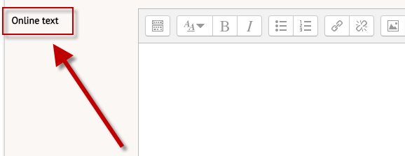

If the submission window has ONLY a file upload, then a file submission must be used.

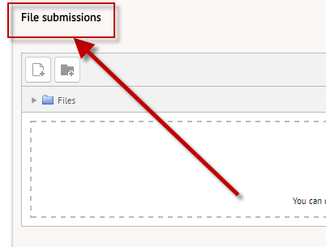

Provided the online text entry is an option, a Google Drive link can be shared.

Then your work is in a Google Drive document (or Sheets, Slides, etc). In the document, locate the ‘Share’ option in the top, right corner.



Clicking ‘Share’ will open the share-settings window.

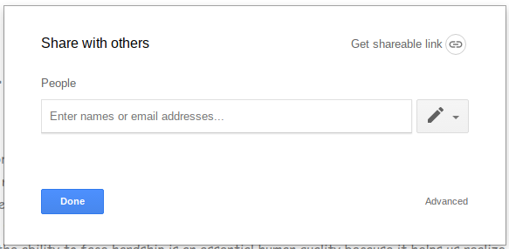

If you share the document with your teacher, the teacher alone can grade the work. Because of the involvement of markers, secondary teachers, subs, etc, a wider share option is required.

To open up more broad sharing, click ‘Get sharable link’ in the top right of the share settings window.

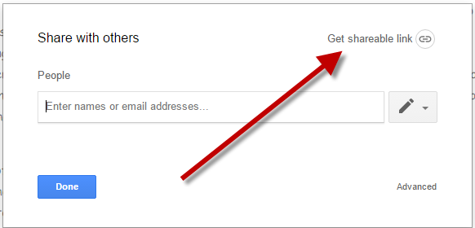

Click the pull down option, and click ‘More’ at the bottom of the list. Note that your school division will be listed instead of Pembina Hills.

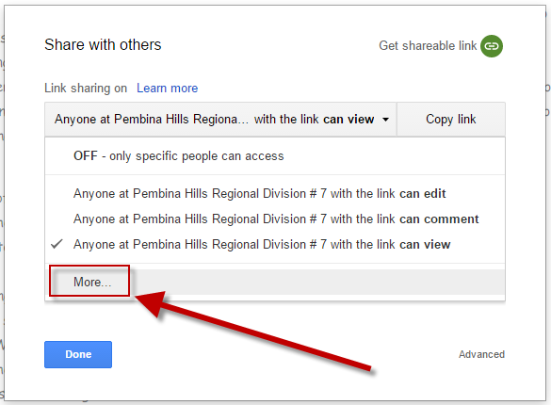

Under the ‘More’ option, choose “Anyone who has the link”

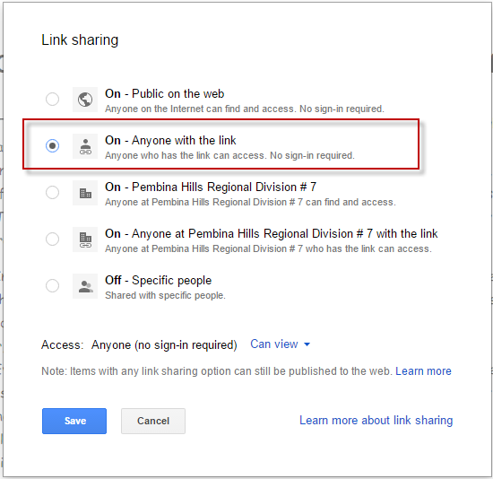

***Note that if you don’t have the ‘More’ option, or don’t have the ‘Anyone with the link’ option, you must submit as a file - link submission will not work.***

Click ‘Save’ at the bottom. This will return to the first share settings window, with the new settings in place. Note that sharing is now ‘Anyone with the link can view.’

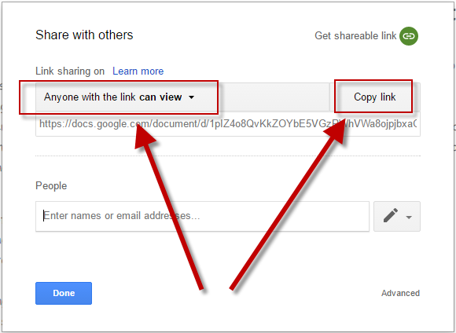

With sharing set up, click the ‘copy link’ button.

Back on the assignment submission page in Moodle, paste the link into the ‘Online text’ window.

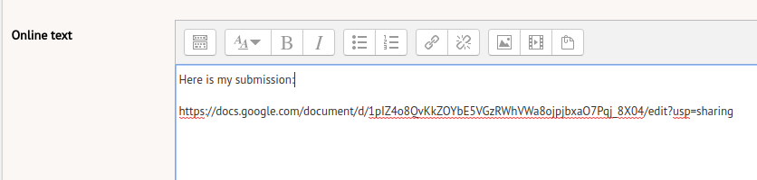

Click ‘Save changes’ on the assignment page, and continue with the submission steps in Moodle.

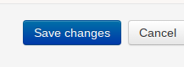

# Submitting as a File on a PC or Mac

Google Drive files live in the cloud and do not have a copy resident on the computer in order to submit in Moodle. In order to submit as a file attachment, the GDrive document needs to be exported.

In Google Drive, in the document to be submitted, click under ‘File’ in the top left corner.

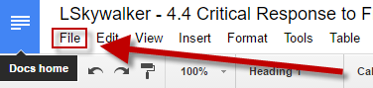

This will open the file menu. Choose ‘Download as’ and then ‘PDF Document’ or ‘Microsoft Word)’. For ‘Slides’ presentation, download as ‘Microsoft PowerPoint’. For ‘Sheets’ documents, select ‘Microsoft Excel’.

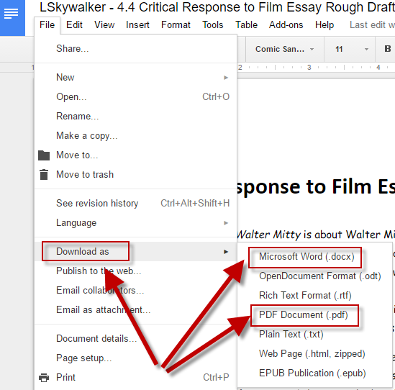

This will export the Google Document as a PDF or MSWord, depending on which you choose. Please check your assignment instructions or ask your teacher for which to choose. It may include a ‘Save As’ opportunity. Remember where it is saved!

Back in Moodle, on the assignment submission page, click the File submission box.

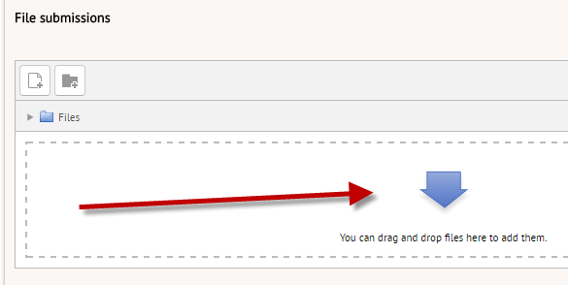

This will bring up the ‘File picker’. Choose the ‘Upload a file’ option.

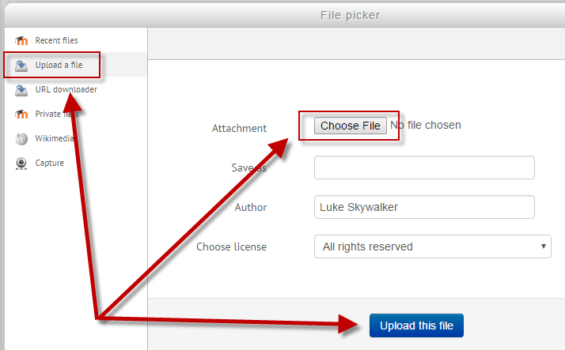

Click the Choose File, find the document exported from the computer, and ‘upload this file’. Submit the assignment.

# Submitting as a File on a Chromebook

Google Drive files live in the cloud and do not have a copy resident on the computer in order to submit in Moodle. In order to submit as a file attachment, the GDrive document needs to be exported.

In Google Drive, in the document to be submitted, click under “File” in the top left corner.



This will open the file menu. Choose ‘Download as’ and then ‘PDF Document’ or ‘Microsoft Word’. For ‘Sheets’ documents, select ‘Microsoft Excel’.



This will export the Google Document as a PDF or MSWord, depending on which you choose. Please check your assignment instructions or ask your teacher for which to choose.

When exported, it will show a notification in the lower right window.

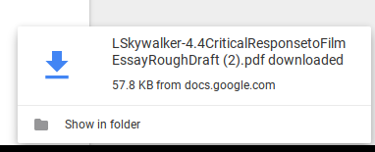

This notification will disappear quickly. Before it goes, click the ‘show in folder’ link at the bottom. If it disappears, the folder is accessible by clicking the circle in the bottom, left corner.



Clicking this circle will pull up available apps on the Chromebook.

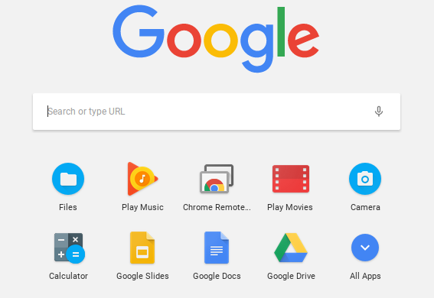

Find the ‘Files’ icon. If it doesn’t appear on the first page, click ‘All Apps’ which will be the last icon in the list.

Clicking the ‘Files’ icon will open the folder to access files on the Chromebook, as well as Google Drive.

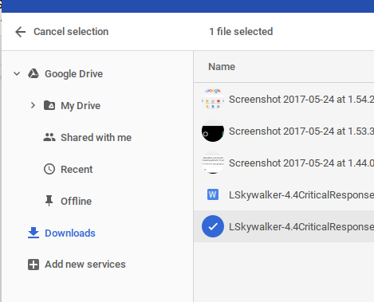

Be sure to look for the file in the ‘Downloads’ folder. Here, find the exported file.

Back in Moodle, on the assignment submission page, drag and drop the file into the submission box, or click the ‘File submission’ box to use the file picker.



A click on the arrow will bring up the ‘File picker’. Choose the ‘Upload a file’ option.



Click the Choose File, locate the document exported from the computer, and ‘upload this file’. Submit the assignment.

# Sharing Video Files in GDrive

This option will work no matter what device the student is working on, be it PC, Mac, or Chromebook.

Submitting a link to a student-generated video in GDrive seems the easiest way to submit work, but there are two key things that permit this:

1. The video must be shared in a way that ADLC teachers and markers can access it.
2. There must be a text entry box for the student to submit the link.

To check to see if a link can be submitted, go to the assignment page in Moodle. If the submission window has an ‘Online Text’ window, then a link can be used to submit work.



If the submission window has ONLY a file upload, then a file submission must be used.



Provided the online text entry is an option, a Google Drive link can be shared.

The student video is in a Google Drive. On the GDrive folder page, identify the video to be shared and single-click to highlight it.

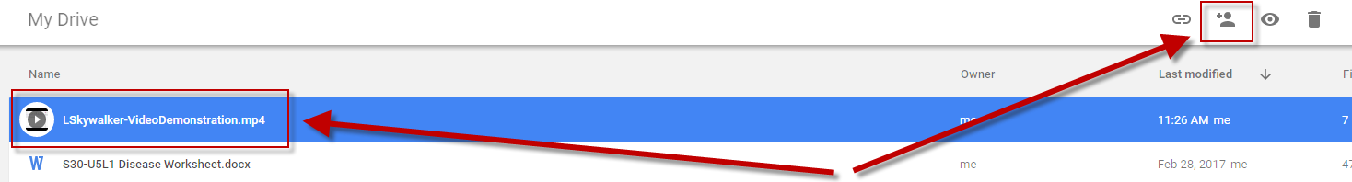

With the video file highlighted, click the ‘Share’ icon  in the top right corner of the window.



If you share the document with your teacher, the teacher alone can grade the work. Because of the involvement of markers, secondary teachers, subs, etc, a wider share option is required.

To open up more broad sharing, click ‘Get sharable link’ in the top right of the share settings window.



Click the pull down option, and click ‘More’ at the bottom of the list. Note that your school division will be listed instead of Pembina Hills.



Under the ‘More’ option, choose “Anyone who has the link”



***Note that if you don’t have the ‘More’ option, or don’t have the ‘Anyone with the link’ option, you must submit as a file - link submission will not work.***

Click ‘Save’ at the bottom. This will return to the first share settings window, with the new settings in place. Note that sharing is now ‘Anyone with the link can view.’



With sharing set up, click the ‘copy link’ button.

Back on the assignment submission page in Moodle, paste the link into the ‘Online text’ window.



Click ‘Save changes’ on the assignment page, and continue with the course work.

