**Studying Film Tutorial Notes**

**Fill** in the blanks or **record** definitions in the space provided. **Check** your answers at the end of this handout.

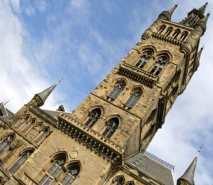**1. Camera angle:** refers to the position of the camera with respect to what’s being viewed (the subject).

Canted angle

a. _____ angle: the camera is above the subject. This angle can make the subject look smaller or powerless

b. _____ angle: the camera is below the subject. This angle can make the subject look strong and powerful.

©2010 Thinkstock

c. _______ ____: the camera is at a neutral level. This shot is most comfortable for viewers, as it mirrors how we typically look at our world.

d. _______ angle: the camera is tilted at an angle. The subject appears slanted in the frame of the shot. This can create uncertainty or uneasiness in the viewer, as if something is ‘not quite right’.

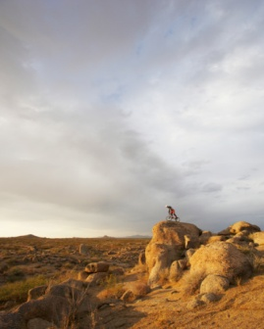 **2. Focus:** what the camera centers on

Extreme long shot

a. Close Up: _______________

b. Extreme Close Up: _____________

c. Medium: You don’t see the subject’s entire body, but you don’t need to either.

©2010 Thinkstock

d. _______ Shot: You see the subject’s entire body, including the surroundings.

e. _______ ______ Shot: These shots are used to show a sense of vastness of surroundings.

Side Lighting

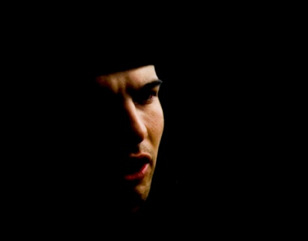**3. Lighting:**

Consider how the following lighting choices can contribute to the mood of a shot.

©2010 Thinkstock

|  |  |
| --- | --- |
| a. Natural: | e. Top: |
| b. Artificial: | f. Back: |
| c. Bright: | g. Side: *can show a character who feels divided or torn between to choices* |
| d. Soft: *can show tenderness* | h. Under: *can be spooky* |

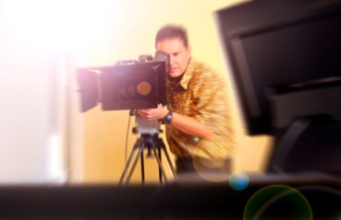**4. Sequence:**

a. ________: action filmed in one continuous take, with no disruptions

b. ________: the conclusion of the shot

©2010 Thinkstock

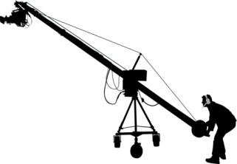**5. Camera Movement:**

©2010 Thinkstock

a. ________: the visual elements around the actor

b. ________: how the actor is positioned in relation to the camera and his surroundings

c. ________: the camera follows the actor

d. ________: the camera scans horizontally, from left to right

e. ________: the camera tilts up or down

**6. Scene:**

a. _________: the time, place, shooting location

b. _________: a progression of related scenes

c. _________: arrangement or display of scenery,

backdrop, or landscape

d. _________: the narrative or sequences of events that make up the story

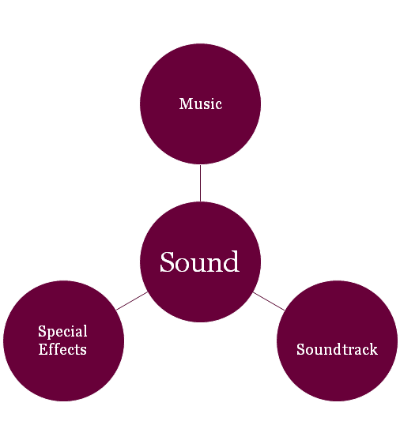

**7. Sound:**

a. _______________: can set the mood for the scene

b. ________: popular music embedded within the film

c. _________ _________: using technology to bring sound into the film.

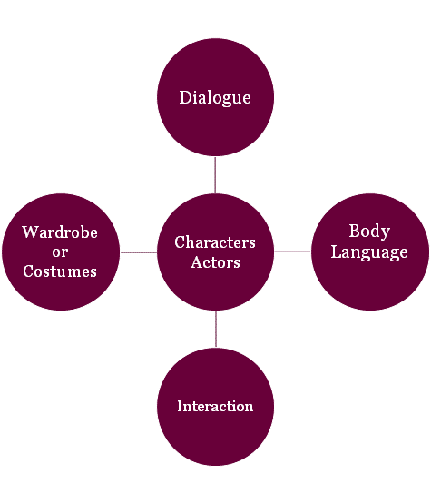

**8. Characters and Actors**

a. ___________: words spoken by the actors

b. _____ _________: nonverbal cues (facial expressions, eye contact, posture)

c. ___________: how the characters work together or conflict with one another

d. ___________: what characters wear, carefully chosen to reveal more about the character

**Answers to the Study Notes:**

***1. a. High***

***b. Low***

***c. Straight On (Medium)***

***d. Canted***

***2. a. the subject occupies most of the frame***

***b. the subject occupies the entire frame***

***d. Long***

***e. Extreme long***

***3. a. warm glow, emphasize reality, usually the sunlight***

***b. sets a scene, has lighting that exists outside of nature, emphasizes something***

***in particular***

***c. reveals vivid or intense details, cheerful, happy***

***e. showcases or highlights the object or subject like they are on stage or under***

***a spotlight; all eyes are on them***

***f. emphasizes the shape or silhouette rather than the individual person***

***4. a. shot***

***b. cut***

***5. a. framing***

***b. blocking***

***c. tracking***

***d. panning***

***e. booming***

***6. a. Setting***

***b. Sequence***

***c. Sets***

***d. Plot***

***7. a. Music***

***b. Soundtrack***

***c. Special effects***

***8. a. Dialogue***

***b. Body language***

***c. Interaction***

***d. Wardrobe***