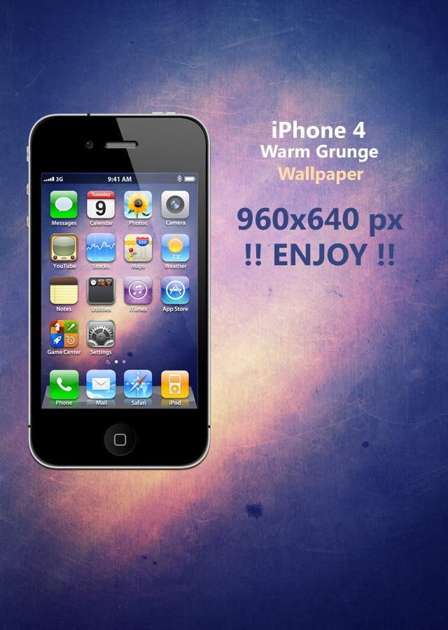
Whose Phone is This?

Quick Check
Before you submit your assignment, do a quick check:
- Did I name my work as directed in the assignment?
- Did I complete all of the steps in the assignment?
- Did I double-check and revise my completed assignment for spelling, grammar, mechanical (capitalization, apostrophes, etc.) errors?
- Did I properly format my response for the type of assignment?
- Did I use the appropriate point of view for the format?
- Did I do the bare minimum or go above and beyond?
- Can I proudly say this is my best effort?

Choose one of the characters and complete the three steps to show what would be on this person’s cell phone. Be sure your answers are written in complete sentences.
Connect to the character not the plot events. Complete the phone template based on the character and who they are now as a result of the events and conflict and what they learned along the way.

Provide a written rationale which includes details and explanations which answer How? and Why? each element connects to the character as a person.

- Wallpaper – Sketch the character’s cell phone wallpaper with colored pencils. Provide a written rationale which includes details and explanations which answer How? and Why? the wallpaper connects to the character as a person.

- Email – This character just received two messages. Thinking back over the reading, explain which other characters just sent messages to this character and include the content of each message.

- Playlist – Write three song titles with artists’ names that would likely be on this character’s playlist. Provide a written rationale which includes details and explanations which answer How? and Why? each element connects to the character as a person.

