**ELA 10-2 Unit 1 Section 1 - Short Story Short Notes**

**Reading Strategies**

After reading the “Reading Strategies” pages, enter the following short notes that you might use to assist you with a better understanding of a literary piece or text:

1. List two pre-reading strategies you might use:

A.

B.

1. List three strategies you may use during or after your reading:

A.

B.

C.

_____________________________________________________________________________________________

**Paragraph Format**

**Define Paragraph:**

List the 3 parts of the paragraph in order, and for each short note (only key words or phrases) the key information.

1)

2)

3)

Define Unity:

**Define Order:**

1. Logical Order:

2. Spatial Order:

3. Time Order:

Define Coherence:

Once you have mastered the creation of well structured paragraphs, you will need to learn to transition from one paragraph to the next to create coherence and “flow” for the reader.

**What is a transition between paragraphs?**

A good transition between paragraphs is a good transition only because it does two things: first, it reminds the reader of what they’ve just read, and second, it gives them a good sense of what they’re going to read next, and why they will be reading it.

**_____________________________________________________________________________________________**

**Reading for Theme in Any Text:**

**All texts have themes (larger messages for the audience). Please review the information on this image on the next page, and refer to it when you are asked to address the theme of a piece. You will be provided with a more in depth study of theme later in your course.**

**Theme**

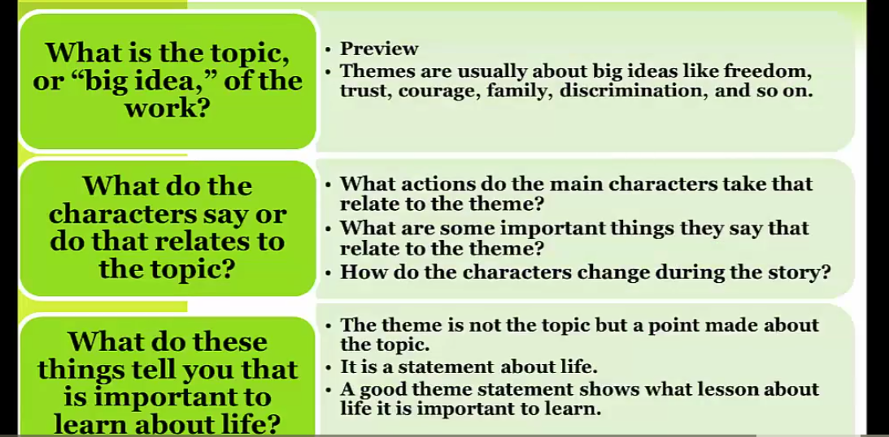

**Define Short Story:**

**Describe the major elements of the short story below.**

1. **Characters are presented in two ways. (from video)**

1) Directly:

2) Indirectly:

**Protagonist-**

**Antagonist-**

**Character Types**

Flat -

Round -

Stock -

Static -

Developing or Dynamic -

**Questions to Consider About Character When You Read**

Do you identify with any of the characters more than others? Why?

Do some/all of the characters remind you of people you know?

Review p. 55 of *Reading and Writing for Success* to see a list of suggested character

traits. Do not use vague words, such nice, kind, mean, etc., when asked to give a

character trait (personality trait).

1. **Setting (Give the information found in the setting):**

**Questions to Consider About Setting When You Read**

What do you learn about the place?

Are the characters in conflict with the setting or environment?

What do we learn about the characters through setting? (rich/poor, position in society,

emotional state)

How does the story contribute to the atmosphere or mood of the story?

1. **Conflict**

The two main categorizations are given for you, but you fill in the types from the video.

Please note that the modern term for the types of conflict is now “person” and not “man.”

**Internal**

Type 1:

**External**

Type 1:

Type 2:

1. **Point of View**

Using the video, describe the 3 different points of view.

First Person:

Omniscient:

Limited Omniscient:

1. **Plot** 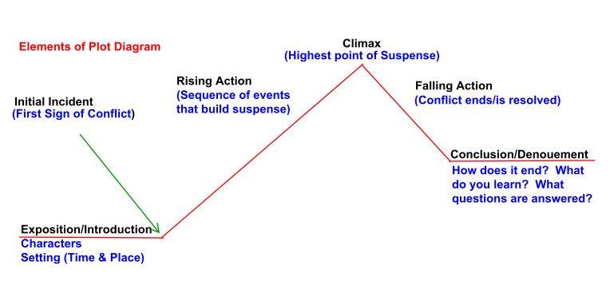
2. **Suspense: (describe)**
3. **Theme** (Review p.2 of these notes for more information about identifying theme)

Please note that while readers may choose different themes for the same text, the real theme is purposefully embedded within a piece. While there is often more than one theme in a piece, one or two particular themes will usually be more strongly supported or all inclusive.

Definition of Theme:

A theme must be completed in a ___________________ and is not just a __________.

**Other Short Story Terms:**

* Antecedent action -
* Foreshadowing -
* Symbol -
* Flashback -
* Character foil -
* Endings
  + Surprise -
  + Indeterminate -

**Use a dictionary to define:**

* + Comedy -
  + Tragedy-

**Within your work, you will be asked to provide supporting quotes from a text. All quotes must be in quotation marks, with the page # in brackets behind the quote.**

You may wish to use this shortcut method to quotes at times.

**Ellipsis - the use of three dots (...) to replace words you choose to omit**

**Example:**

**Question:** What is the weather like?

**Text:** The road was slippery with ice, as the freezing rain had fallen during the night, while we slept. (*Notice the question asks about the **weather only**, and not the road conditions or when it occurred.)

**Answer:** "...as the freezing rain had fallen...." (You need to only include the information that will address the given question. The three dots, or ellipsis, replace words left out and if you use it at the end of a sentence you need four dots to show it goes to the very end.)

If you are not sure you are understanding how to use ellipsis, you may write the quotation out in full, of course.