1.4 Elements of Plot Diagram Assignment

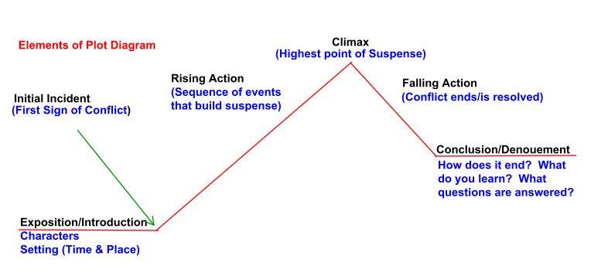

**Initial Incident** - may also be known as motivation (what motivates the character to oppose the antagonist)

**Rising Action** - may also be known as **complications** that build suspense

Reviewing “**Lather and Nothing Else” (p. 342)**, identify the elements of plot in the form below. You must give the best quote you can find to prove that what you say is true (evidence). A handy shortcut tool to use when you are quoting to prove specific information is the use of ellipsis. (See your short notes.)

**I suggest you start by identifying the climax before considering the rising action. This will help to ensure you do not “go beyond” the climax by accident, as this is easily done, and is a common error.**

**/18 Marks**

**1. Introduction/Exposition /4**

**What is going on in the beginning of the story?**

Characters:

Setting (Time and Place):

Quote to Prove Setting:

1.

**2. Initial Incident /2**

**When do you realize there is conflict or a problem?**

Quote to Prove:

1.

**3. Rising Action /3**

**(Give three significant/relevant quotes to prove the conflict/suspense is escalating.)**

1.

2.

3.

**4. Climax (**the highest point of suspense**): /2**

**What is the absolute highest point of suspense when you still wonder if the Captain**

**will be killed?**

Quote to Prove:

1.

**5. Falling Action /2**

**How is the conflict resolved or ended?**

Quote to Prove:

1.

**6. Conclusion/Denouement (final story wrap-up) /2**

**What do you learn at the very end of this story?**

Quote to Prove:

1.

**7. What is the theme of this short story? (What is the message for people beyond the**

**text, itself?) Remember this must be only one sentence that sums up the main**

**message, so choose your words very carefully, and make sure they are meaningful. /2**

**8. We make an inference when we draw a conclusion from what we have learned.**

**What inference can you make about the Captain’s true feelings about the barber**

**after you learn his thoughts at the very end of the story? /1**