3.3 Rhythm and Rhyme

“Annabel Lee” (Edgar Allan Poe) /15

**Refer to your Poetry Short Notes to Complete this Work.**

Edgar Allan Poe - “Annabel Lee”

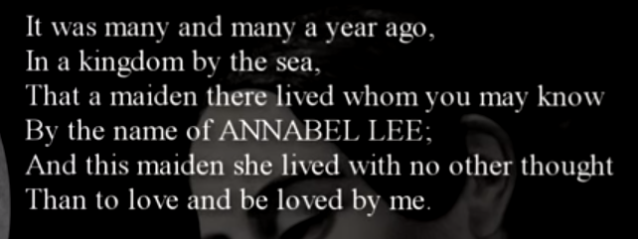

1. Give the rhyme scheme of this stanza of the poem (use capital letters for rhyme scheme). **/1**
2. Syllables are the division of words where each unit will have a single vowel. When you look a word up in the dictionary, you will see the syllable breaks. A simple way to count syllables is to read/say a word slowly and count the syllables on your fingers as you read.

Examples: Read (1 syllable)

Read--ing (2 syllables)

To-day(2), I (1) will(1) be (1) read-ing (2) and (1) writ-ing(2). = 10 syllables in this line.

Count the syllables for each of the first six lines of this poem and place the number for each line beside the given line number.

**/2**

(l)

(2)

(3)

(4)

(5)

(6)

After looking for line length patterns, make a general statement about Poe’s chosen line lengths and explain his purpose for this. **/2**

1. Visit this webpage link to learn about ["Edgar Allan Poe's Love Life](https://poeinterest.wordpress.com/edgar-allan-poes-love-life/). After reading this information, review the video again. In a well written paragraph with topic, supporting, and closing sentences, discuss how a text creator’s real life might be reflected in their work. Use Poe and his famous poem “Annabel Lee” as supporting evidence. Review the scoring rubric on the next page so you know the paragraph expectations.

|  |
| --- |
| Paragraph Rubric |

|  |  |
| --- | --- |
| Excellent | * Topic sentence **addresses the given topic with confidence** * You have included at least 3 significant supporting sentences * Your closing sentence is purposeful and effective * Sentence structure, word choice, and mechanics are excellent |
| Proficient | * Topic sentence **addresses the given topic competently** * You have included at least 3 relevant supporting sentences * Your closing sentence is purposeful * Sentence structure, word choice, and mechanics are almost error free |
| Satisfactory | * Topic sentence **addresses the given topic**, but could be more specific * You have included at least 3 supporting sentences * Your closing sentence is present, but could be more effective * Sentence structure, word choice, and mechanics have errors but the communication is basically clear |
| Limited | * Topic sentence **does not address the given topic specifically** * You have included fewer than 3 supporting sentences * Your closing sentence does not sum up the paragraph * Sentence structure, word choice, and mechanics have too many errors |
| Redo | Please contact your teacher for discussion before you attempt this  assignment again. No mark can be given for this work at this time. |
|  | **/10** |
|  | Teacher Comments: |

If you want to learn more “cool” information about Poe, visit the entire website!

[Edgar Allan Poe](https://poeinterest.wordpress.com/edgar-allan-poes-writing-style/) .