Observations of The Shape of a Girl
“Looks Like, Sounds Like, Feels Like”
Observations of
The Shape of a Girl: Braidie, 10 years old (p. 34)
 | Looks like… | 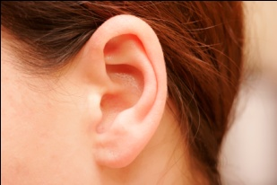Sounds like… | 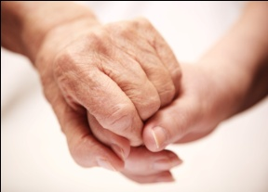Feels like…
Setting:

place and time where events take place
Character:

relationships
with other characters in the play

Tone:

the feeling or emotions that the author conveys

Observations of The Shape of a Girl
“Looks Like, Sounds Like, Feels Like”
Observations of
The Shape of a Girl: Braidie, 12 years old (p. 40, 44, or 47)
 | Looks like… | Sounds like… | Feels like…
Setting:

place and time where events take place
Character:

relationships
with other characters in the play

Tone:

the feeling or emotions that the author conveys

Observations of The Shape of a Girl
“Looks Like, Sounds Like, Feels Like”
Observations of
The Shape of a Girl: Braidie, 14 years old (p. 51)
 | Looks like… | Sounds like… | Feels like…
Setting:

place and time where events take place
Character:

relationships
with other characters in the play

Tone:

the feeling or emotions that the author conveys

Observations of The Shape of a Girl
“Looks Like, Sounds Like, Feels Like”
Observations of
The Shape of a Girl: Braidie as a teenager (throughout the play)
 | Looks like… | Sounds like… | Feels like…
Setting:

place and time where events take place
Character:

relationships
with other characters in the play

Tone:

the feeling or emotions that the author conveys

