horizontal line

The Thrifty Bean

**BUSINESS PLAN**

# OVERVIEW

I would be the CEO and Founder of The Thrifty Bean. The Thrifty Bean would be a small used items and consignment store which would offer an affordable, eclectic shopping experience. We would sell a large variety of items ranging from records and books to clothes and collectibles. We would also offer a drop off site where people could donate items they no longer used to The Thrifty Bean to help and find these neglected treasures a new loving home.

# EMPLOYEES

1. Floor Manager

The Floor Manager of The Thrifty Bean would be a part time employee making minimum wage ($13/hour for those under the age of majority, $15/hour for those at or above the age of majority) with the potential to increase with seniority and good work habits.

1. Junior Sales Executive

The Junior Sales Executive position would be a casual (summer) employment opportunity for one or two of the students in town. They would be paid student wage, $13/hour.

# LOCATION

The Thrifty Bean would be based out of a leased space on Centre Avenue in Black Diamond (126 Centre Avenue, Black Diamond, AB, T0L 0H0). This location is ideal for The Thrifty Bean because it is on a street that sees a great deal of traffic, especially during the summer. Those who pass through the quaint town of Black Diamond frequently stop to browse the shops lining the busy street. By this logic, a space on Centre Avenue would provide the greatest flow of customers to The Thrifty Bean.

# BUSINESS MODEL

## Sole Proprietorship

Ideally, The Thrifty Bean would be a sole proprietorship where I would be in complete control of the business and its capital. The sole proprietor model of a business does have many possible disadvantages however, the uniqueness of The Thrifty Bean would allow me to conquer most of these with relative ease. For example, as a small town resident, I already have the respect of many people around town and great people skills. The combination of these two factors provide me with some of the necessary skills to operate a small business in a small town. Secondly, the start up costs of The Thrifty Bean are significantly lower than most businesses because we sell consignment. Lastly, should The Thrifty Bean fail, I would very much like to take responsibility for it (in accordance with Canadian Small Business Law) as it is my business. Overall, when considering that most of the risks of a sole proprietorship would most likely have little effect on The Thrifty Bean I see no reason to share my business or my responsibility.

## Partnership

A partnership would be my second choice for a business model for The Thrifty Bean because the combining of my capital with someone else’s in a firm could help to offset the costs of the business and keep me out of debt if something were to go wrong. Unfortunately, a partnership would not be my preferred pick as The Thrifty Bean would be indebted to my partner (in accordance with Canadian Small Business Law) if they were to get the business out of a sticky situation. I would also prefer not to jointly manage The Thrifty Bean and in a partnership any and all partners may assist with the management of the business if they felt so inclined. Overall, a partnership would not be the right choice for The Thrifty Bean mainly due to the sharing of responsibility.

The only source I used was course material.

Sample Advertisement on the next page.

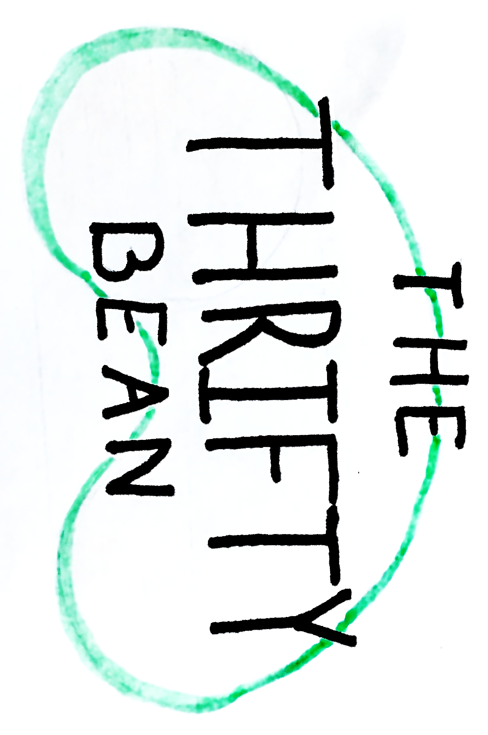

A unique shopping experience in downtown Black Diamond.

Come on by and check us out!

Open 10am-5pm Monday through Saturday

Contact Information: 1-800-5555-55555

[Thriftybean@gmail.com](mailto:Thriftybean@gmail.com)