**M10 Doing Assignments**

Last Updated: January 9, 2016

At some point, you may have to submit an assignment in your course.

In the Table of Contents, an assignment has a distinctive icon.



The best advice for assignments is to carefully read instructions. Instructions may include examples, requirements, tips, and even rubrics that explain exactly how your assignment is going to be marked.

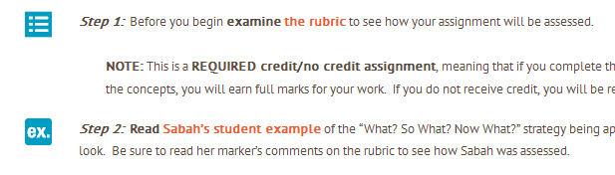

At the bottom of the assignment page is the Submission status. Here you will find many bits of useful information, including the attempt number, grading status, and a place where you can add comments.

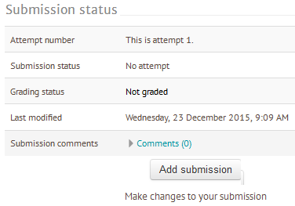

Most important is the Add submission button, which will allow you to add your assignment.

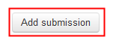

Selecting this button will reveal either a text submission box, a file submission box, or both, depending on the assignment.

Use the text box to enter any text necessary for your assignment, use the text formatting tools at the top of the box as you wish.

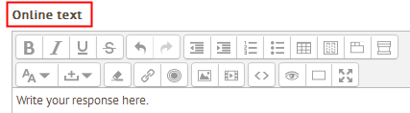

The file submission box lets you add computer files to your assignment. You can drag and drop files here, or you can click the add file button. That brings up the file picker window that lets you upload a file from your computer, or choose a file from your private files that you've already uploaded.

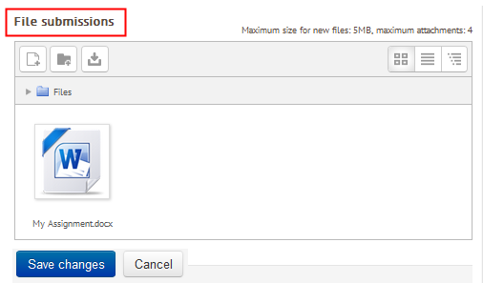

When you've added the text and files you want, it's very important to save your changes. In the next document, we'll discuss the final submission and grading status of your assignment.

So now you have completed your work and added your assignment to the ADLC online learning

system, it's time to officially submit it. It is important to note that after adding your assignment work and files, it still must be submitted. In this submission status, we can see that this assignment is still labelled as draft, and has NOT been submitted.

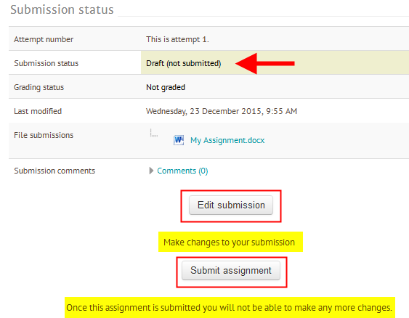

This means you can still make changes by clicking the Edit submission button. Here you can edit text, or, you can click on your assignment to download it, delete it, or edit the name. As always, if you

have made changes, don't forget to save them.

Now it's time to officially submit your assignment. You'll get a warning, because once you submit, you won't be able to make any further changes to your assignment. Select the Continue button.

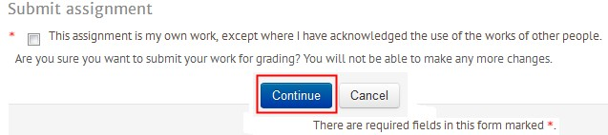

We can now see in the submission status that your assignment has been officially submitted for

grading. We can also see it's not yet graded. In future tutorials, we'll discuss how to review your assignments and check your grades.



**Contact**

If at any time you have questions, please contact:

**Technical Help Desk**

1-866-774-5333 ext. 5322 [moodlesupport@adlc.ca](mailto:moodlesupport@adlc.ca)