## How to Submit Work from Google Drive

This document will work through the student submission process when working in Google Drive. Although this document uses a Google Doc for the example, the steps apply the same for Slides, Sheets, Pics, etc, but an separate instruction is created for video.

The document will break into the following trees as it works through the process, depending on the student’s situation:

**Submitting the GDrive Document as a Link**

This option will work no matter what device you’re working on, be it PC, Mac, or Chromebook.

Submitting a link to your work in GDrive seems the easiest way to submit work, but there are two key things that permit this:

1. The document must be shared in a way that ADLC teachers and markers can access it.
2. There must be a text entry box for the student to submit the link.

To check to see if a link can be submitted, go to the assignment page in Moodle. If the submission window has an ‘Online Text’ window, then a link can be used to submit work.

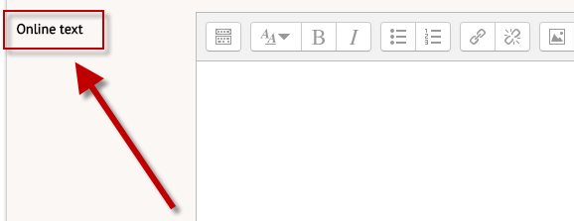

If the submission window has ONLY a file upload, then a file submission must be used.

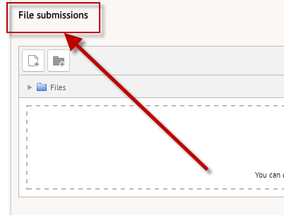

Provided the online text entry is an option, a Google Drive link can be shared.

Then your work is in a Google Drive document (or Sheets, Slides, etc). In the document, locate the ‘Share’ option in the top, right corner.



Clicking ‘Share’ will open the share-settings window.

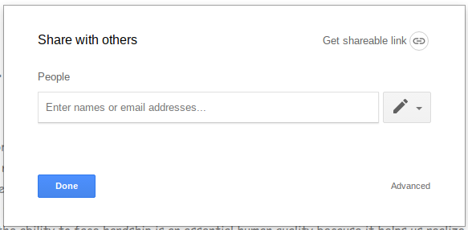

If you share the document with your teacher, the teacher alone can grade the work.

To open up more broad sharing, click ‘Get sharable link’ in the top right of the share settings window.

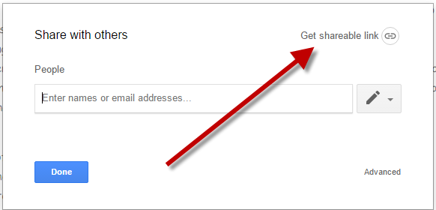

Click the pull down option, and click ‘More’ at the bottom of the list. Note that your school division will be listed instead of Pembina Hills.

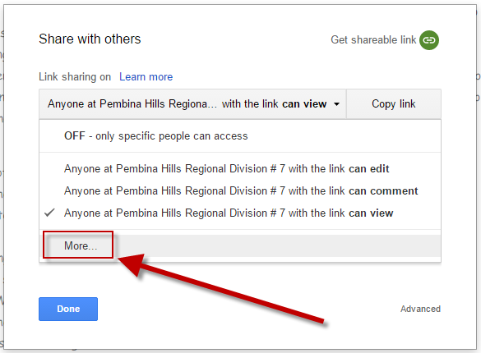

Under the ‘More’ option, choose “Anyone who has the link”

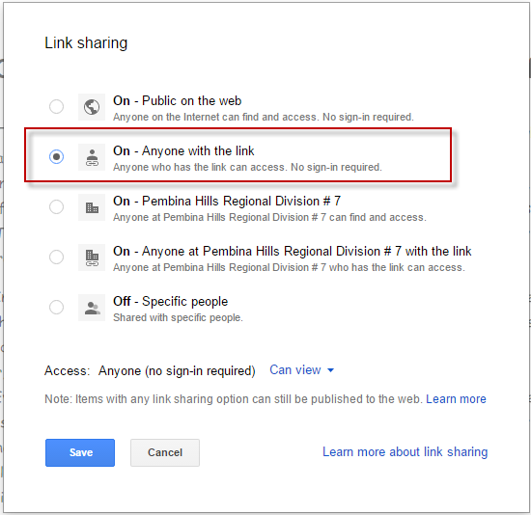

***Note that if you don’t have the ‘More’ option, or don’t have the ‘Anyone with the link’ option, you must submit as a file - link submission will not work.***

Click ‘Save’ at the bottom. This will return to the first share settings window, with the new settings in place. Note that sharing is now ‘Anyone with the link can view.’

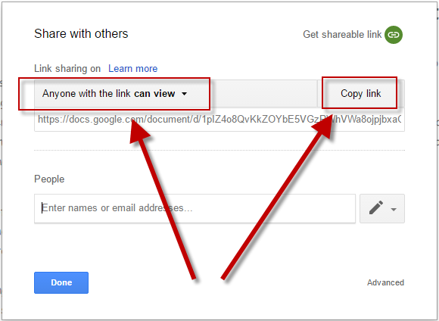

With sharing set up, click the ‘copy link’ button.

Back on the assignment submission page in Moodle, paste the link into the ‘Online text’ window.

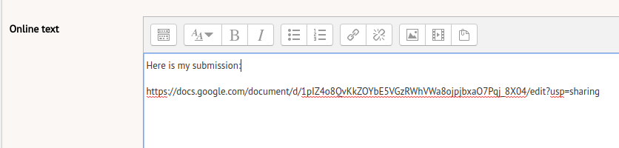

Click ‘Save changes’ on the assignment page, and continue with the submission steps in Moodle.

