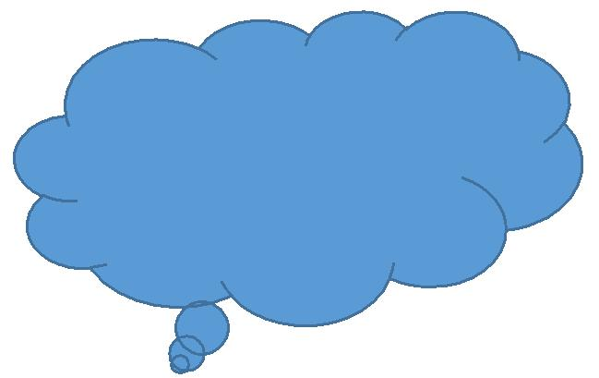 **Name: ___________________**

**Theme 1: Reflection**

**Reflect upon these statements regarding identity.**

|  |
| --- |
| Read the following statements and decide whether you strongly agree, agree, disagree, or strongly disagree with them. |

|  |  |
| --- | --- |
| You can usually figure out a person’s personal identity by looking at their appearance. | A person’s personal identity stays the same throughout his or her life. |
| 🞏 strongly agree  🞏 agree  🞏 disagree  🞏 strongly disagree | 🞏 strongly agree  🞏 agree  🞏 disagree  🞏 strongly disagree |
| I consider my culture to be a big part of my personal identity. | Most of my values and beliefs stem from what my family has taught me to be important. |
| 🞏 strongly agree  🞏 agree  🞏 disagree  🞏 strongly disagree | 🞏 strongly agree  🞏 agree  🞏 disagree  🞏 strongly disagree |
| Community groups I belong to have added to my personal identity. | I believe that volunteering is a responsibility of everyone in a community. |
| 🞏 strongly agree  🞏 agree  🞏 disagree  🞏 strongly disagree | 🞏 strongly agree  🞏 agree  🞏 disagree  🞏 strongly disagree |

|  |  |
| --- | --- |
|  |  |

**Now answer these questions.**

|  |
| --- |
| What did you learn in this theme on personal identity that you didn't know before? |
| What did you enjoy most about working through this theme? |
| What were some challenges or difficulties you experienced when working through this theme? |