**The Process of Addition**

When using the pencil and paper method to add two numbers, follow these steps.

1. Place the numbers so that one number is above the other and the numbers in the **ones place** align.

|  |  |  |  |  |  |
| --- | --- | --- | --- | --- | --- |
| **Example** | 1 | 2 | 8 | Think: Estimate |  |
| **+** | 6 | 5 |  |
|  |  |
|  |  |  |  | 130 + 70 = about 200 |  |



2. Starting at the right, add the values of the numbers in the ones place.



8 + 5 = **13**

Each place can only have one digit, so the **3** is placed under the ones place.

**1**

1 2 8

* 6 5

 **3**

The **1** is carried over to become part of the value in the tens place. 

Think: 13 is 1 ten and 3 ones. The 1 ten moves (gets carried over) to the tens place in the question.

3. Next, add the values in the **tens place**.

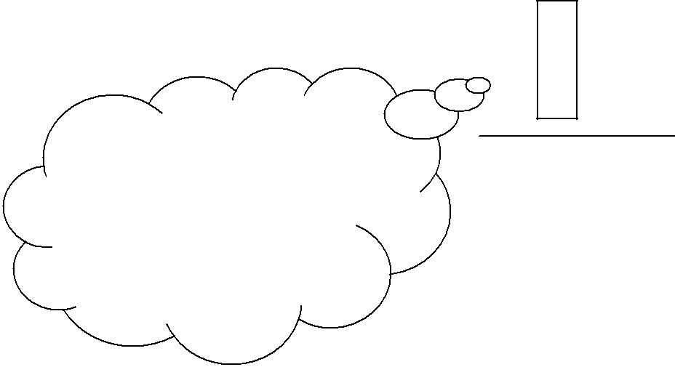

1 12 8

6 5

**+**

Think: The numbers in

the tens place should be

thought of as:

10 + 20 + 60 = 90 (9 is recorded in the tens place.)

Knowledge and Employability Studio

Mathematics

1 + 2 + 6 = **9**

Since there is only one digit in the answer, it is placed under the tens place and nothing will be carried over to the hundreds place.

Numbers: Whole Numbers:

©Alberta Education, Alberta, Canada (www.LearnAlberta.ca) **Adding and Subtracting Whole Numbers** 2/11

4. Next, add the values in the **hundreds place**.

1 + 0 = **1**

Since the second number, 65, does not have a digit in the hundreds place, we say that it has 0 in the hundreds place.

1

1 2 8

* 6 5

**1** 9 3  128 + 65 = **193**



Think: The numbers in the hundreds place should be thought of as:

100 + 0= 100

(1 is recorded in the hundreds place.)

To add larger numbers, repeat the same steps for each additional place. The process for  [adding decimal numbers](http://www.learnalberta.ca/Redirector/Redirect.aspx?Id=cb1cdc9a-70d8-4c15-9c3a-e2d60a383fa9) is similar.

Knowledge and Employability Studio

|  |  |
| --- | --- |
| Mathematics | Numbers: Whole Numbers: |
| ©Alberta Education, Alberta, Canada (www.LearnAlberta.ca) | **Adding and Subtracting Whole Numbers** 3/11 |

**The Process of Subtraction**

When using the pencil and paper method to subtract one number from another, follow these steps.

1. Place the numbers so that one number is above the other and the numbers in the **ones place** align.

|  |  |  |  |  |  |
| --- | --- | --- | --- | --- | --- |
| **Example** | 5 | 8 | 7 | Think: Estimate |  |
| **–** | 9 | 2 |  |
|  |  |
|  | 590 – 90 = about 500 |  |
|  |  |  |  |  |



2. Starting at the right, subtract the values of the numbers in the ones place.

7 – 2 = **5**

Each place can only have one digit, so the **5** is placed under the ones place.

5 8 7

**–** 9 2

 **5**

Knowledge and Employability Studio

|  |  |
| --- | --- |
| Mathematics | Numbers: Whole Numbers: |
| ©Alberta Education, Alberta, Canada (www.LearnAlberta.ca) | **Adding and Subtracting Whole Numbers** 4/11 |

3. Next, subtract the values in the **tens place**.

|  |  |  |  |  |  |
| --- | --- | --- | --- | --- | --- |
|  | 4 5 | | 18 | 7 |  |
| 8 – 9 = ? |  | – | 9 | 2 |  |
| If the second number (the number under the |  |  |
| first number) is **MORE** than the value of the |  |  |  |  |  |
|  |  |  |  |  |
|  |  |  |  |  |
| first number, you must borrow **1** from the |  |  |  | 5 |  |
| place to the **LEFT**. |  |  |  |  |  |
| In the example, 1 is borrowed from 5, |  |  |  |  |  |
| leaving **4** in the hundreds place. |  |  |  |  |  |
|  |  |  |  |  |  |



Think: 80 – 90 cannot be done so you need to borrow from the hundreds place. You borrow 1 from the hundreds so 80 + 100 = 180.

(1 is recorded in front of the 8 in the tens place to show 180.)

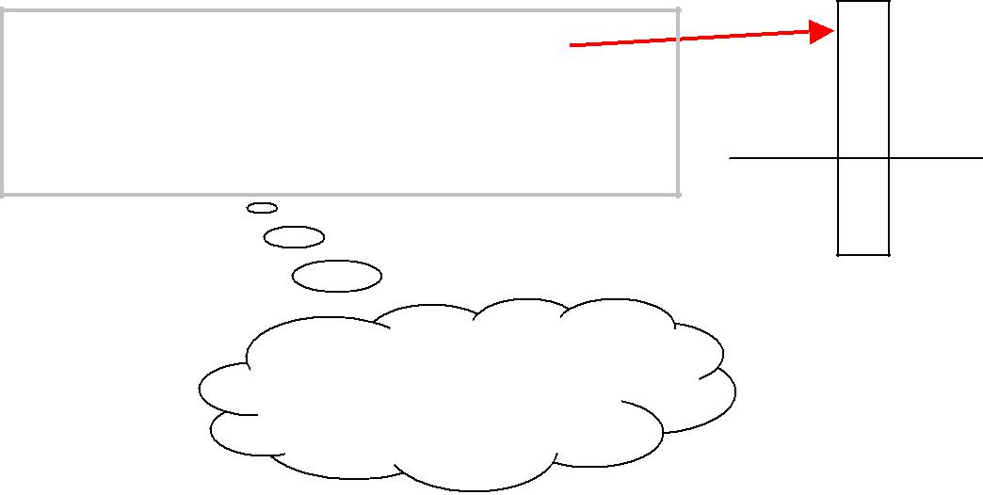

The 1 is placed in the tens place in front of 8, so that 8 becomes 18. 18 – 9 = **9**

Think: 180 – 90 = 90

(9 is recorded in the tens place.)

1

4 8 7

**–** 9 2

**9** 5

Knowledge and Employability Studio

|  |  |
| --- | --- |
| Mathematics | Numbers: Whole Numbers: |
| ©Alberta Education, Alberta, Canada (www.LearnAlberta.ca) | **Adding and Subtracting Whole Numbers** 5/11 |

4. Next, subtract the values in the **hundreds place**.

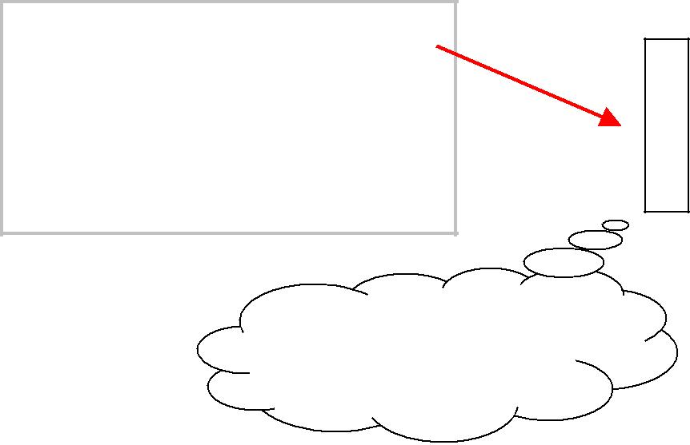

|  |  |  |  |  |
| --- | --- | --- | --- | --- |
| 4 – 0 = **4** | 1 | | | |
| Since the second number, 92, | | 4 | | 8 | | 7 |  |  |  |  |
| **–** | | 9 | | 2 |  |  |  |  |
| does not have a digit in the | |  |  |  |  |
| hundreds place, we say that it | |  |  |  | |  |  |  |  |  |
| **4** | | 9 | | 5 |  |  |  |  |
| has 0 in the hundreds place. | |  |  | 587 – 92 = **495** |  |
|  |  |
|  |  |



Think: 400 – 0 = 400 (4 is recorded in the hundreds place.)

To subtract larger numbers, repeat the same steps for each additional place value. The process for subtracting decimal numbers is similar.

**Fact Families**

Remember that addition and subtraction are related operations.

**Fact families** show how addition and subtraction sentences are related. Additionsentences can be written two ways:

496 + 241 = **737**

241 + 496 = **737**

Subtraction sentences can be written two ways:

**737** – 496 = 241

**737** – 241 = 496

Together, these four mathematical sentences make a **fact family.**

496 + 241 = 737

241 + 496 = 737

737 – 496 = 241

737 – 241 = 496

*The numbers in this fact family are: 241, 496 and 737.*

Knowledge and Employability Studio

Mathematics

Numbers: Whole Numbers:

©Alberta Education, Alberta, Canada (www.LearnAlberta.ca) **Adding and Subtracting Whole Numbers** 6/11

**Verifying Answers in Subtraction**

When you subtract, you can verify whether your answers are right using a variety of methods, such as opposite operations, mental mathematics, calculator, manipulatives and diagrams.



**Example** The grocery store has 90,000 units in stock.

If the store sells 47,000 units of the food product in stock, how many will they have remaining according to their computer?

The store manager calculated in his mind. The number 47,000 is close to 50,000.

He thought 90,000 – 50,000 equals 40,000.

The difference between the 50,000 rounded number and the

47, 000 original number is 3,000. So, 40,000 + 3,000 equals a

remaining 43, 000 units.

|  |  |  |  |  |  |  |  |  |  |  |  |  |  |  |  |  |  |  |  |  |
| --- | --- | --- | --- | --- | --- | --- | --- | --- | --- | --- | --- | --- | --- | --- | --- | --- | --- | --- | --- | --- |
| 9 |  | 0 |  | 0 |  | 0 |  | 0 |  | - |  | 4 |  | 7 |  | 0 |  | 0 |  | 0 |
|  |  |  |  |  |  |  |  |  |  |  |  |  |  |  |  |  |  |  |  |  |

He checked his answer on the computer calculator. It displayed a result of

43,000

His mental calculation was correct.

Knowledge and Employability Studio

|  |  |
| --- | --- |
| Mathematics | Numbers: Whole Numbers: |
| ©Alberta Education, Alberta, Canada (www.LearnAlberta.ca) | **Adding and Subtracting Whole Numbers** 7/11 |