 | Step #2 | Collect/brainstorm information and ideas
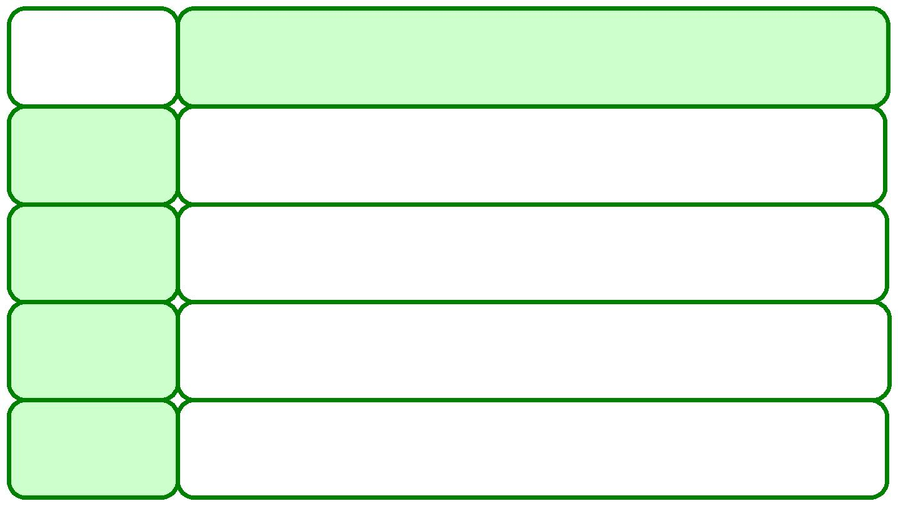 | For a
 | paragraph | You need to find/think of …
 | that is …
 | Descriptive | sensory details — how things look, feel, sound, smell and
 |  | taste
 | Narrative | details about the situation—how it began, what happened
 |  | in the middle, how it ended
 | Persuasive | facts, evidence, and examples to back up or prove your
 |  | opinion

a list of details, facts, or steps to explain the idea Expository or process

