**Reflecting on My Writing**

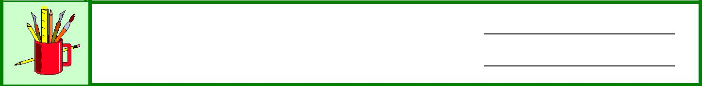

**Name:**

**Date:**

Answer the following questions to help you assess your writing work in the lessons you have just completed.

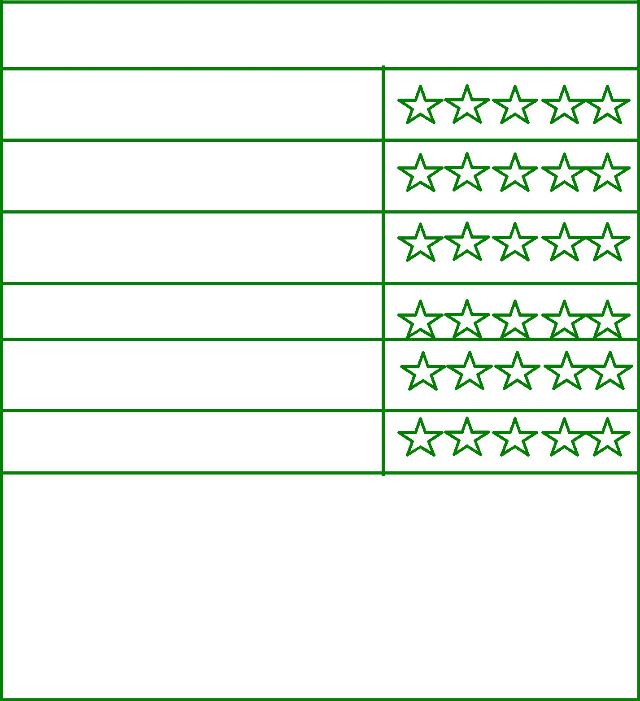

**How I rate my own …**

1 Star = Poor/5 Stars = Great

Ideas

**Are my ideas original and interesting?**

**Does my writing express my ideas well?**

Organization

**Does my writing have a clear beginning, middle, and ending? Does it flow well?**

Development

**Does my writing include enough details and descriptions?**

Style

**Is my writing interesting and enjoyable to read?**

Mechanics

**Is my writing free from errors in grammar, spelling, and punctuation?**

Presentation

**Is my writing neat and well presented?**

Other comments I have about my writing:

|  |  |
| --- | --- |
| Knowledge and Employability Studio | Writing/Reflecting on Writing/ |
| English Language Arts | **Reflecting on My Writing** 1/1 |

©Alberta Education, Alberta, Canada (www.LearnAlberta.ca) 2006