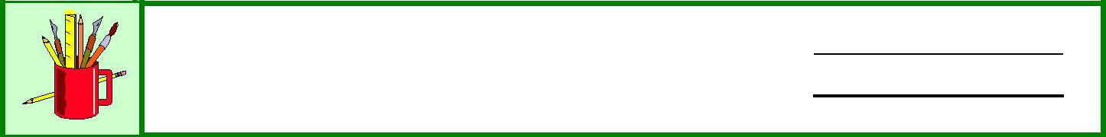

**Digital Story Planner** **Name:**

**Date:**

Fill in the information in this organizer and then follow it as you create your digital story.

**Audience:**

**Message:**

**Story Outline:**

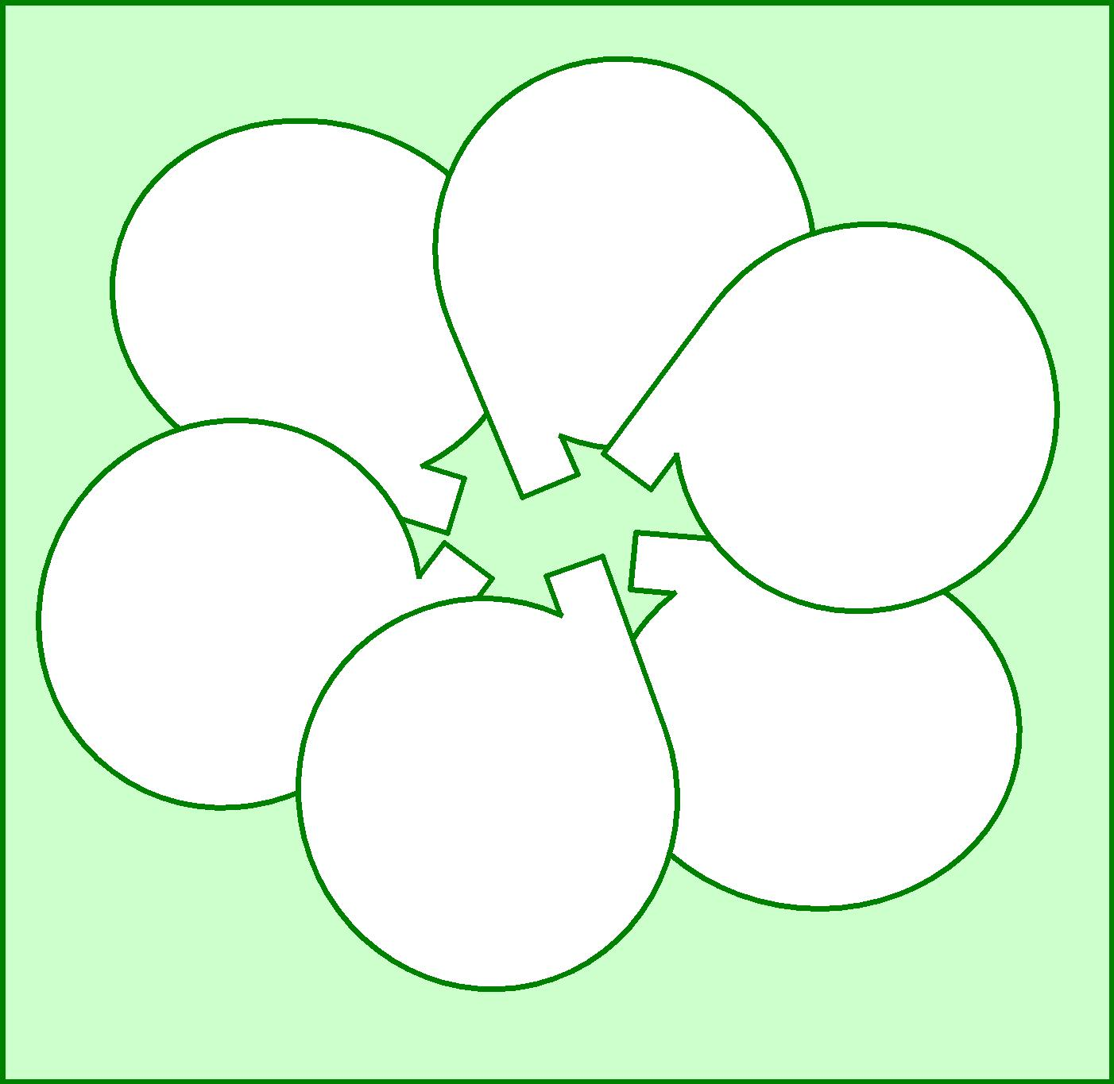

**What do the characters do?**

**Who is the story about?**

**When does the story take place?**

**How does the story turn out?**

**Where does the**

**story take place?**

**Why do the characters do**

**what they do?**

|  |  |
| --- | --- |
|  |  |
|  |  |
|  | 2007 |

**Information to Include:**

**Images**

|  |  |  |  |
| --- | --- | --- | --- |
| Images | Already Have | Create | Find |
|  |  |  |  |
|  |  |  |  |
|  |  |  |  |
|  |  |  |  |

**Multimedia; e.g., animation, transitions, music**

•

•

•

**Design; e.g., colours, fonts**

•

•

•

**Storyboard Template:**

Use this template to create a complete storyboard on paper or posterboard.

|  |  |  |  |  |  |  |
| --- | --- | --- | --- | --- | --- | --- |
| Image |  | Image |  | Image |  | Image |
|  |  |  |  |  |  |  |

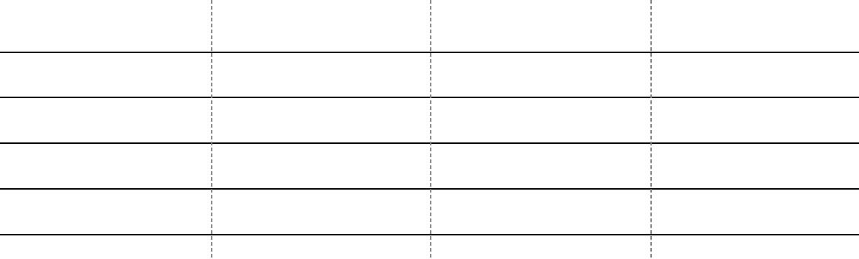

Transitions

Voiceover

Effects

Soundtrack

Notes

|  |  |
| --- | --- |
| Knowledge and Employability Studio | Infusing FNMI Perspectives/Oral Traditions |
| English Language Arts/Social Studies | **Unit Overview: Oral Traditions** 15/22 |

You may wish to complete your draft of your story/script here: