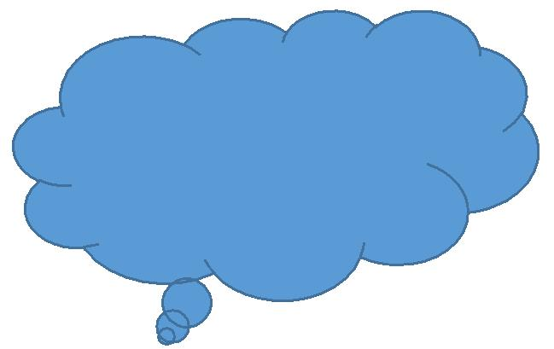 Name: ___________________

**Lesson 23: Reflection**

Complete the following questions regarding the digital story you have created:

|  |
| --- |
| Is the message of your story clear? Support your answer. |
| Is the story organized in a way that is easy to understand? Explain how it is or is not. |
| Did you use interesting visuals to support your story? Give two examples and explain how they are interesting. |
| Does the music or sound support your message? Explain how it does/does not support the message. |