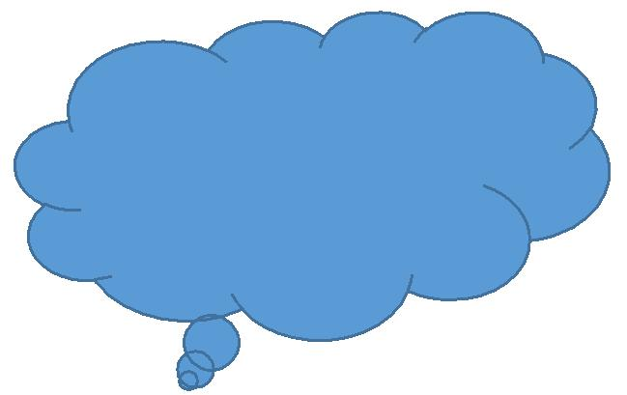 Name: ___________________

**Lesson 31 — Activity 2:**

**Reflection**

Complete the following questions to show your reading personality. For each question, mark all the answers that apply.

|  |
| --- |
| 1. What kinds of books interest you?  * fantasy * mystery * historical fiction (a story that takes place in a particular time period in the past) * science fiction * realistic fiction (a fictional story that could happen in real life) * graphic novels |
| 1. What information do you consider when choosing a novel?  * your favourite author * what the genre is * titles that catch your interest * exciting or interesting covers * other: ___________________________ |
| 1. How do you learn about new books?  * by visiting the library * by visiting bookstores * by researching online * from friends |
| 1. You have heard about a book that might be good; what do you do?  * ask friends if they have read or heard about the book * visit websites to read reviews * if it’s a favourite author of yours, read the new book |