Physical Education 20

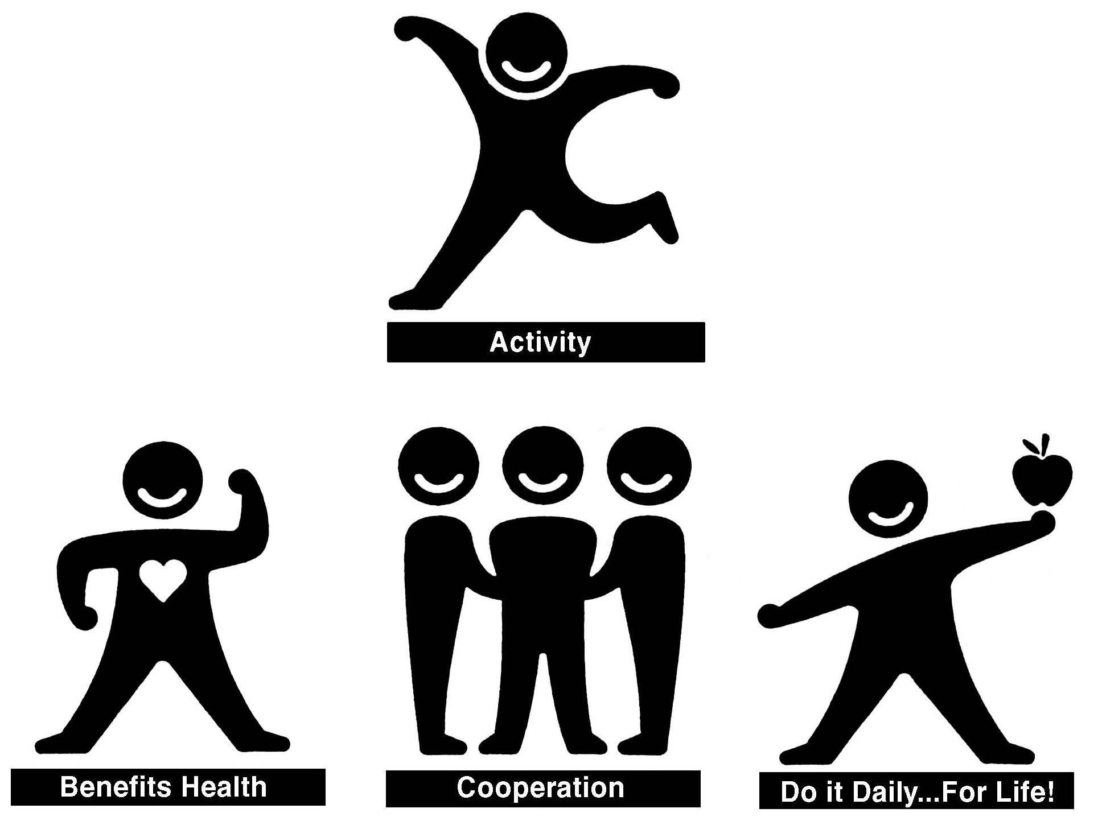

**Assignment Booklet**

**Volunteer Component**

Volunteering is the practice of people working on behalf of others or a particular cause without payment for their time and service. Volunteering is considered an unselfish act.

What does it take to be a volunteer?

CARING... enough to do something

INITIATIVE... to turn your caring into action

COMMITMENT... to follow through on responsibilities to which you have agreed

**For this portion of the PE course, remember that your volunteering must be in a placement where somebody else is active because of your volunteering.**

**\*\* Remember that you MUST submit 3 pictures of you volunteering. Your hours will not count without the pictures.\*\***

Completion Directions:

1. Complete the log for your volunteer hours. **Your mentor/supervisor will sign the log one time**, when you have finished all 10 volunteering hours.
2. Have your volunteer mentor/supervisor fill in the two page evaluation after you have finished all 10 hours of volunteering. Again, a physical signature from the mentor is required.
3. Complete the reflection questions.
4. Submit a volunteer package to the course that contains:

* Volunteering log sheet
* Mentor/Supervisor Evaluation (2 page document)
* Volunteer Reflection
* Minimum of 3 pictures of volunteer**Volunteering Log Sheet**

Student Name: __________________________________

Mentor and/or Supervisor Name: __________________________________

Location: __________________________________

Dates: From: ________________ To: ________________

|  |  |  |
| --- | --- | --- |
| **Day** | **Volunteer Activity Performed (include details)** | **Time Spent Doing Activity** |
| Date: |  |  |
| Date: |  |  |
| Date: |  |  |
| Date: |  |  |
| Date: |  |  |
| Date: |  |  |
| Date: |  |  |
| Date: |  |  |
| Date: |  |  |
| Date: |  |  |
| Date: |  |  |
| Date: |  |  |
| Date: |  |  |
| Date: |  |  |
| Date: |  |  |

**Comments from Mentor and/or Supervisor:**

|  |
| --- |
|  |

**Student Signature: ___________________________________________________________**

**Mentor and/or Supervisor’s Signature: _________________________________________________________ __________________**

**Mentor and/or Supervisor’s Phone: ___________________________________________________________________________**

**Mentor and /or Supervisor’s E-mail: __________________________________________________________________________**

**Volunteer Reflection**

***“A mind that is stretched by a new experience can never go back to its old dimensions.”***

* Oliver Wendell Holmes

*Please submit 3 photos of you volunteering along with the following questions.*

1. Why did you choose to volunteer in this activity?

**Answer:**

|  |
| --- |
|  |

1. What has been the best aspect of this experience?

**Answer:**

|  |
| --- |
|  |

1. What skills did you use?

**Answer:**

|  |
| --- |
|  |

1. What skills did you gain?

**Answer:**

|  |
| --- |
|  |

1. How did your volunteering benefit others?

**Answer:**

|  |
| --- |
|  |

1. What lessons and/or knowledge would you like to take with you into a possible future career?

**Answer:**

|  |
| --- |
|  |

1. Based on your volunteering experience, of what are you most proud?

**Answer:**

|  |
| --- |
|  |

1. During your volunteering experience, what was your biggest challenge? How did you handle it?

**Answer:**

|  |
| --- |
|  |

**Mentor and/or Supervisor’s Evaluation of Volunteer Student**

Name: __________________________________ Date: _________________

Location: ___________________________

Please rate the student by clicking the box beside the number that best describes the student’s performance.

RATING SCALE: ☐ 5 Excellent ☐ 2 Needs Improvement

☐ 4 Very Good ☐ 1 Unsatisfactory ☐ 3 Satisfactory ☐ 0 Not Applicable

|  |  |
| --- | --- |
| **PUNCTUALITY** | **RATING** |
| Punctuality – on time. | ☐ 5 ☐ 4 ☐ 3 ☐ 2 ☐ 1 ☐ 0 |
| Attendance – regular. | ☐ 5 ☐ 4 ☐ 3 ☐ 2 ☐ 1 ☐ 0 |

|  |  |
| --- | --- |
| **PERSONAL QUALITIES AND WORK HABITS** | **RATING** |
| Cooperation – ability to work with others. | ☐ 5 ☐ 4 ☐ 3 ☐ 2 ☐ 1 ☐ 0 |
| Adaptability – ability to adapt to new tasks or situations. | ☐ 5 ☐ 4 ☐ 3 ☐ 2 ☐ 1 ☐ 0 |
| Willingness to accept suggestions for improvement. | ☐ 5 ☐ 4 ☐ 3 ☐ 2 ☐ 1 ☐ 0 |
| Dependability – fulfills commitments and promises. | ☐ 5 ☐ 4 ☐ 3 ☐ 2 ☐ 1 ☐ 0 |
| Reliability – completes tasks on time. | ☐ 5 ☐ 4 ☐ 3 ☐ 2 ☐ 1 ☐ 0 |
| Initiative – eager to learn. | ☐ 5 ☐ 4 ☐ 3 ☐ 2 ☐ 1 ☐ 0 |
| Demonstrates interests and enthusiasm for volunteering. | ☐ 5 ☐ 4 ☐ 3 ☐ 2 ☐ 1 ☐ 0 |
| General grooming and appearance. | ☐ 5 ☐ 4 ☐ 3 ☐ 2 ☐ 1 ☐ 0 |

|  |  |
| --- | --- |
| **EXECUTION OF WORK DUTIES** | **RATING** |
| Has the ability to learn. | ☐ 5 ☐ 4 ☐ 3 ☐ 2 ☐ 1 ☐ 0 |
| Uses equipment in an effective and safe manner. | ☐ 5 ☐ 4 ☐ 3 ☐ 2 ☐ 1 ☐ 0 |
| Completes tasks outlined. | ☐ 5 ☐ 4 ☐ 3 ☐ 2 ☐ 1 ☐ 0 |
| Is efficient. | ☐ 5 ☐ 4 ☐ 3 ☐ 2 ☐ 1 ☐ 0 |
| Works consistently and conscientiously. | ☐ 5 ☐ 4 ☐ 3 ☐ 2 ☐ 1 ☐ 0 |

1. Student’s strong points (talents or abilities, outstanding traits):

**Answer:**

|  |
| --- |
|  |

1. Recommendations for students to improve:

**Answer:**

|  |
| --- |
|  |

1. Other comments:

**Answer:**

|  |
| --- |
|  |

Supervisor and/or Mentor’s Name:_______________________ _________________________

Date: _______________________________________________________________________

Supervisor and/or Mentor’s Position: __________________________________________________

Organization and/or Business:

____________________________________________________ ________________________

Address: ____________________________________________________________________

Telephone: __________________________________________________________________

E-Mail: _______________________________________

**Physical Education – Volunteering Assignment Booklet Marking Summary**

|  |  |  |
| --- | --- | --- |
| **Volunteering Assignment Booklet** | **Possible Marks** | **Assessment** |
| **Volunteering Log Sheet:**   * Is filled in with details of activity./2   Use of proper grammar and spelling. /1   * Neatness /1 * Mentor and/or supervisor’s signature /1 * Completed 10 hours /10 | **15** |  |
| **Photographs/Video**   * Photos and/or video are clearly visible and display a suitable image of the student engaged in volunteering. | **5** |  |
| **Mentor and/or Supervisor Evaluation** | **20** |  |
| **Volunteer Reflection Questions**   * Each question is answered in complete sentences with proper grammar, spelling and neatness. | **10** |  |
| **Total** | **50** |  |