

# FAS1060 Creating Accessories

**Assignment 2 Unlined Patch Name: < >**

**Pocket Sample** **Date:** **< >**

***Total: /12 Marks***

**Instructions**

* This assignment is to teach you how to make a patch pocket. Watch the Pocket Videos: “Unlined Pockets” or “Curved Pockets” and follow the instructions to complete this.
* Take close-up pictures of each step. Insert the pictures into a PowerPoint or Google Slides file or insert them into this document. Label each step.
* A **patch pocket** is a piece of fabric that is shaped (square, rounded, heart-shaped, etc.) and then attached to the outside of the garment.

Unlined Patch Pocket will be marked as follows:

|  |  |
| --- | --- |
| **Category** | **Marks** |
| **Pocket has nice straight folded edge** | **/2** |
| **Back stitches on sides are straight** | **/2** |
| **Trimmed seam allowances are straight and even** | **/2** |
| **Pressing and turning corners are neat** | **/2** |
| **Overall pocket is neat and even** | **/2** |
| **Presentation has all necessary pictures and captions** | **/2** |
| **TOTAL** | **/12** |

**How to Make the Unlined Patch Pocket**

1. Cut a square of woven fabric 15 cm X 15 cm.
2. With the wrong side of the fabric facing up, turn top under 1 cm so the right side of the fabric shows on top.

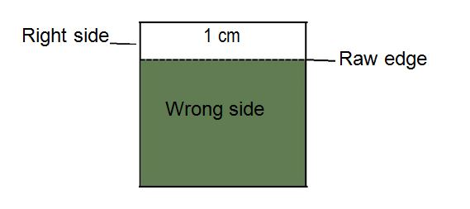

1. Permanent stitch 5 cm from the top.
2. Fold the top down to make a facing 3 cm so the right sides of fabric are together.

|  |  |
| --- | --- |
| Fold |  |
| **→** |  |
| Wrong side | **}** 3 cm |
|  |  |
|  |  |
| Right side |  |
|  |  |

1. Stitch a seam 1.5 cm from each side Back stitch at the end of the facing.   
     
     
   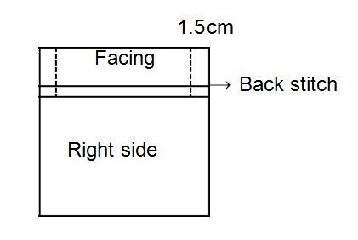
2. 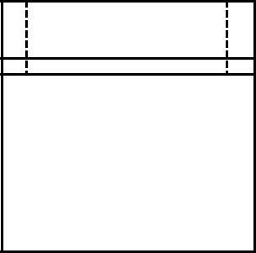Trim the top seam allowance layer on the facing to about ½ the width (7 mm). Trim the corners leaving 3 mm of fabric at the point.
3. Turn the facing right side out. Push out the corners and press along the sewing line.   
     
   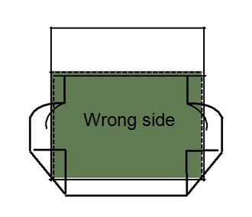
4. Fold corners diagonally to where the sewing lines meet.

1. Trim 3 mm from the point of the corner, cutting only one layer (see shaded area).

**Note you leave .5 cm from the fold, just cutting off very tip. Do not cut the fold!**

**Watch video!**

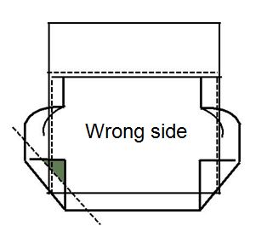

1. After trimming corners, press each side in to have the completed pocket.

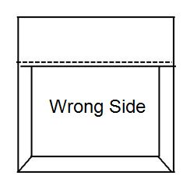

**Patch Pocket Sample**

Insert the pictures of the steps along with captions into this document OR insert them into a PowerPoint or Google Slides file. Add captions to explain the steps.

**Do not submit individual pictures.** Upload this assignment as one file.

**Save the assignment to your computer as FirstInitialLastNameFAS1060A2.**

**Submit as Assignment 2.**