**Stakeholder’s Chart /27 marks**

**Instructions:**

Look at the MAP on the next page.

* Consider what is there already.
* As you look at the map, think about everything that is represented and the stakeholder requests.
* Decide which stakeholders receive land, how much land they will receive, and reason for your decision.
* Fill in **all** areas typing between the **< >**.
  + Be prepared to justify your decisions
* **Note:** Amount of Land Allotted – Each square represents 1 hectare; total map is 768 hectares.

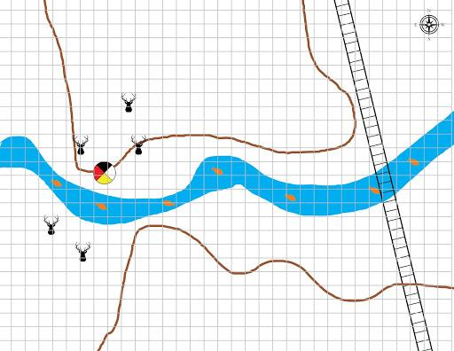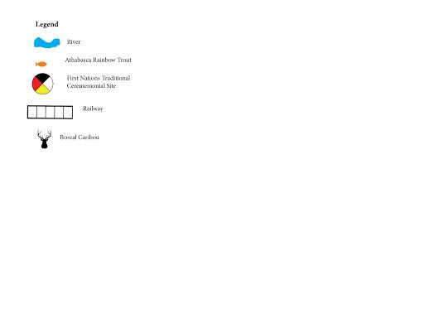

**Map /16 marks**

**Instructions:**

* You will want to be able to write on this map, whether digitally or by printing it off.
* Add the various stakeholders to your map, using your completed Stakeholder’s Chart as your guide.
* Add symbols to the existing legend to define each stakeholder.
* On the map, indicate the location and amount of land allotted, using the symbols and colours from your legend.

You will be marked according to the rubric at the end of this assignment; please read the rubric very carefully.

|  |  |  |  |  |  |  |
| --- | --- | --- | --- | --- | --- | --- |
| **Stakeholder** | **Land Requested** | **Reason for Requested Land** | **Benefit**  (Economic, Environmental, Social, Cultural) | **Considerations** | **Amount of Land Allotted** | **Reason for Land Allotment** |
| **Indigeneous Peoples** | 144 hectares | Ceremonial Site | **<Cultural>** | Ceremonial site and access to it. Caribou preservation | **< >** | **<Sacred Heritage Site>** |
| **Forest Products Company** | 334 hectares | Harvesting of trees for paper/wood products | Economic | Need to be near the access road | **< >** | **< >** |
| **Five members of public** | Total of 45 hectares (15 hectare each) | To each build a cabin as a summer home | **< >** | Would like to be in the trees and near the river | **< >** | **< >** |
| **Private campground developer** | 50 hectares | To develop a campground as a business | Economic | Would like to be in the trees and near the river | **< >** | **< >** |
| **Mining Company** | 200 hectares | To develop and run a mining operation | **< >** | Needs to be near the railroad. | **< >** | **< >** |
| **General Store and Gas Station** | 1 hectare | To run a private business | **< >** | Needs road access | **< >** | **< >** |
| **Ski Resort Owner** | 150 hectares | To develop a ski resort | Economic | Needs to be near a mountainous area | **< >** | **< >** |
| **Ranch Operator** | 100 hectares | Land for cattle to graze | **< >** | Close to the river would be nice, but not essential | **< >** | **< >** |
| **Conservation Society** | As much as possible | Protect animal habitat | Environmental | Need to consider each protected species’ requirements | **< >** | **< >** |
| **Private developer** | 50 hectares | To build a Recovery Centre in a quiet environment | Economic  / Social | Needs to be in or near the trees in a quiet area | **< >** | **< >** |
| **Farmer** | 100 hectares | Harvest the trees in order to grow agricultural products i.e. mustard, barley, etc. | **< >** | Needs to be near the railroad or have road access | **< >** | **< >** |

When you have complete the chart and the map, submit both under 5.1 Submission Page.