[**Find**](http://www.worksmartontario.gov.on.ca/scripts/default.asp?contentID=2-6-1&amp;mcategory=health) **the Hazards in the Workplace**

As an employee, you have rights that protect yo[u a](http://www.worksmartontario.gov.on.ca/scripts/default.asp?contentID=2-6-1&amp;mcategory=health)gainst health and safety hazards on the job.

You have the right to participate in [workplace health and safety issues and to know abou](http://www.worksmartontario.gov.on.ca/scripts/default.asp?contentID=2-6-1&amp;mcategory=health)t any potential hazards.

Workplace hazards can be physical ([i.e. constant l](http://www.worksmartontario.gov.on.ca/scripts/default.asp?contentID=2-6-1&amp;mcategory=health)oud noise), biological (i.e. bacteria and viruses), ergonomic (i.e. improperly adjusted workstations and chairs), chemical (i.e. exposure to fumes), or psychological (stress)

[The following pages contain images of various workplaces.](http://www.worksmartontario.gov.on.ca/scripts/default.asp?contentID=2-6-1&amp;mcategory=health)

How many potential hazards can you find in each picture? There is no need to submit your answers.

Find the Hazards: Fast Food – Can you find10 hazards?

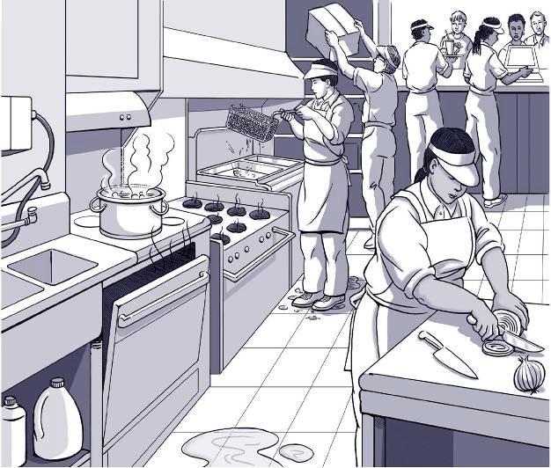

**Sharp knife can cut.**

Find the Hazards: Grocery Store –Can you find 8 hazards?

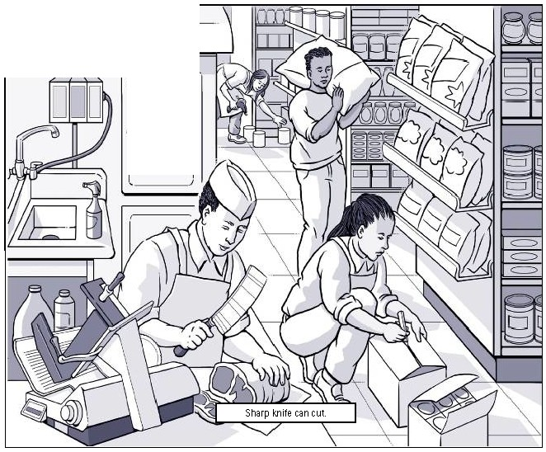

-- - ,

J,

Find the hazards: Office – Can you find 8 hazards?

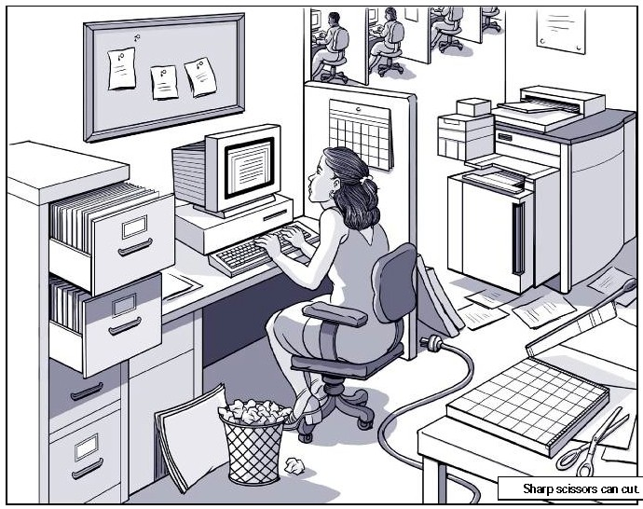

Find the Hazards: Factory- Can you find 10 hazards?

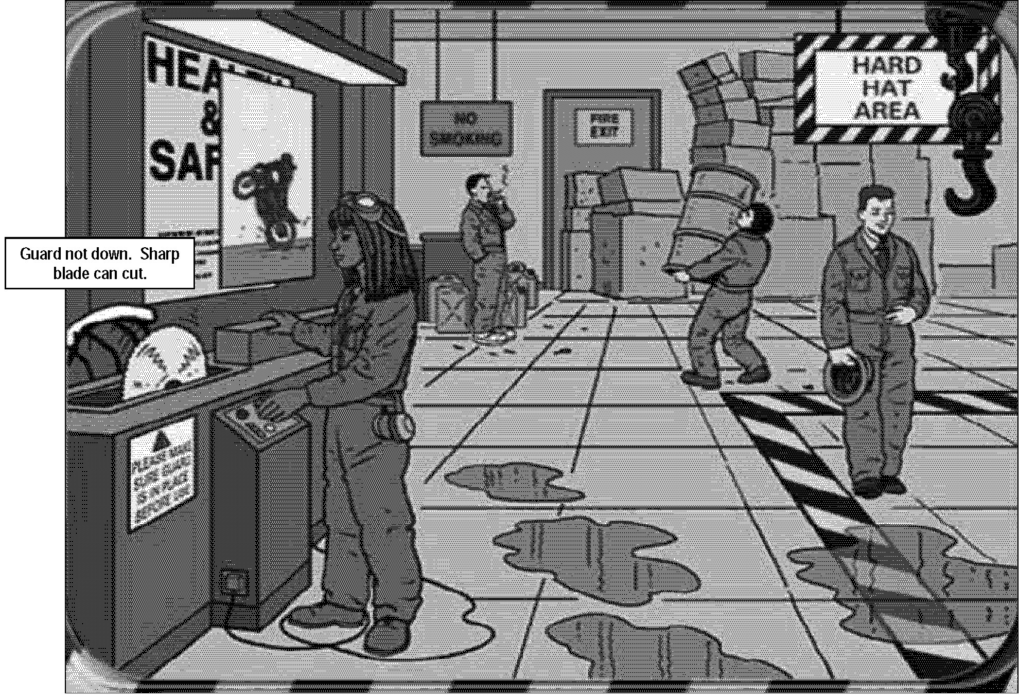

Find the Hazards: Farm – Can you find 20 hazards?

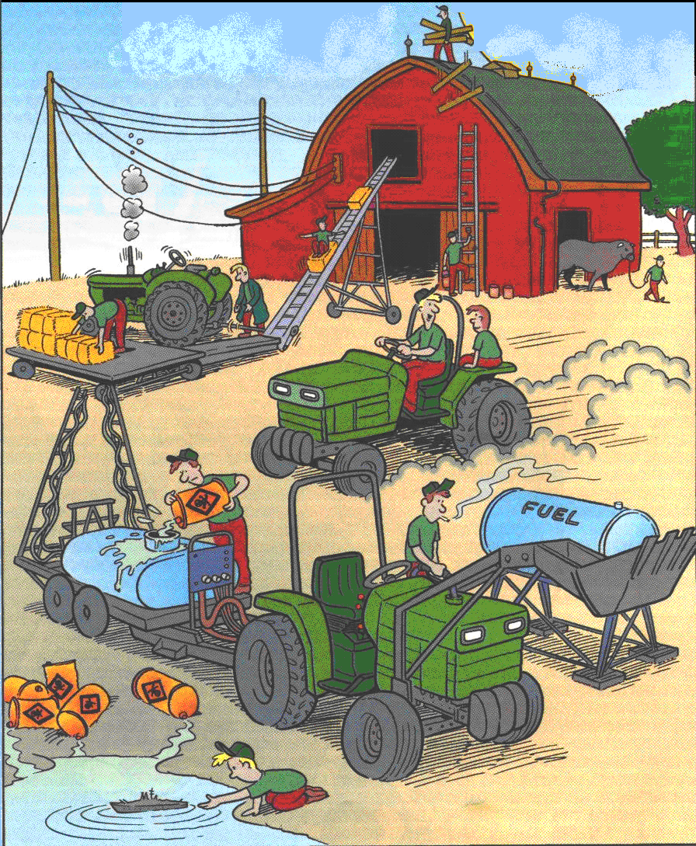

**Ladder is broken.**