

1. Go to: “**Start Your Training – Register, It’s Free!**”

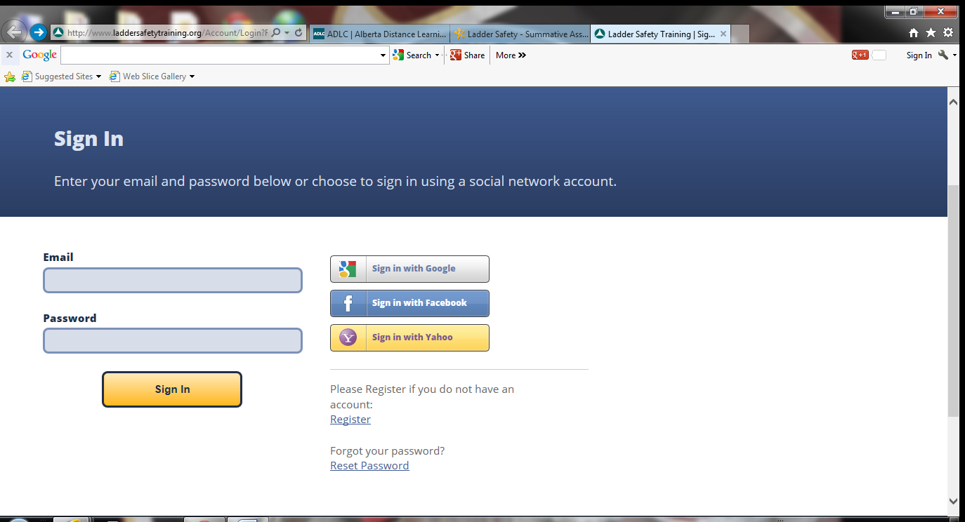

2. Enter your information: First name, Last name, an active email address, a password, for **Company** put in the name of your school, for **Position** put in **Student**, for **Industry** put in **Education**. Then enter your postal code. Don’t forget to check the box to accept the Terms of Use. Then click on **Register** at the bottom.

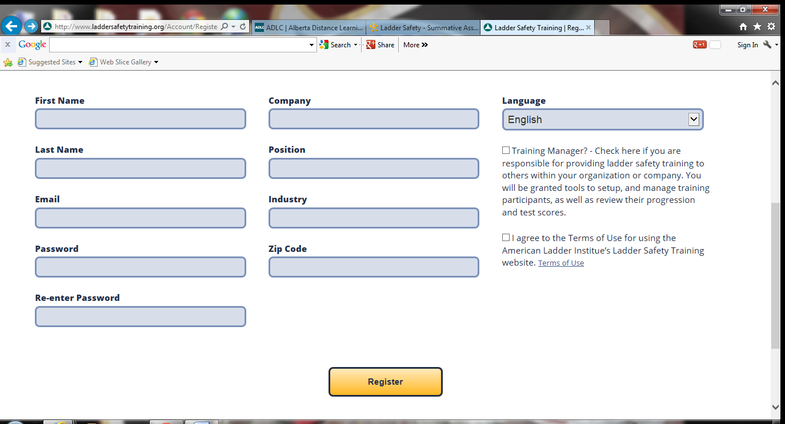

3. You are now given instructions to complete the steps to achieve the two certificates: Stepladder Safety and Single & Extension Ladder Safety. Complete the pre-test, video and then the final test. Once you achieve 90% you will be awarded your certificate. Follow the same steps to achieve the 2nd certificate

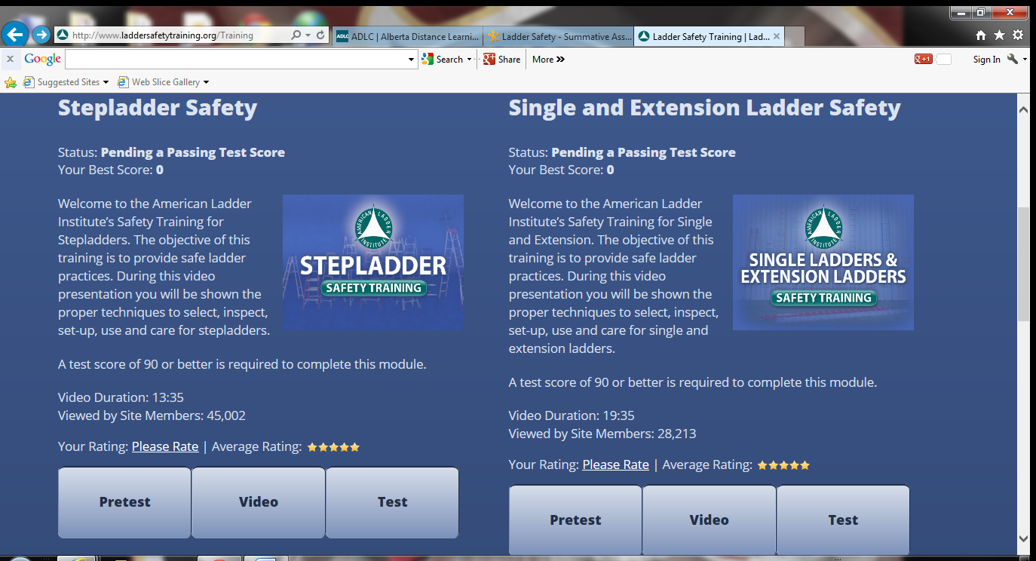

4. Click on **Safety Certificate** and you have the option to open or save your certificate. Save your certificate to your data stick or desktop. You can also print off your certificate.

