Science 7
Unit A
Lesson 1
Self-Check Quiz

Answer all 5 questions in the spaces provided. Think carefully before typing your answers. If you need help, return to the lesson in the online course. Save your quiz when you are done.

Leave your answers in blue; it will be easier for you and your teacher to see them later.

Question 1

Is a vegetable garden an ecosystem?

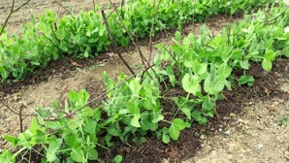
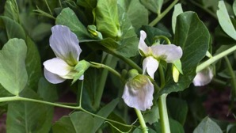

Type your answer here.

Question 2

What is the difference between an ecosystem and a community?

Type your answer here.

Question 3

In an ecosystem, organisms interact with each other and the environment. Give an example of two organisms interacting with each other in a particular ecosystem.

Type your answer here.

Question 4

A child brings rocks from a road and throws them into a pond. Explain whether the child is adding biotic or abiotic factors to the ecosystem.

Type your answer here.

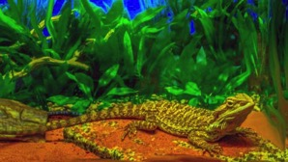
Question 5

Is a single lizard in a terrarium an ecosystem? Explain.

Type your answer here.

Congratulations! You have completed this self-check quiz.

Now it's time to carefully compare your answers to the suggested answers in the online course. When comparing, you should feel free to make changes to your answers or make extra notes.

Don't forget to save the quiz whenever you make changes.

Keep this quiz for study purposes. If you want more feedback, share it with your teacher.

