Science 7
Unit A
Lesson 2
Self-Check Quiz

Answer all 5 questions in the spaces provided. Think carefully before typing your answers. If you need help, return to the lesson in the online course. Save your quiz when you are done.

Leave your answers in blue; it will be easier for you and your teacher to see them later.

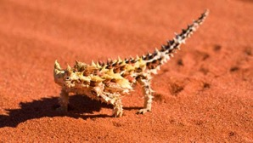
Question 1

How do animals in a desert meet their need for water?

Type your answer here.

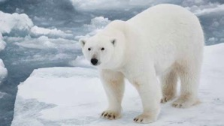
Question 2

What happens to a species when its needs are not being met?

Type your answer here.


Question 3

How can some plants survive the winter months without air, water, warmth, or sunlight?

Type your answer here.

Question 4

What should scientists look for if they want to find life on other planets or moons?

Type your answer here.

Question 5

Are there any organisms that do not need other organisms to live? Explain your answer.

Type your answer here.

Congratulations! You have completed this self-check quiz.

Now it's time to carefully compare your answers to the suggested answers in the online course. When comparing, you should feel free to make changes to your answers or make extra notes.

Don't forget to save the quiz whenever you make changes.

Keep this quiz for study purposes. If you want more feedback, share it with your teacher.

