Science 7
Unit A
Lesson 3
Self-Check Quiz

Answer all 5 questions in the spaces provided. Think carefully before typing your answers. If you need help, return to the lesson in the online course. Save your quiz when you are done.

Leave your answers in blue; it will be easier for you and your teacher to see them later.

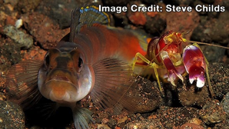
Question 1

A goby fish and a pistol shrimp share a burrow that they live and hide in.

Watch this video to learn how the goby fish and pistol shrimp interact.

What kind of symbiotic relationship exists between the goby fish and the pistol shrimp? Explain.

Type your answer here.

Question 2

Watch this video carefully.

Some species are so well adapted to each other that they form a single functioning unit. A coral polyp is an example of this intimate relationship. The video shows how the coral (an animal) interacts with a special kind of algae called zooxanthellae (a plant). What kind of symbiosis is this? Does the coral benefit from the algae? How? Does the algae benefit from the coral? How?

Type your answer here.

Question 3

Watch this video carefully.

The interaction between the hermit crab and the anemones is an example of mutualism. Notice the crab’s shell. It was abandoned by a gastropod that died of natural causes. Now, the crab uses the shell for protection. What is the relationship between the gastropod and the hermit crab? Explain.

Type your answer here.

Question 4

In a parasitic relationship, one species is harmed while another species benefits. Do you think a parasite ever kills its host? Explain.

Type your answer here.

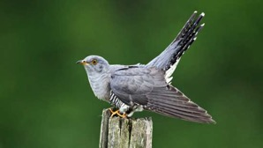
Question 5

The cuckoo bird does not bother to rear and feed its young.

Instead, it tricks an unsuspecting warbler into doing the job. The cuckoo removes an egg from a warbler nest and lays its own egg into the nest. Because its egg looks very similar to the warbler’s egg, the warbler is unaware of the switch. When the eggs hatch, the warbler feeds and cares for the cuckoo egg as if it is her own. The growing cuckoo chick soon dwarfs the warbler chicks in the nest. It may even toss them out. What kind of symbiotic relationship is this? Explain.

Type your answer here.

Congratulations! You have completed this self-check quiz.

Now it's time to carefully compare your answers to the suggested answers in the online course. When comparing, you should feel free to make changes to your answers or make extra notes.

Don't forget to save the quiz whenever you make changes.

Keep this quiz for study purposes. If you want more feedback, share it with your teacher.

