Science 7
Unit A
Section 1
Self-Check Quiz

Answer all 5 questions in the spaces provided. Think carefully before typing your answers. If you need help, return to the lesson in the online course. Save your quiz when you are done.

Leave your answers in blue; it will be easier for you and your teacher to see them later.

Question 1

Soon after a dead tree falls in a forest, it becomes a nursery for new life.

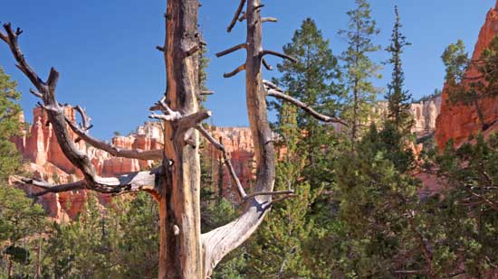
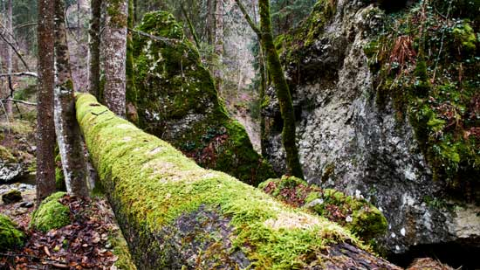

Moss, fungi, and ferns grow all over it. Insects and bacteria feed on the decaying wood. Is this an ecosystem? Explain.

Type your answer here.

Question 2

Soon after a dead tree falls in a forest, it becomes a nursery for new life.

Moss, fungi, and ferns grow all over it. Is the decaying wood of the log a biotic or abiotic factor? Explain.

Type your answer here.

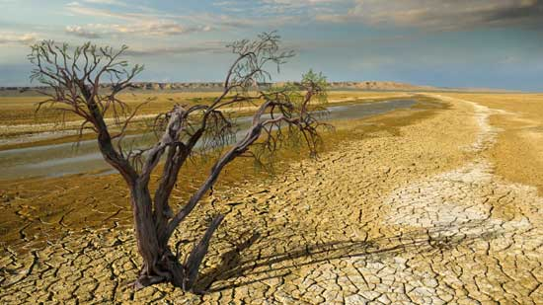
Question 3

The tree in this photograph did not die from old age. What do you think happened to it? Describe your answer in terms of its basic needs.

Type your answer here.

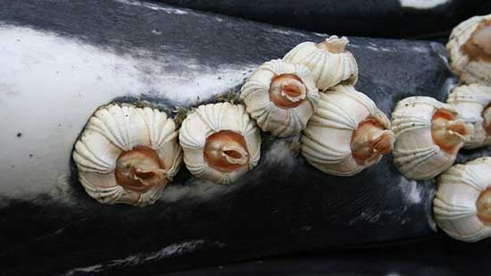
Question 4

Barnacles are hitch hikers. They cemented themselves to the skin of this whale.

The barnacles do not harm the whale. They feed on tiny plankton in the water. This is the same food that the whale feeds on. What are two ways in which the barnacles benefit from the whale? What kind of ecological relationship do the whale and barnacles share?

Type your answer here.

Question 5

Are there any symbiotic relationships in which no one benefits? Explain.

Type your answer here.

Congratulations! You have completed this self-check quiz.

Now it's time to carefully compare your answers to the suggested answers in the online course. When comparing, you should feel free to make changes to your answers or make extra notes.

Don't forget to save the quiz whenever you make changes.

Keep this quiz for study purposes. If you want more feedback, share it with your teacher.

