Science 7
Unit A
Lesson 4
Self-Check Quiz

Answer all 5 questions in the spaces provided. Think carefully before typing your answers. If you need help, return to the lesson in the online course. Save your quiz when you are done.

Leave your answers in blue; it will be easier for you and your teacher to see them later.

Question 1

What characteristics identify a producer? Give an example in your answer.

Type your answer here.

Question 2

What is the role of consumers in an ecosystem? Give an example in your answer.

Type your answer here.

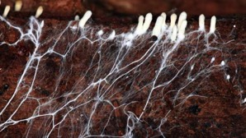
Question 3

This is a fungal colony of mycelium living in soil.

These organisms are decomposers. How do decomposers help the soil?

Type your answer here.

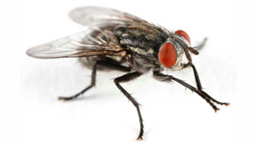
Question 4

Flesh flies feed on dung and dead animals.

The flesh fly has does not have a glamorous job. It feeds on dead and rotting bodies and on feces. It not only feeds on dead material. It lays eggs that hatch into maggots. Maggots break down dead animal bodies. After the maggots are finished their job, another type of organism takes over. Decomposers turn everything that is left into soil nutrients. This timelapse video shows a dead fox being broken down by maggots.

What type of organism is the flesh fly? Why is this kind of organism important to the ecosystem? Explain the difference between a scavenger and a decomposer.

Type your answer here.

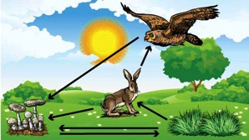
Question 5

This is a simple ecosystem consisting of plants, rabbits, owls, and fungi.

What would happen if the owls disappeared from this ecosystem? How about the rabbits? The fungi? Explain what would happen in terms of the roles of each organism.

Type your answer here.

Congratulations! You have completed this self-check quiz.

Now it's time to carefully compare your answers to the suggested answers in the online course. When comparing, you should feel free to make changes to your answers or make extra notes.

Don't forget to save the quiz whenever you make changes.

Keep this quiz for study purposes. If you want more feedback, share it with your teacher.

