Science 7
Unit A
Section 2
Self-Check Quiz

Answer all 5 questions in the spaces provided. Think carefully before typing your answers. If you need help, return to the lesson in the online course. Save your quiz when you are done.

Leave your answers in blue; it will be easier for you and your teacher to see them later.

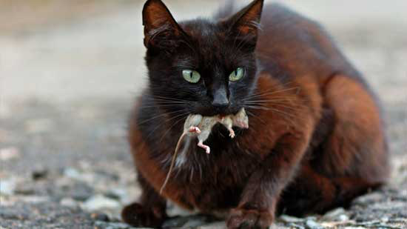
Question 1

Cats will eat mice when they have the chance. Mice eat grains. Describe how energy flows through this food chain. Where does the energy come from? What happens to it?

Type your answer here.

Question 2

Cats eat mice. Cats eat birds, too. Mice are eaten by owls. Birds eat both worms and grains. Worms are decomposers that consume dead grain plant material. Explain what the food web would look like that describes these relationships.

Type your answer here.

Question 3

Use all the organisms listed in Question 2 to construct a food pyramid. Each level of the food pyramid should be labeled with its appropriate role in the ecosystem. Do your best to explain the food pyramid your have constructed and labeled.

Type your answer here.

Question 4

Describe how carbon cycles through the cat food web you drew in Question 3.

Type your answer here.

Question 5

The earthworm is an exception in energy pyramids. Why do most energy pyramids not contain a level for decomposers?

Type your answer here.

Congratulations! You have completed this self-check quiz.

Now it's time to carefully compare your answers to the suggested answers in the online course. When comparing, you should feel free to make changes to your answers or make extra notes.

Don't forget to save the quiz whenever you make changes.

Keep this quiz for study purposes. If you want more feedback, share it with your teacher.

