Science 7
Unit A, Lesson 7
Lesson Activity
Wildlife Sampling

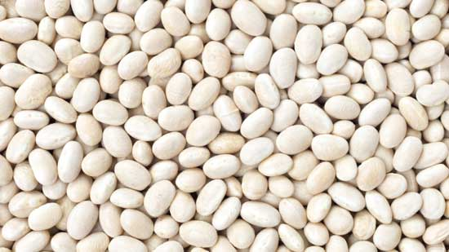
How do scientists gather data so they can make decisions regarding wildlife management? How do they know how big a population is when they cannot count every individual? In this activity, you will learn how to sample wildlife using the Capture-Recapture technique.

Capture-recapture, or mark and recapture, is a technique commonly used by ecologists to estimate the size of a population.

Materials:

- medium-sized bowl
- dried white beans (about one or two cupfuls) DO NOT COUNT the beans!
- small paper or plastic cup
- a marker pen
- paper and pencil
- ruler

Instructions:

- Place all the beans in the bowl. Estimate how many beans are in the bowl. Do this by simply looking at the beans in the bowl and making your best guess. Write this number on a separate piece of paper (or use the space provided on the sheet you can download in step 2) and label it ESTIMATE.
- Use a table such as the one shown below to record your data.

Wildlife Sampling

ESTIMATE: ORIGINAL CAPTURE:
How many beans do you think there are? These beans are the first sample that you put Xs on.

Trial | Sample | Recapture | P  (total population)
 | How many total beans in sample? | How many of the beans in the sample have an “x” on them?
A
B
C
D
E
F
G
H
I
J
TOTAL

- Using the small cup, “capture” a sample of the beans from the bowl. Do this by dipping the small cup into the bowl, and scooping up beans. DO NOT use your hands or fingers to help push beans into the cup. “Capturing” only some of the beans is perfectly normal.
- Mark each captured bean with a small X. Count them. This is the ORIGINAL captured amount. Record this number (label it “ORIGINAL”) alongside your ESTIMATE. The chart you downloaded in step 2 has a place at the top for this.) The ORIGINAL and ESTIMATE numbers are important; you will use them for a math calculation later.
- Put the captured beans back in the bowl with the others. Toss and shake the bowl gently for about 20 seconds to mix all the beans thoroughly.
- Capture another sample of beans with the cup. Count all the beans in the cup and put this number in the Sample A block of the chart.

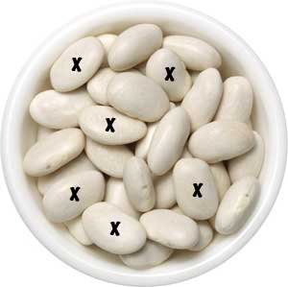
- DO NOT put the beans back in the bowl yet. First, count how many of your Sample A beans have small Xs on them. Put this number in the Recaptured A block of the table. Now, put your beans back in the bowl. Toss and shake the bowl gently for about 20 seconds to mix all the beans thoroughly.
- Repeat steps 6 and 7 nine more times. You will have 10 sets of data (from A to J).
- Add the numbers in each of the two columns (Sample and Recapture) to get a total for each column. Put the totals in the TOTAL line at the bottom of the table.
- Now it is time to use the numbers to do a calculation of how many beans (the POPULATION of beans) are in the bowl. This number will be represented by the letter P. This is the math we use to find P:

If that looks complicated, don't worry! It is easy to put into a calculator. On your calculator, you would enter the ORIGINAL number, multiply by the TOTAL SAMPLE, then divide by the TOTAL RECAPTURED.
Writing this as a math equation, it would look like this:

P = ORIGINAL x TOTAL SAMPLE ÷ TOTAL RECAPTURED

For example, let's say you have an ORIGINAL capture number of 38. Your TOTAL SAMPLE might be 330. Your TOTAL RECAPTURED might be 60. So with these example numbers, 38 x 330 ÷ 60 = 209. So P, the calculated population of beans, is 209. Write this number down – note there is a spot to write this number in the bottom right corner of the table.

- Now count all the beans in the bowl. That is the ACTUAL number -- the population of beans.

You will now have three very important numbers, each representing the number of beans in the bowl:
ESTIMATE = this is the guess you made at the beginning.
P (POPULATION) = this number you got with the Capture-Recapture activity (steps 1–10) and your calculator.
ACTUAL = this is the number you got in step 11 by actually counting all the beans.

Questions:

Think about the following questions very carefully. Then, type answers in the space provided. When you have your answers, click the questions in the online course for feedback.

- How does the ACTUAL number of beans you counted in step 11 compare to the initial ESTIMATE you made in step 1?

- How does the ACTUAL number of beans you counted in step 11 compare to the number P you calculated in step 10?

- How would you rate the Capture-Recapture technique used in this activity in terms of how accurate it is in estimating population size? (Is this a poor, fair, good, or excellent technique for estimating population size?) Explain.

