Science 7
Unit A
Lesson 9
Self-Check Quiz

Answer all 5 questions in the spaces provided. Think carefully before typing your answers. If you need help, return to the lesson in the online course. Save your quiz when you are done.

Leave your answers in blue; it will be easier for you and your teacher to see them later.

Question 1

For what kinds of things do organisms of the same species compete? Think about possible differences between producers and consumers when you answer.

Type your answer here.

Question 2

What happens when two different species are sustained by the same resource?

Type your answer here.

Question 3

If two species compete for the same resource, will one of the species always die out?

Type your answer here.

Question 4

One species often loses when two species compete for the same resources. You might expect the number of species to decrease as a result. Does competition between species always reduce species diversity in an ecosystem? Explain.

Type your answer here.

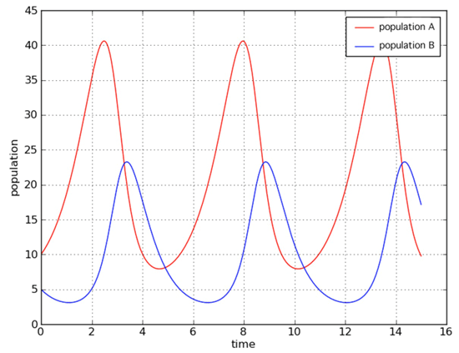
Question 5

Predator-prey relationships can be very complex. Many of these relationships are cyclic. For example, populations of two species in a predator-prey relationship are plotted over time.

Examine this graph closely. Which population do you think is the predator and which populations is the prey? Explain why you think this relationship is cyclic (in other words, why do the shapes of the graphs repeat).

Type your answer here.

Congratulations! You have completed this self-check quiz.

Now it's time to carefully compare your answers to the suggested answers in the online course. When comparing, you should feel free to make changes to your answers or make extra notes.

Don't forget to save the quiz whenever you make changes.

Keep this quiz for study purposes. If you want more feedback, share it with your teacher.

