Science 7
Unit A
Section 3
Self-Check Quiz

Answer all 5 questions in the spaces provided. Think carefully before typing your answers. If you need help, return to the lesson in the online course. Save your quiz when you are done.

Leave your answers in blue; it will be easier for you and your teacher to see them later.

Question 1

What is the value of using a basic ecosystem sampling technique?

Type your answer here.

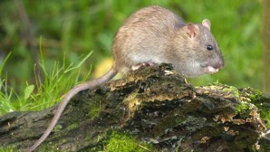
Question 2

Originally from China, the Norway rat has invaded almost every continent. It got there by stowing away on ships. The Norway rat is large with a body of up to 25 cm long. It is the only rat species capable of surviving Alberta winters, at least in the shelter of buildings. In 1951, Alberta launched a very aggressive campaign to get rid of them. Alberta is now the largest rat-free populated area in the world. The rats are very adaptable to new environments. They reproduce quickly. They eat almost anything. They are a model invasive species. Without knowing it, humans have helped rats invade the world.

Norway rats are perhaps most harmful to humans in the ecosystem. They chew holes in buildings and eat large amounts of grain. They even kill small livestock such as chickens. Most importantly, they carry many deadly diseases.

Although Norway rats have many predators in new environments, they always manage to do well. In new ecosystems, they do great harm to native species that live, roost, or nest on the ground. Seabirds and amphibians are most at risk from their invasion.

Explain how an invasive species, such as the Norway rat, weakens the ecosystem it invades.

Type your answer here.

Question 3

Do members of the same species compete with each other in ecosystems? Explain.

Type your answer here.

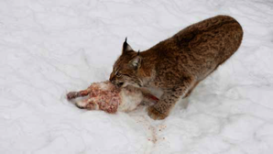
Question 4

Lynx prey on snowshoe hares. When these two populations are sampled over time, a distinct cycle emerges. An increase in lynx always follows an increase in hares and vice versa.

What causes this cycle?

Type your answer here.

Question 5

A fire burns a section of a forest ecosystem. The area that burned goes through succession and eventually returns to normal. Describe how secondary succession works in a forest.

Type your answer here.

Congratulations! You have completed this self-check quiz.

Now it's time to carefully compare your answers to the suggested answers in the online course. When comparing, you should feel free to make changes to your answers or make extra notes.

Don't forget to save the quiz whenever you make changes.

Keep this quiz for study purposes. If you want more feedback, share it with your teacher.

