Science 7
Unit A
Lesson 12
Self-Check Quiz

Answer all 5 questions in the spaces provided. Think carefully before typing your answers. If you need help, return to the lesson in the online course. Save your quiz when you are done.

Leave your answers in blue; it will be easier for you and your teacher to see them later.

Question 1

Explain the meaning of the term endangered species.

Type your answer here.

Question 2

Extinction occurs naturally. All the dinosaurs went extinct. Why should we act to prevent the current extinctions of animals?

Type your answer here.

Question 3

Human activities cause ecosystem change and organisms adapt to natural changes in ecosystems all the time. Why don’t organisms simply adapt to the changes?

Type your answer here.

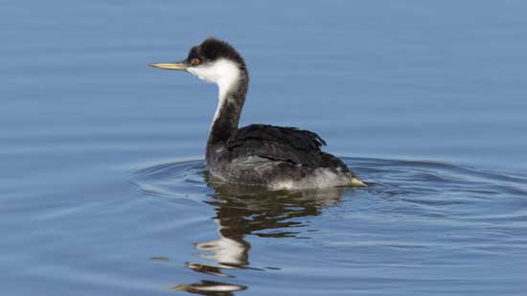
Question 4

The western grebe is listed as a species of special concern in Alberta. These birds require a very specific habitat. They need shallow water filled with cat tails, bullrushes, or reed grass to build and anchor their nests. They also need deeper water near their nests that supports the small fish they prey on. This specific habitat is very limited in Alberta. Loss of these habitats has reduced significantly the western grebe population.

What kinds of actions would help to protect this species?

Type your answer here.

Question 5

What does “of special concern” mean in describing the health of a population?

Type your answer here.

Congratulations! You have completed this self-check quiz.

Now it's time to carefully compare your answers to the suggested answers in the online course. When comparing, you should feel free to make changes to your answers or make extra notes.

Don't forget to save the quiz whenever you make changes.

Keep this quiz for study purposes. If you want more feedback, share it with your teacher.

