Science 7
Unit A
Section 4
Self-Check Quiz

Answer all 5 questions in the spaces provided. Think carefully before typing your answers. If you need help, return to the lesson in the online course. Save your quiz when you are done.

Leave your answers in blue; it will be easier for you and your teacher to see them later.

Question 1

What are some ways in which ecosystems are damaged by humans?

Type your answer here.

Question 2

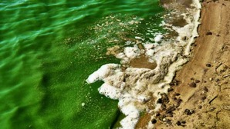
Toxic blooms of blue-green algae are becoming common in many Alberta lakes. The algae, which are actually bacteria, multiply rapidly in nutrient-rich warm water. The nutrient most responsible for algae blooms is phosphorus, which is in detergents, fertilizers, and human and animal wastes.

What are some ways that we can reduce the occurrence of algae blooms in lakes?

Type your answer here.

Question 3


Sometimes human activity harms wildlife in unexpected ways. We have begun to understand that many activities result in underwater noise pollution. That noise can harm many ocean animals.

How have we learned about these effects?

Type your answer here.

Question 4

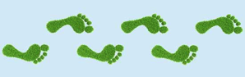
What is “ecological footprint”?

Type your answer here.

Question 5

Grain farming can damage ecosystems over time. Monoculture (growing just one species over a large area) reduces biodiversity. The use of pesticides kills many insects in the ecosystem. Animals that eat insects also ingest harmful pesticides. Chemical fertilizers wash from the soil into rivers and ponds, polluting them and unbalancing their aquatic ecosystems. Over-tilling the soil breaks down its structure and damages soil organisms.

Can you think of ways that grain farming might be made more sustainable?

Type your answer here.

Congratulations! You have completed this self-check quiz.

Now it's time to carefully compare your answers to the suggested answers in the online course. When comparing, you should feel free to make changes to your answers or make extra notes.

Don't forget to save the quiz whenever you make changes.

Keep this quiz for study purposes. If you want more feedback, share it with your teacher.

