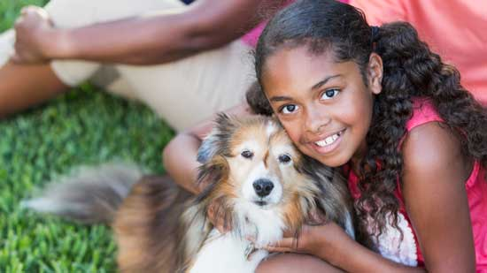
Science 7
Unit A, Section 4
Project
Design a Sustainable Ecological Doghouse

You are required to submit this project to your teacher for marks. Very carefully, read the project task and how to do it. Be sure to read the rubric, which explains the expectations for this project.

Situation

Like humans, dogs need a comfortable home! But it would be great if doghouses could be built while taking into account sustainability. The ideal situation would be to create and excellent doghouse that serves the needs of the dog, but also uses sustainable materials and requires the least amount of energy as possible.

Task

Your mission is to design a doghouse. Your dog should be cosy and warm during a long cold Alberta winter. It should enjoy its house in summer, too.

Here’s the catch – your doghouse should be built as sustainably as possible. Remember the basic principles of sustainability. You are trying to build a doghouse with the smallest ecological footprint possible. Your doghouse should be ecologically sensitive in the way it looks, too. (Does it fit into its surroundings?) Here are a few ideas to keep in mind:

- The materials you choose should be suitable for a doghouse, but are they recycled and/or recyclable? Do the materials come from sustainable sources?
- Your doghouse should have a heater, but your design should keep energy loss to a minimum. Remember comfort has several aspects. Your dog should be warm in winter and cool in summer, be able to get in and out easily, enjoy some light, and have a comfortable place to rest.
- When you describe your design, be sure to describe the ecology of the surrounding area. How does your doghouse fit into the ecology of the area where it is built?

Method

Choose the way you would like to communicate your design. You can choose from the following ideas.

- Build a real doghouse for your real dog! Then, photograph or video various aspects of it to share with your teacher. (This might take a long time! Better to make a model or a plan -- the, do the real thing for Fido!)
- Build a model. For example, you might build it with Lego, popsicle sticks, cardboard, or some other convenient material. Then, photograph or video various aspects of your model to share with your teacher.
- Draw several pictures to show clearly the interior and exterior features of your design. Use pencil and paper, or use a computer drawing program such as Adobe Photoshop or Gimp.
- Build a structure in Minecraft and take screenshots.
- Write a detailed written plan about your design.
- Use any other creative ideas you have, but check with your teacher first!

Requirements

You must answer the following questions to communicate clearly information about your design.

- You can provide written answers to these questions, or you can include the answers as labels if you produce a drawing of your design.
- You can address these questions by recording yourself (and your model or drawings) on video or make an audio recording.

- How does your doghouse design keep your dog comfortable? Remember that comfort includes temperature, movement, light levels, and physical space.
- How do the parts of your design respect the principles of sustainability?
- Describe how your doghouse fits into the surrounding ecological area. The ecological area is up to you. You could build your doghouse in a forest area, beside a waterfall, in a grassland, in a desert, or somewhere else of your choice -- even under a tree in your backyard.

Rubric

This rubric explains how your project will be marked. It explains everything you must include in your assessment. Read it very carefully before you start your work.

Design a Sustainable Ecological Doghouse
20 marks

CRITERIA | PERFORMANCE
CRITERIA |  | NOT OK | OK | GOOD | EXCELLENT
CRITERIA | Not Submitted  0 marks | Does not meet criteria  1 mark | Minimally  meets criteria  2 marks | Fully meets criteria  3 marks | Exceeds  criteria  4 marks
Keeping your dog comfortable - clearly explained | Not  Submitted | No parts or explanation of how design keeps dog comfortable. | Few parts of design dedicated to dog comfort, but details unclear. | Some parts of design dedicated to dog comfort; some supporting details. | Many parts of design dedicated to dog comfort; many supporting details.
Design respects principles of sustainability | Not  Submitted | No sustainability details mentioned or connected to design; details lacking. | Sustainability details mentioned but not connected to design; details lacking. | Sustainability details mentioned and connected to design; some supporting details. | Sustainability details and connected to design; many supporting details.
Description of how design fits into local ecology | Not  Submitted | Ecological fit not included. | One or two ecological fit details included. | Some ecological fit details included. | Many interesting ecological fit details included.
Creativity | Not  Submitted | Design very simple, lacking imagination. | Design very simple, but shows some imagination. | Design has some creative features and shows some imagination. | Design has creative features and shows great imagination.
Communication | Not  Submitted | Design not clearly communicated; details lacking. | Design partly communicated; some details lacking or confusing. | Design communicated partly; many details included. | Design communicated clearly with much detail.

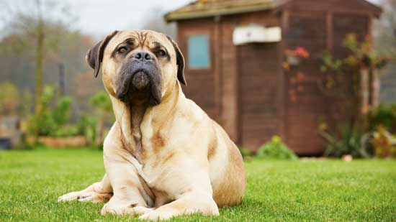

Submitting Your Work

If you do this project as pencil drawing(s) on another piece of paper, you will have to scan your work to submit it.

If you have prepared any other electronic images or documents for this project, you will need to submit them. The same goes for any Internet location where your work is located, you will need to submit the URL so your teacher can view your work.

When you are ready to submit your completed project, return to the project page in your course and click the “Add submission” button at the bottom of the page and follow the directions.

Note that when you submit anything to your teacher, PLEASE INCLUDE YOUR NAME IN THE DOCUMENT TITLE. For example, you might title it something like this:

UnitA_section4project_Jenny_Smith.doc

